Overview

Stochastic techno-economic evaluation of cellulosic biofuel pathways

Xin Zhao, Purdue University, 7654763288, zhao269@purdue.edu
Tristan R. Brown, State University of New York, 3155653003, trbro100@esf.edu
Wallace E. Tyner, Purdue University, 7654940199, wtyner@purdue.edu
In 2007, the US Energy Independence and Security Act (EISA) set a target of blending 36 billion gallons per year (BGY) ethanol equivalent of renewable fuels by 2022 (EPA, 2013). The Act spearheaded a shift in focus from corn-based ethanol to cellulosic biofuel in which cellulosic biofuel blending volumes are to grow annually, from zero in 2008 to at least 16 BGY in 2022. However, the target level for cellulosic biofuel has never been met due to a lack of industry production capacity (Schnepf, 2013). For instance, the initial 2013 cellulosic biofuel blending mandate was 1 billion gallons. This was subsequently revised down to 14 million gallons by the Environmental Protection Agency (EPA) and finally to 6 million gallons, which was still much higher than the 0.8 million gallons actually produced that year (EPA, 2015). Compared with 1st-generation biofuels, cellulosic biofuels are advantageous because they have lower life-cycle greenhouse gas (GHG) emissions and can use non-food feedstock which results in reduced indirect land-use change and smaller effects on food prices. Nevertheless, cellulosic biofuels require more expensive conversion technology due to the recalcitrance of cellulose and presence of lignin, which results in higher capital costs and lower yields than for 1st-generation pathways. In order to reduce the financial risks faced by private investors due to the high capital cost yield uncertainty, government incentives may be necessary (EPA, 2013). A fundamental question is, among all the potential cellulosic biofuel pathways, which ones are more technically and economically feasible, less risky, and incur the lowest costs?
A series of techno-economic analyses (TEA) have been conducted on a range of cellulosic biofuel production pathways (Jones et al., 2009; Phillips et al., 2011; Zhu et al., 2014; Zhu and Jones, 2009). Previous studies have focused on creating reliable capital and production cost estimates using TEA for a given biofuel pathway. Most studies modelled TEA at a plant size of 2,000 dry metric tons per day (MTPD), a base year of 2007, and use of either corn stover or woody biomass as feedstock. However, direct comparisons cannot necessarily be made among the pathways due to important differences in assumptions (e.g., different price projections and economic assumptions) (Brown, 2015). In addition, most previous studies conducted engineering economic analyses via a discounted cash flow rate of return (DCFROR) tool developed by National Renewable Energy Laboratory (NREL). Petter (2014) has pointed out that there are differences between engineering economic analyses and economic/financial analyses (Petter and Tyner, 2014). The differences mainly turn on financing, tax, working capital, and general inflation assumptions. The present study employs the economic/financial approach to TEA since it better models actual financial conditions. In addition, the existing literature on cellulosic biofuel TEAs mainly calculated deterministic breakeven prices with limited consideration of uncertainty or sensitivity analyses. The deterministic breakeven price is generally the price for which there is a 50 percent probability of earning more or less than the stipulated rate of return. However, for an investment under relatively high uncertainty, it is unlikely that investors would provide financing to a project with a 50 percent chance of generating a return lower than the stipulated hurdle rate. Investors are risk-averse and most would not invest under this condition. The point estimate breakeven price therefore does not represent the threshold under which investment would occur. Hence, quantifying the distribution of breakeven prices provides potential investors with more information on the economic feasibility of a potential investment. The objective of this study is to quantify the NPVs and breakeven price distributions of cellulosic biofuel pathways under technological and economic uncertainty in a manner permitting comparisons to be made among the results for different pathways. The results of this analysis provide policy makers and private investors with information on which potential biofuel pathways are stochastically dominating and how uncertainty affects the economic feasibility of each pathway.

Methods
Eight cellulosic biofuel pathway scenarios, including high-temperature gasification and Fischer–Tropsch synthesis (HTG & FTS), low-temperature gasification and Fischer–Tropsch synthesis (LTG & FTS), fast pyrolysis and hydroprocessing (FPH), hydrothermal liquefaction (HTL), indirect-heat gasification and acetic acid synthesis (IHG & AAS), direct-heat gasification and acetic acid synthesis (DHG & AAS), enzymatic hydrolysis and fermentation (EH), and gasification and methanol-to-gasoline (MTG), are selected for comparison. The basic data used are from the relevant literature. The base year for this study is 2011. Production is assumed to begin in 2013 after a two-year construction period. The production assumptions and data are in concert with the original studies for each pathway. We conduct a spreadsheet-based financial analysis in which @Risk, a spreadsheet add-in software program from Palisades Corporation, is employed to incorporate uncertainty. Identical economic assumptions are applied for all of the pathways. NPV, IRR and breakeven fuel price are derived in order to assess and compare the cellulosic biofuel pathways. Both deterministic and stochastic analysis are conducted. Stochastic analysis is done using Monte Carlo simulation in which probability distributions representing factor variability are sampled repeatedly with all the model calculations done and stored for each Monte Carlo iteration. Thus, the inherent uncertainty in the model inputs is translated to uncertainty in outputs such as breakeven price or NPV. Stochastic analysis needs more comprehensive knowledge about production so as to develop the probability distributions and simulate production under uncertainty. In the Monte Carlo simulation, uncertainty is added to the following technical parameters: capital investment, feedstock cost, fuel yield and energy prices. The minimum, mode and maximum values are estimated so that a Pert distribution could be applied. Based on our study and literature data, a Beta general distribution is benchmarked for fuel yield for each of the pathways. In addition, Geometric Brownian motion (GBM) is applied to project the prices of gasoline and natural gas. Diesel and LPG prices are projected using the twenty-year historical relationship between diesel or LPG and gasoline. For the purpose of the present study, we created a method to derive the distribution for breakeven price. That is to first calculate a breakeven price for each iteration in the simulation and then either create a probability density distribution using calculated breakeven prices or fit a known distribution to the set of breakeven prices based on Akaike information criterion (AIC). This permits the visual comparison of breakeven price distributions for all the pathways. Distributions of breakeven prices provide a similar measure of projects in terms of decision-making compared to distributions of NPVs but represent a lucid and easy-to-communicate result.

Results

In the deterministic analysis, the breakdown and breakeven fuel prices are calculated for all the eight pathway scenarios. The breakeven prices of the eight pathways are in the range of 3.11 – 4.71 $/GGE. FPH results in the lowest breakeven price, 3.11 $/GGE, of which capital cost accounts for 0.94 $/GGE, feedstock cost for 1.07 $/GGE, operating cost for 1.35 $/GGE and 0.25 $/GGE is the electricity generation credit. In terms of stochastic analysis, stochastic breakeven price distributions are generated to present the results (Figure 1). As expected, the means of breakeven fuel price distributions are about equal to deterministic results, at which investors face 50 percent probability of gain or loss. In general, stochastic breakeven price distributions provide much more information than deterministic breakeven price. With uncertainty embedded, stochastic breakeven price could reach as high as 6.80 $/GGE in the LTG & FTS pathway or as low as 2.44 $/GGE in the FPH pathway. LTG & FTS has the highest standard deviation, 0.44 $/GGE, while HTL has the lowest standard deviation, 0.20 $/GGE. Investors can make use of stochastic dominance to compare the alternative pathways.

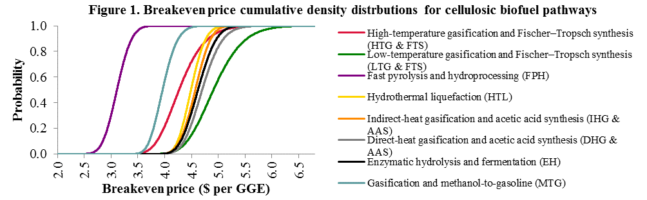

Conclusions
Based on the analysis in this study, the following lessons are learned: (1) With the current level of oil prices, none of the eight cellulosic biofuel pathway scenarios could be profitable in the deterministic analysis. The fast pyrolysis and hydroprocessing (FPH) scenario resulted in the lowest deterministic breakeven price, followed by methanol-to-gasoline scenario. (2) The fast pyrolysis and hydroprocessing scenario has the highest stochastic dominance rank among all the pathway scenarios. FPH resulted in 58.8 percent probability of loss, which is the lowest among the eight pathway scenarios studied. (3) Both NPV distributions and breakeven price distributions are created in stochastic analysis. The results from deterministic analysis (point estimates) only provide useful information to risk-neutral decision-makers; relatively, stochastic analysis provides more information on the measurements and economic feasibility of a project, based on which risk-averse investors can make better decisions. According to stochastic dominance based on return on investment, most risk-averse investors would prefer the fast pyrolysis & hydroprocessing pathway to other cellulosic biofuel production pathway studied.

