Spatial analysis of air quality impacts from using natural gas for road transportation
Fan Tong, ftong@andrew.cmu.edu
Paulina Jaramillo, pjaramil@andrew.cmu.edu
Ines Azevedo, iazevedo@cmu.edu
Department of Engineering and Public Policy, Carnegie Mellon University
412-268-2670

Overview
The negative environmental externalities (such as air pollutants and climate change) from energy use are primary challenges to the sustainability of human society. The NRC report on the Hidden Costs of Energy¹ found that “in 2005, the vehicle sector produced $56 billion in health and other nonclimate-change damages”, most of which are associated with petroleum use. While it may take decades for consumers to fully adopt sustainable transportation technologies², several researchers have suggested that alternative fuel-vehicle pathways, including natural gas-based pathways, could contribute to a reduction of non-climate change environmental and health externalities^{3–7}. In this paper, we analyze the benefits of different pathways for using natural gas in the transportation sector with regards to reduced non-climate change environmental and health externalities in each county in the United States.
Method
For this analysis we focus on light-duty and heavy-duty on-road vehicles, which account for more than 75% of transportation energy consumption¹. Our analysis addresses non-climate change environmental and health externalities from criteria air pollutants (CAP) emitted throughout the life cycle of natural gas-based fuels, from energy extraction to vehicle driving. The emissions inventory are drawn from the GREET model, and other recent estimates^{8–10}. For damage estimations and valuations, we follow the “damage function approach”^{1,11} and use the marginal damages from the AP2 model¹¹ and EASIUR model¹². We consider gasoline (for light duty vehicles, LDV) or diesel (for heavy-duty vehicles, HDV) internal combustion engine vehicles as the baseline vehicles, and we assess the benefits of natural gas pathways as the reduced externalities compared to those from petroleum use. The functional unit is one vehicle mile traveled (VMT) for light-duty vehicles, and one short ton of cargo moved over one mile (ton-mile) for heavy-duty vehicles. Behavioral changes in driving patterns that may occur when natural gas is used instead of petroleum are not considered.
Results
Figure 1 compares the median damages of natural gas pathways for passenger vehicles and heavy-duty trucks across counties. Battery electric vehicles (BEV) powered with natural gas electricity and compressed natural gas (CNG) have 80% and 15% lower median damages than gasoline passenger vehicles. If charged with grid-average electricity, BEVs have a 20% higher median damage. For heavy-duty trucks, CNG-SI and LNG-HPDI trucks both have a 45% lower median damages compared to conventional diesel trucks.
Figure 2 shows the county-level spatial distribution of benefits from CNG passenger vehicles compared to gasoline vehicles in terms of reduced life cycle CAP emissions and avoided damages. Looking across regions, we find that urban areas are likely to achieve larger benefits than rural areas due to larger population densities. Los Angeles and San Francisco Bay Area, for example, stand out as regions where larger reduction benefits could happen.

Conclusions
The use of natural gas in road transportation sector to reduce environmental damages are possible but the benefits are contingent on how natural gas is used and where to replace petroleum fuels. We find that vehicle tailpipe emissions are the largest contributor of damages from HDVs while CAP emissions in feedstock extraction, fuel production, and vehicle operation all play important roles in causing damages from LDVs.
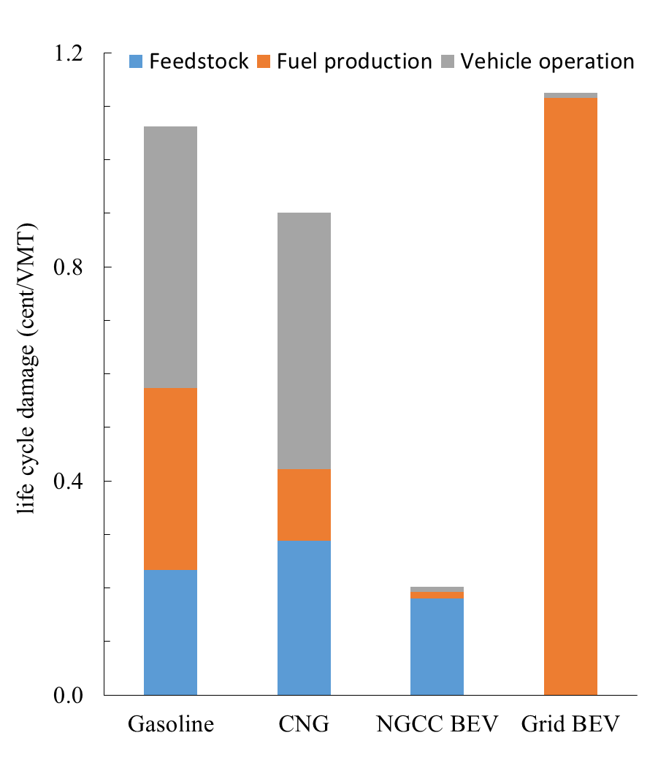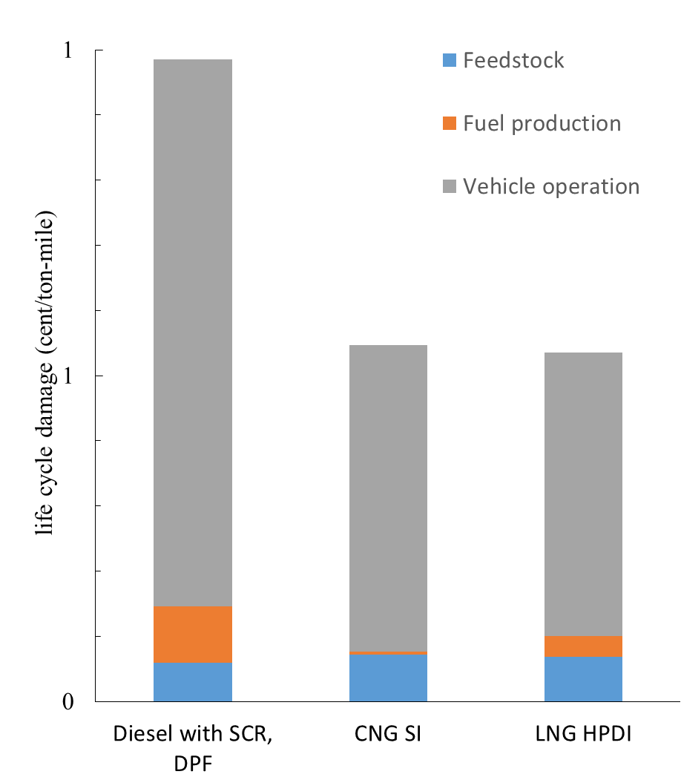
Figure 1 Life cycle health and non-climate change environmental damages for passenger vehicles (left) and heavy-duty trucks (trucks). The life cycle damages shown are median damages across U.S. counties for each fuel pathway. There are four pathways for passenger vehicles, conventional gasoline, compressed natural gas (CNG), battery electric vehicle (BEV) powered by natural gas electricity and grid electricity. There are three pathways for heavy-duty trucks, conventional diesel, CNG, and liquefied natural gas (LNG), all complying with the current U.S. EPA 2010 tailpipe emission standards. DPF = diesel particulate filter; SCR = selective catalytic reduction; SI = sparking ignition; HPDI = high-pressure direct ignition.
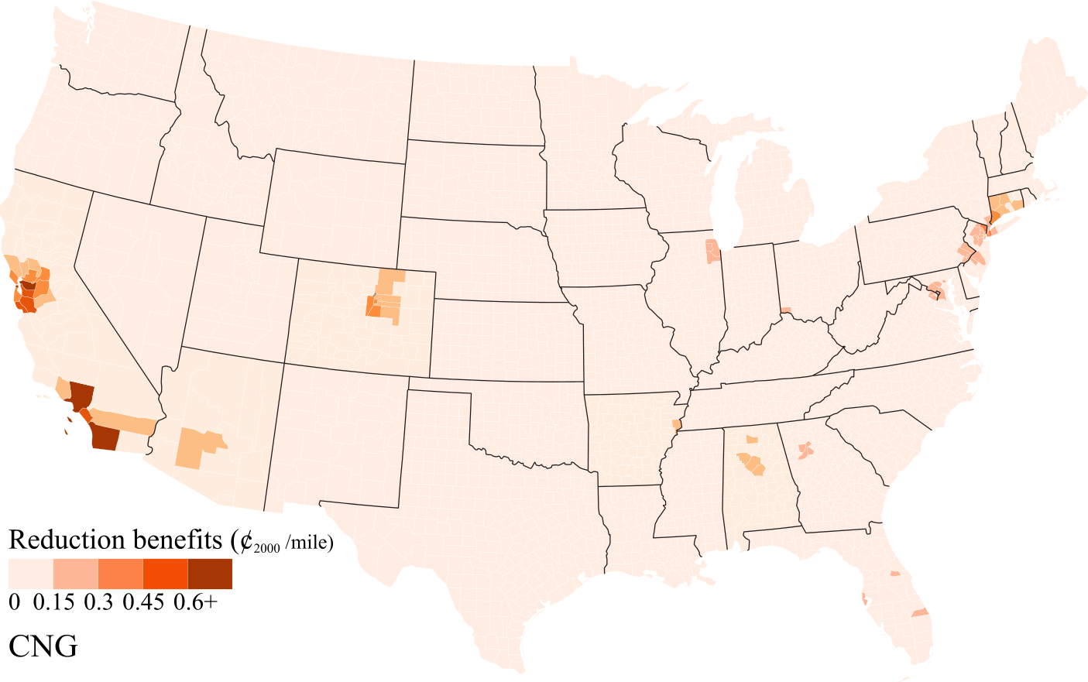
Figure 2 Regional distributions of reduced life cycle damages from CNG passenger vehicles compared to conventional gasoline.

