Overview

Power Grid Reliability: Implications of Environmental Regulation and Coal Plant Retirement in Systems with Large Scale Penetration of Wind Power
Mohsen Rahmani, Carnegie Mellon University, 412-0268-3005, Rahmani@andrew.cmu.edu
Paulina Jaramillo, Carnegie Mellon University, pjaramil@andrew.cmu.edu
Gabriela Hug, Carnegie Mellon University, ghug@ece.cmu.edu
The Environmental Protection Agency’s regulations and the Renewable Portfolio Standards have provoked a prolonged debate about the reliability of the power system¹. EPA regulations will likely lead to the retirement of coal-fired power plants while the state RPSs will continue to drive large-scale deployment of the renewable energy sources, primarily wind ². Combined, these changes in the generation fleet may affect the reliable operations of the power system, as coal plants are well-suited to balance the low frequency variability of wind power³. In order to understand the implications of these alterations, we extensively analyse the operations of the PJM electricity system under different wind penetration and coal plant retirement scenarios. For this purpose, we use a security constraint unit commitment (SCUC) model to evaluate the grid’s ability to provide and transfer least cost energy to consumers. We evaluate several metrics including electricity prices, unserved energy, and transmission congestion for each study scenario. We also assess the share of wind and coal power plants in the total generation, the emissions for a number of air pollutants, and the amount of wind curtailment for each scenario.

Methods
We used the PJM Interconnection system as a test system to evaluate the interaction of coal plant retirements and increased levels of wind power. To populate the power system model, we used Energy Exemplar’s Eastern Interconnection datasets, which include PJM⁴. The dataset include information for the transmission lines, generators and nodes, fuel prices and system demand. We used the PLEXOS software to run the SCUC problem. In SCUC, the objective is to find a least cost generation dispatch considering a variety of constraints on generation and the transmission system. Running the entire Eastern Interconnect is computationally intensive. Since the focus of our study is the PJM region, we thus extracted the PJM system from the EE-EI datasets and prepared a standalone dataset for PJM. So as to not completely lose the interaction between PJM and other regions, we modelled external lines connected to external nodes (19 nodes) by creating a hypothetical region. We modelled the transmission system using maximum and minimum thermal limits for lines and transformers above 69 KV. Finally, we address the N-1 Security constraints by including reserve requirements in the model. N-1 security constraints ensure that the system would continue its reliable operation even after failure of a component such as a transmission line or a generator. We considered two types of operating reserves in our model, spinning and non-spinning reserves. These reserves are meant to cover the load for a short period of time, usually 10 minutes, if an unexpected outage happens in the system.
We developed several generation scenarios to access the reliability of PJM, the most important are:

1) Base: we analyse the economic and electrical performance of the PJM system with 2013’s installed capacity and demand.
2) Retirement: we remove 19 GW of coal capacity from the Base scenario. We used the EPA's Power Sector Modelling Platform v.5.13 ⁵ to develop the coal power generator retirement scenario. We identify that 30% of the total installed coal capacity in PJM in 2013, 19 GW, may retire by 2018.
3) Wind & retirement: we integrated 15GW de-rated wind capacity and retired 19 GW coal generation capacity. From the Eastern Interconnection database ⁶ we selected high capacity wind sites at the state level, up to the RPS target. This scenario represents a spatially diverse distribution of wind sites.

We used locational marginal prices (LMP) to show the economic effect of coal plant retirements and wind integration on the system. Finally as the goal of federal environmental policy and the renewable portfolio standards is to reduce pollutant emissions from the power generation sector, we thus estimate the total emissions of carbon dioxide (CO₂), sulfur dioxide (SO₂) and nitrogen oxides (NO_{x}) for each scenario

Results
In this work, we evaluated the PJM system reliability and its economic performance in scenarios where we retired coal-fired power plants and added higher levels of wind power. We found that coal plant retirements might result in significant reductions in emission of criteria air pollutants or CO₂, as shown in Fig. 1. However, a more significant reduction in emissions can take place if increased wind generation accompanies such retirements where wind farms are geographically distributed across the PJM system. This suggests that federal policies that encourage coal plant retirement and the state Renewable Portfolio Standards are synergistic in their efforts to reduce emission. However, our results suggest that higher electricity prices accompany these emissions benefits. If coal plants retire and wind power does not increase, electricity prices increase by 18% (from 31.48 to 37.00 $/MWh), as shown in Fig. 2. While wind can reduce these prices slightly, it cannot bring them to the levels observed in the Base scenario. Our finding suggests that while these two changes are synergistic and integration of wind can mitigate some of the negative effects of retiring coal plants while providing significant emission reductions, other strategies may be needed to prevent increased congestion costs and load shedding events. Such strategies may include investments in new transmission and/or generation capacity, as well as the use of novel technologies and operational protocols.

Fig. 1: Co₂ Emission Fig. 2: LMP contours
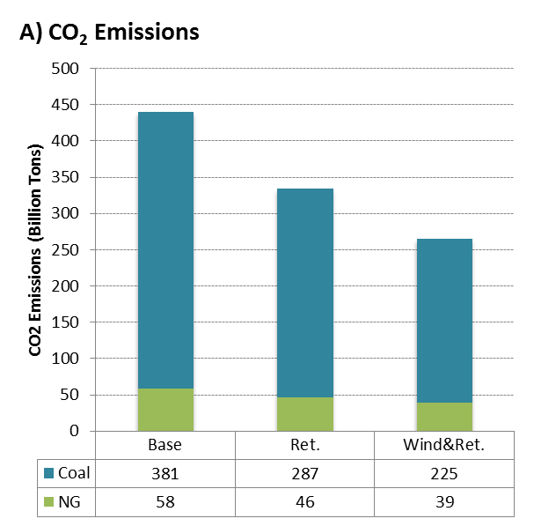 | 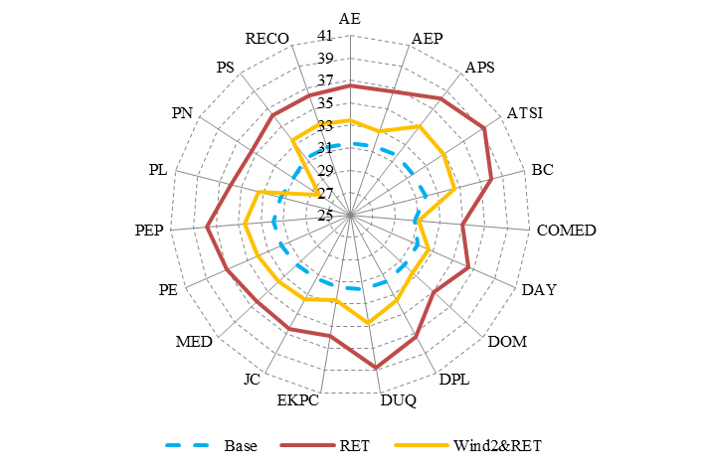  Ret  Wind & Ret.

Conclusions
We conclude that without transmission upgrades, retirement of coal-fired power plants will likely result in considerable transmission congestion and higher energy prices. In addition, we found that retirement and parallel growth of wind energy, with a proper allocation, will lead to a significant reduction in the air pollutants. Furthermore, the addition of wind power, based on the RPS, can generally reduce emissions, and improve the system reliability and electricity market performance, particularly at low and medium load levels. At times of high peak, however, wind may not provide sufficient benefits to overcome the constraints that result from coal plant retirements.

References
1. Fleischman, L., Cleetus, R., Deyette, J., Clemmer, S. & Frenkel, S. Ripe for Retirement: An Economic Analysis of the U.S. Coal Fleet. Electr. J. 26, 51–63 (2013).
2. U.S. Energy Information Administration. Annual Energy Outlook2014 with projections to 2040. (2014). at <http://www.eia.gov/forecasts/aeo/pdf/0383(2014).pdf>
3. Oates, D. L. & Jaramillo, P. Production cost and air emissions impacts of coal cycling in power systems with large-scale wind penetration. Environ. Res. Lett. 8, 024022 (2013).
4. Energy Exemplar. Eastern Interconnect Commercial Datasets. (2014). at <http://energyexemplar.com>
5. EPA. EPA’s Power Sector Modeling Platform v.5.13. (2013). at <http://www.epa.gov/powersectormodeling/BaseCasev513.html>
6. NREL. Eastern Wind Dataset. (2013). at <http://www.nrel.gov/electricity/transmission/eastern_wind_methodology.html>

