Potential impacts of materials on future low carbon transition : A case of low carbon technologies in road-transport sector

Seyed Mehdi Mohaghegh, UCL Institute for Sustainable Resources , +44 (0) 203 108 9337, s.mohaghegh.12@ucl.ac.uk
Ilkka Keppo, UCL Energy Inistitue, +44(0) 203 108 9072, i.keppo@ucl.ac.uk
Christophe McGlade, UCL Institute for Sustainable Resources, +44 (0) 203 108 5961, christophe.mcglade@ucl.ac.uk

Overview

In recent years several studies have considered the issue of critical materials required by the energy sector. The focus has been particularly on low- carbon energy technologies. These studies anticipate an increasing deployment of these low-carbon technologies in responses to the adverse effects posed by climate change. They investigate whether there are sufficient material resources to deploy low-carbon technologies on the scale required, and how the supply of these materials will be affected by the consequent increase in demand.

Based on a quantitative literature review, this research has highlighted the gaps in previous studies and it illustrates that there is currently no comprehensive approach for investigating the demand-side dynamics of energy related materials. We suggest that one option to improve the projection of future demand is through the use of energy-system modelling. By considering the material requirement of energy technologies, bottom-up, technology-rich energy system models can be used to examine and calculate demand-side dynamics in conjunction with supply-side dynamics. Such an approach would, we believe, represent a significant enhancement to the existing literature.

In this research, we neither develop a new method for assessing material criticality nor identify any new critical materials. Instead, we will first select a list of critical materials from the output of studies, which have already identified the critical materials. Then using a consistent approach and fully taking into account the uncertainties that exist, investigate the material intensity of these materials for each energy technology that may require some of these materials.
.

Methods

By a quaititive litreture review a group of critical energy releated materials will be selected. The selected materials will be used in TIAM-UCL which is a bottom-up energy system model. The TIAM-UCL energy systems model is a global optimisation model that investigates decarbonisation of the global E3 (energy-environment-economy) system. The TIAM-UCL can be used to develop scenarios for future demand of energy related materials.

Results

By mapping the criticality factors into the TIAM-UCL, it appears that the energy system model could improve the future demand projections and could contribute to the material criticality assessment methods.

By applying material intensity of the road transport low carbon technologies in the TIAM-UCL, it provides an insight into the material demand under different scenarios. In this poster, the results from 2 degree and 5 degree scenarios will be illustrated.

The results indicate that under a 2 degree scenario, the demand from this sector has a significant impact on the supply of these critical materials; specifically the cobalt demand, which seems to be more critical for future low carbon scenarios.

Conclusions

Based on a quantitative literature review of previous studies in energy related critical materials, it was discovered that there is lack of a comprehensive approach for future material demand projections. By mapping criticality factors into a bottom-up energy system model, it was concluded that embedding material intensity into the model has the potential to fill this gap.

The results from TIAM-UCL demonstrate that under 2 degree scenarios, availability of materials could slow down the projection of electric vehicle scenarios. In conclusion recycling of materials is a potential solution to alleviate the risk of resource scarcity. It addition to recycling, material efficiency improvement could play an important role in transition to a low carbon energy system. The below graph illustrates the amount of resource for these materials and the cumulative demand from the results of the current study.

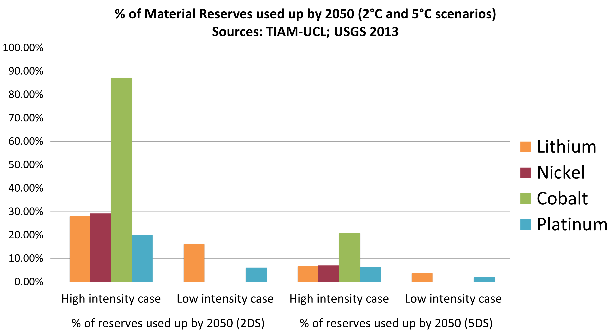
Figure 1 Material reserved used by 2050 from road transport sector

For some energy related materials such as platinum, which plays a crucial role in fuel cell technology, the availability of resources would not cause a constraint for future low carbon energy projections. However, there is a need for substantial investment on production facilities to increase the production capacity.

References
Achzet, B. & Helbig, C., 2013. How to evaluate raw material supply risks—an overview. Resources Policy, 38(4), pp.435–447. Available at: http://www.sciencedirect.com/science/article/pii/S0301420713000445 [Accessed January 11, 2014].

Alonso, E. et al., 2012. Evaluating rare earth element availability: a case with revolutionary demand from clean technologies. Environmental science & technology, 46(6), pp.3406–14. Available at: http://dx.doi.org/10.1021/es203518d [Accessed January 27, 2014].

Angerer, G. et al., 2009. Raw materials for emerging technologies. English summary. Fraunhofer Institute for Systems and Innovation Research (ISI) and Institute for Future Studies and Technology Assessment (IZT). Commissioned by the German Federal Ministry of Economics and Technology Division IIIA5-Mineral Resources.

Erdmann, L. & Graedel, T.E., 2011. Criticality of non-fuel minerals: a review of major approaches and analyses. Environmental science & technology, 45(18), pp.7620–30. Available at: http://dx.doi.org/10.1021/es200563g [Accessed April 28, 2014].

Graedel, T.E., 2011. On the Future Availability of the Energy Metals. Annual Review of Materials Research, 41(1), pp.323–335. Available at: http://www.annualreviews.org/doi/abs/10.1146/annurev-matsci-062910-095759 [Accessed October 31, 2013].

Hertwich, E.G. et al., 2014. Integrated life-cycle assessment of electricity-supply scenarios confirms global environmental benefit of low-carbon technologies. Proceedings of the National Academy of Sciences, p.1312753111–. Available at: http://www.pnas.org/content/early/2014/10/02/1312753111 [Accessed October 7, 2014].

