Estimating the Need for New Electricity Capacity Due to Operational limitations in the Existing Fleet

Chris Nichols, National Energy Technology Laboratory, 304 285 4172, christopher.nichols@netl.doe.gov

Gavin Pickenpaugh, National Energy Technology Laboratory, 412 386 0291, gavin.pickenpaugh@netl.doe.gov

Overview
The Annual Energy Outlook 2014 (AEO’14), the premier energy market forecast produced by the U.S. Energy Information Administration (EIA), forecasts that just under 300 GW of new electricity generation capacity will be required to be built in the next 30 years. Historical capacity additions have averaged around 20 GW per year, or double the rate projected in the AEO’14 and most other energy forecasts. Given that myriad organizations – many without intimate knowledge of the energy industry - use these forecasts in their planning efforts, it is imperative that the assumptions and methodology behind these results are as accurate and reasonable as possible. The AEO’14 forecasts that most of the existing coal and nuclear electricity generating fleet will remain online until 2040 and continue to operate at their historic output levels. Further investigation into the operational characteristics of power plants indicate that older units may not be able to produce the same output over time. This paper investigates the possible need for new baseload electricity generation capacity if aging units are not able to operate at their historic levels and will provide recommendations for model input modifications.

Methods
The National Energy Modeling System (NEMS) is the model platform the EIA uses to forecast the need for new electricity generation capacity builds, among a myriad of other model outputs related the energy sector. NEMS uses an algorithm based on the existing capacity and the projected growth in electricity demand to forecast how much new capacity will be needed. Figure 1 shows the projected electricity generation in billion kilowatt-hours by fuel source from the AEO’14 Reference Case. In this Case, the total electricity generation grows at a roughly linear rate. Electricity generation from coal and nuclear, traditionally the suppliers of baseload power, remain relatively constant over the entire projection period.
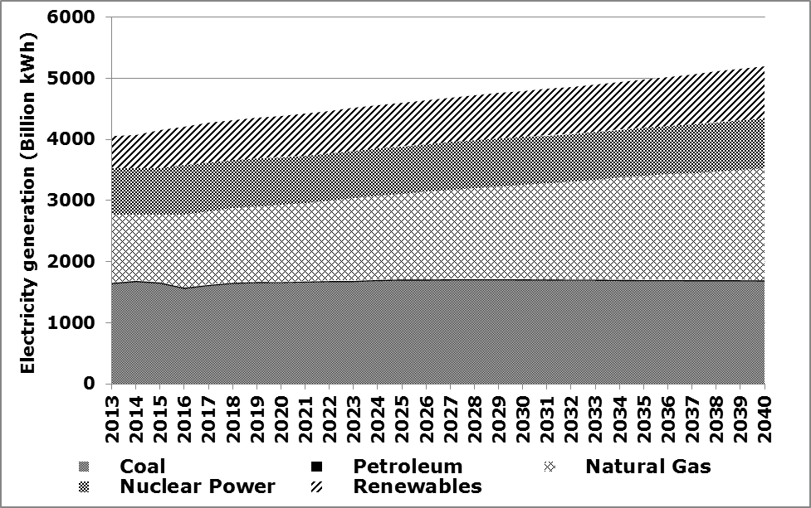
Figure 1. Projection of electricity generation by fuel from AEO'14 to 2040
Almost all of the growth in generation is provided by natural gas (due to a relatively low price path for gas) and some gains in renewable (due mainly to renewable energy standards at the state level). As seen in Figure 2, this generation profile is supported by new capacity builds of natural gas combined cycle and renewable energy plants (which are backed-up by the combustion turbines) later in the projection period. Also of note in Figure 2 is the relatively low magnitude of new nuclear and coal builds, which implies that nearly all of the electricity generation projected for these fuel sources through 2040 will be from existing power plants. The age of an average nuclear or coal is already around 40 years old. The combination of generation and capacity projected in the AEO’14 imply capacity factors in the range of 80-90% for coal and nuclear plants by 2040, when these plants will be nearing 70 years old on average.

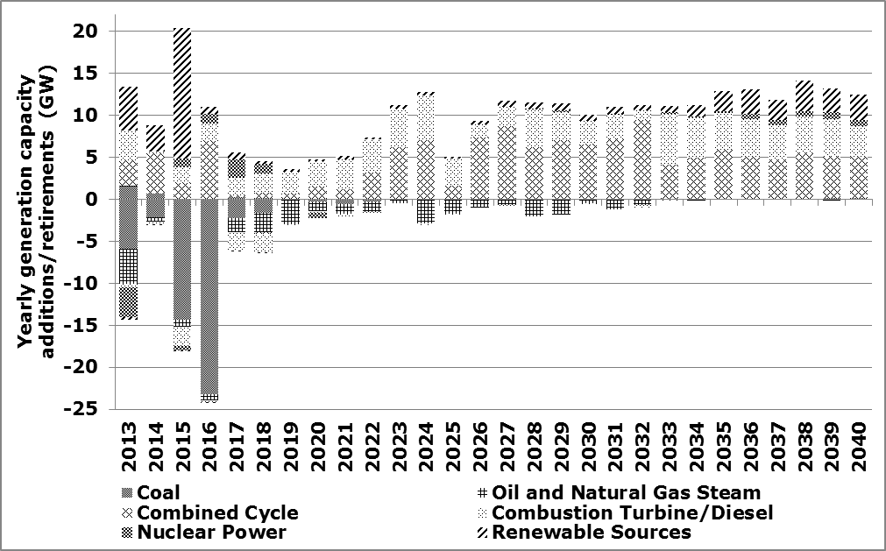

Figure 2. Electricity generation capacity additions and retirements in AEO'14
Although life extensions are possible for both nuclear and coal units, sustained operations at such high capacity factors are unrealistic for a fleet of power plants well into old age. In Figure 3, the average capacity factor is shown by unit age for coal power plant operations over the time period of 1998 to 2012. As seen in the figure, the average capacity factor drops drastically around age 50 for coal units, due to maintenance, operational issues and profitability concerns.
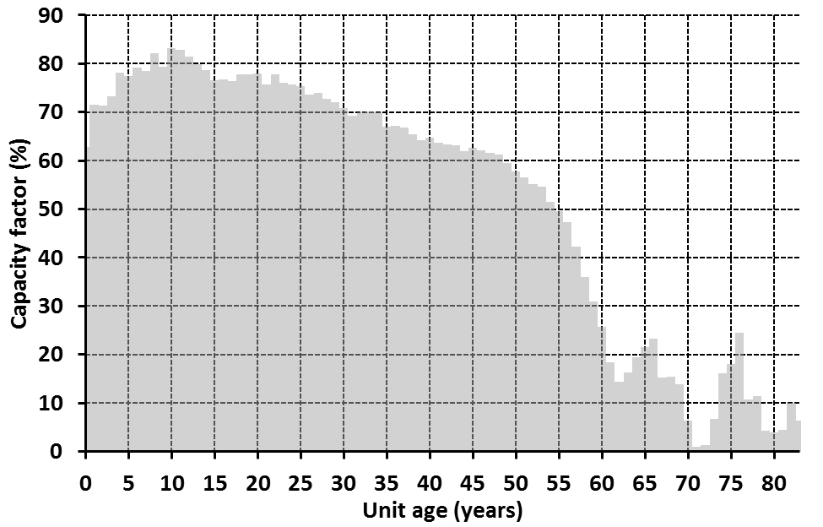
Figure 3. Average capacity factors by age for coal unit operations from 1998-2012
Although nuclear units do not show a similar profile (likely due to the fact that a coal unit with operational issues can often run at lower capacity, while nuclear units must often be shut down for extended outages to deal with problems), it is exceedingly unlikely that the current baseload fleet will be able to perform at the levels projected in the AEO’14. The recent announcement of the early retirements of the San Onofre and Crystal River nuclear power plants demonstrates the vulnerability of nuclear units to premature and permanent shutdowns. Around 40 GW of coal-fired generation – 15% of the total capacity – has also already been announced for retirement as well, with NEMS only forecasting 10 GW more of coal retirements out to 2040.

In order to forecast the potential loss of electricity generation based on unit degredation with age, we constructed a model based on the performance of units historicall. Figure 4 employs kernel density estimators to approximate the density (i.e., distribution) of capacity factors for the various age groups,. The vast majority of the units 0-30 years tend to have capacity factors greater than 60%, with peak concentrations in the 75% to 85% capacity factor range. Beyond age 30, the densities of the age groups appear more spread out and display peak concentration capacity factor than younger age groups. For instance, the 31-40 age group appears to have a peak capacity factor concentration in the range of 70% to 80%, while the peak concentration of the 41-50 age group is in the 60% to 70% range, and the 51-60 age group displays a peak concentration in the range of 55% to 65% range. The density of the over 60 age category looks remarkably different than any of the other age groups, displaying its largest concentration in the 5% to 15% capacity factor range.
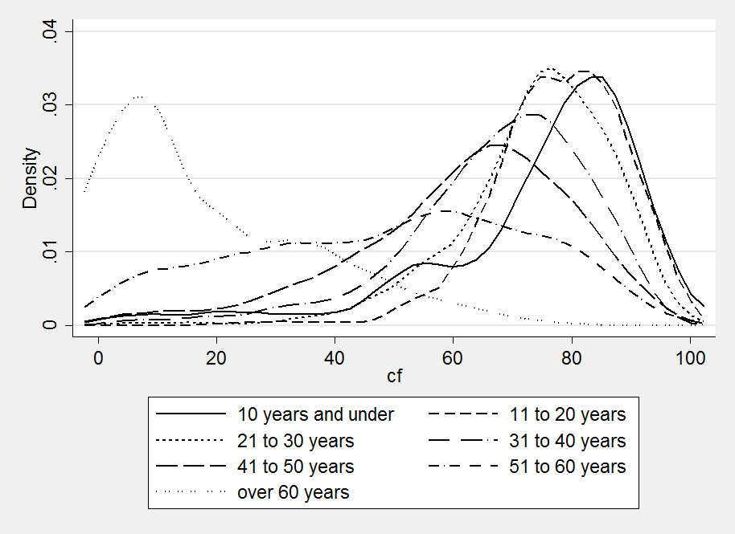
Figure 4. Density estimates of Capacity Factor by age group
Regression analysis was used to estimate the rate of decline for units 30 or more years old. A simple regression of capacity factor on age for units in the 30 to 60 year age group, results in a statistically significant coefficient estimate of 0.9425 (see equation 1). This implies units that are 30 years of age and older see a decline in capacity factor of around 0.94 percentage points per year. Note that regression analysis conducted for units under 30 years of age did not result in a statistically significant coefficient for age; thus the analysis was only conducted for units in the 30 and over age range.
To provide a more conservative estimate of the decline in capacity factor over time, a multiple regression analysis was conducted in which capacity factor is the dependent variable and the explanatory variables include age, nameplate capacity, and the ratio of average fuel cost of the unit to the Henry Hub natural gas price. The regression results for units over 30 to 60 years of age, imply that for each year a plant ages beyond 30 years, capacity factor declines approximately 0.56 percentage points.
Regression formulas (equations 1 and 2) and results (Table 1) are displayed below for units ranging in 30 to 60 years in age.
(2) ${\text{CF}}_{\text{ij}}=β_{0}+β_{1}{\text{Age}}_{\text{ij}}+β_{2}{\text{NNC}}_{\text{ij}}+β_{3}\text{Avgfuel}\text{cos}{\text{ttogasprice}}_{\text{ij}}$
i = unit
j = year of observation
Age = Unit age
NNC = Unit nameplate capacity
Avgfuelcosttogasprice = average unit fuel cost for unit i in year j divided by Henry Hub gas price in year j

Table 1. Regression results
Variable | (1) | (2)
Age | -0.9425*** (0.0229) | -0.5621*** (0.0259)
NNC | ---- | 0.0152*** (0.0009)
Avgfuelcosttogasprice | ---- | 4.3677*** (0.1065)
Constant | 67.3258*** (1.3973) | 67.3258*** (1.3973)
R-squared | 0.1349 | 0.2601
Number of Observations | 10,902 | 10,884
***99% significant level (Standard errors in parentheses)

Results

The regression results above were subsequently incorporated into a spreadsheet model, which calculates the annual generation of the remaining coal units per year based on their calculated capacity factors form 2014 to 2040. The model also removed the same capacity per year as the EIA’s 2014 AEO reference case forecasted retirements. The 2008 – 2013 average capacity factors of all currently operating coal units were used for the first year of the model (2014). The average capacity factors were used each year until the unit turned 30 years old. After age 30, a de-rate factor (as described above) was applied each year, therefore decreasing the units capacity factor, until the unit turned 70. After the age of 70 years, the unit was retired.

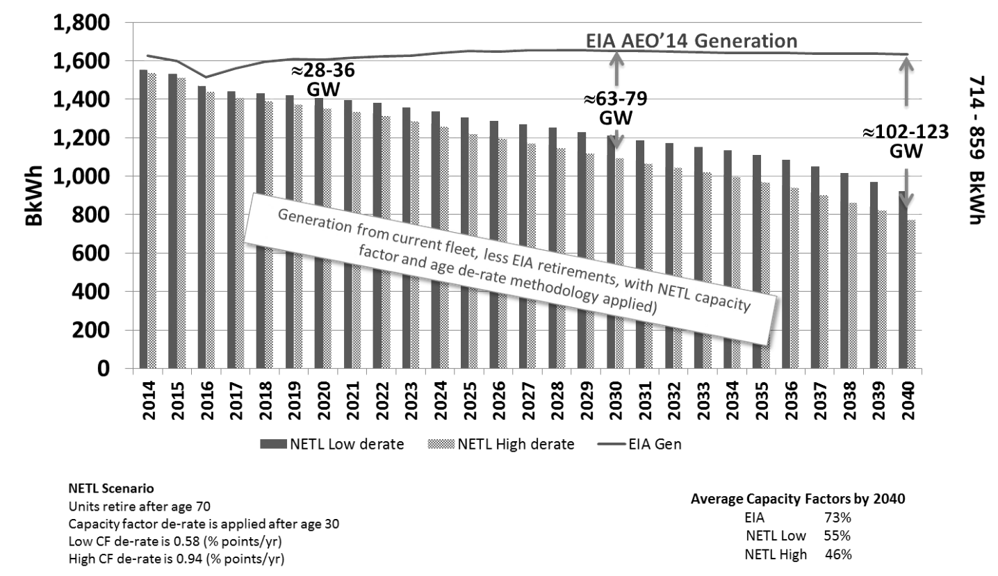
Figure 5. Forecasts of electricity generation from coal in AEO'14 and NETL scenarios
Figure 5 shows forecasts of electricity generation from coal using the NETL model results compared with the AEO’14 results. The gray bars on the graph show the annual generation using the higher capacity factor de-rate value (0.94 %pt/yr) and the blue bars show the annual generation using the lower capacity factor de-rate value (0.56 %pt/yr). The top line shows the EIA AEO 2014 forecasted coal generation for the reference case. The area in between the bars and line is the difference in generation from what EIA forecasted and the NETL model results. Estimated capacity installments to make up for the lost generation were calculated using an 80% capacity for these new builds. The model and graph show a potential for a significant capacity gap in 2040 of over 100 GW.

Conclusions
Failure to account for an aging fleet and reducing the historical relationship between GDP and electricity demand do appear to downplay the need for new electricity generation capacity in NEMS, but it is important to examine the magnitude of the possible shortfall. In 2040, over 180 GW of the coal-fired fleet will be over 70 years old, with almost 70 GW over 80. At the same time in the nuclear fleet, using a lower assumed retirement age, almost 40 GW of existing capacity will be over 60 years old. Depending on assumed plant lifetimes, there could be 110-220 GW of baseload capacity by 2040 that simply cannot operate anywhere near the high capacity factors projected by the AEO’14, if at all.

References
Wild, J., S. Vaterlaus, H. Worm, C. Spielmann and M. Finger (2006): „Swiss Natural Gas Market – Evaluation of the demand for an open market from the viewpoint of the players and analysis of the market openings in selected countries of the EU,“ Study on behalf of Swiss Energy and VSG, forthcoming. (German language)

Wild, J. and C. Spielmann (2005): "Investment and Quality Incentives for Electricity Distribution Networks," Contribution to the 4th international Energy industry conference (IEWT 2005) at Vienna Institute of Technology, 16.-18.2.2005. (German language)

Wild, J. and S. Vaterlaus (2003b): "Regulation of Electricity Distribution Networks – Balance between efficiency and investment incentives," DVWG (Editors.), Investments decisions and cost management in network industries, Schriftenreihe der DVWG, Nr. B 262. (German language)

Telser, H., S. Vaterlaus, P. Zweifel and P. Eugster (2004): What is the performance of our health system?, Publishing house: Rüegger: Zurich. (German language)

Stata 13 was employed to construct the density estimates. Some reasons we chose to employ kernel density estimates rather than histograms are the ease in graphing multiple density estimates in one figure, as well as the smoothness of kernel density lines. For more information, see: http://www.stata.com/manuals13/rkdensity.pdf
Figure 4 excludes units with heat rates equal to 0 or greater than 35,000 and exclude units with capacity factors greater than 100
The figure uses annual data from 1998 to 2013, from Ventyx

