EVALUATING THE ECONOMICS OF SOLAR PV FOR RESIDENTIAL, COMMERCIAL AND INDUSTRIAL CUSTOMERS

Shelly Hagerman, Carnegie Mellon University, 941-350-5693, shagerma@andrew.cmu.edu
Granger Morgan, Carnegie Mellon University, 412-268-2672, granger.morgan@andrew.cmu.edu
Paulina Jaramillo, Carnegie Mellon University, 412-268-6655, paulina@cmu.edu

Overview
The market for rooftop solar photovoltaic (PV) technology has expanded significantly in recent years, largely driven by government and state incentive programs, abundant supply of low-cost silicon, and substantial drops in module prices. However, if the use of rooftop solar PV is to continue to grow, it is important that it become cost competitive without subsidies. From the utility customer’s perspective, PV is competitive when it can produce electricity at a levelized cost equivalent to the electricity rate provided by the local distribution company, a condition sometimes referred to as “socket parity.” For residential customers, we estimate that only Hawaii has achieved socket parity state-wide without the use of subsidies. Extending the analysis to commercial and industrial customers requires consideration of how different rate tariff structures affect the economics of solar PV. In addition to paying for energy consumed, larger customers (>30 kW) are usually charged for their peak demand. We perform an initial case study set in Raleigh, North Carolina and use multiple reference commercial load profiles and both default and time-of-use rate structures to compare the economics across customers.

Methods
We first estimate the NPV of residential solar PV systems with the primary inputs of regional installation costs, financing parameters, county-level electricity prices, and annual energy production for locations across the U.S. We compare the NPV across pessimistic, optimistic, and best estimate scenarios of installation cost and financing parameters as well as the electricity price escalation rate, as seen in Table 1.
Table 1: Scenarios for evaluating the economic viability of rooftop solar PV.
Variable | Pessimistic Estimate | Best  Estimate | Optimistic Estimate
Installation Cost ($/W) | 80th Percentile | Median | 20th Percentile
Loan Interest Rate | 10% | 7% | 5%
Loan Term (Years) | 5 | 15 | 20
Electricity Price Escalation Rate (per year) | 2% | 3% | 5%
When valuing the economics without subsidies, we assume that 30% of the annual energy produced by the system would be exported back to the grid [1]. Thus, we value 70% of the energy generated by the system at the local retail rate with the remainder at a regional average wholesale prices during the first half of 2013 [2]. However, when including subsidies in our analysis, we account for state-wide net-metering, rebates, and loan programs as well as state and federal tax credits. When including the federal investment tax credit, the tax credit is distributed over five years, as per the five-year compliance period [3]. On the state level, we considered net metering, rebates, and loan programs as well as state personal tax credits as available from the Database of State Incentives for Renewables & Efficiency (DSIRE). We assume that personal tax credits are distributed evenly over five years, unless the state’s program requires a shorter period, for which we assume the tax credit is used in full during the first year.
For our initial case study on the economics of solar PV for commercial and industrial customers, we estimate the net present value (NPV) and break-even costs for sixteen commercial reference load profiles created by the Department of Energy. For each of these loads, we consider a 10 kW solar PV system and assign a default and time-of-use rate tariff based on the peak annual demand of the original load. As a part of these tariffs, we examine how demand ratchets and minimum bill calculations affect the economics of solar PV. We assume tax deductions for depreciation of the solar PV system using a five-year Modified Accelerated Cost Recovery System (MACRS).

Results
In the best estimate scenario without subsidies, only Hawaii has achieved socket parity at the residential level, having break-even costs above current installed costs of around $4.4/W [4]. Even in the optimistic scenario, which assumes low installation costs and interest rates, long loan terms, and high electricity price escalation rates, widespread socket parity has not been achieved. Given that widespread parity at current installation costs without subsidies is unlikely, we considered the economics with the Federal ITC alone (Figure 1B), as well as the combination of the Federal ITC and existing state subsidies (Figure 1C). Federal and state subsidies improve the economics for several states, yet widespread parity is still not achieved.
Given Q1 2015 installation costs for commercial systems, we find that loads under tariffs with demand charges tend to have a worse NPV than those under energy-only tariffs. The exceptions that occur are a result of the characteristics of individual load profiles, as some profiles have peak demands coincident with solar generation. Thus, the economics are dependent on how much and how often solar PV can reduce the peak demand. In this preliminary case study, we find that time-of-use rates were favorable for a small load (positive NPV) but did not show any consistent advantage for larger loads (with both tariffs yielding a negative NPV). We also find that the use of demand ratchets had little effect on the NPV. However, both of these results are specific to the reference loads and tariffs considered in this analysis.
A | B | C
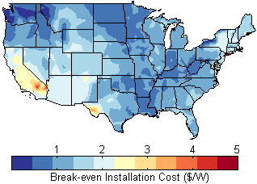 | 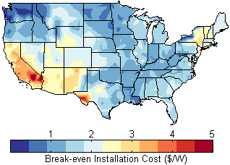 | 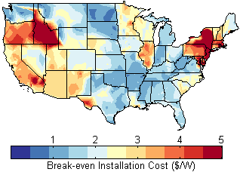
Figure 1: Break-even installation costs for residential utility customers for the best estimate without subsidies (A), with the Federal ITC (B), and with the Federal ITC and state subsidies (C).

Conclusions
Our results suggest that socket parity without subsidies has not yet become a reality in the lower 48 states. For residential solar systems to reach socket parity, a sensitivity analysis revealed that continued installation-cost reductions are critical, along with the availability of low-interest loans and the ability to reduce or eliminate annual maintenance costs. Further, socket parity is highly dependent on how much and at what rate excess electricity is sold back to the grid. Net metering programs do improve the economics of residential solar systems, but they are a form of subsidy that would provide free access to the grid to this distributed generation resource.
The economics of solar PV for commercial industrial customers in a given location are dependent on the individual load profile and applicable utility rate tariff. Since demand charges are typically computed at a subhourly resolution, the use of hourly data may inadequately estimate the economics of installing solar PV. For future work, we will examine how the use of measured load and solar output data with greater time resolution compares the results achieved when using simulated load and solar output data.

References
[1] Naïm Darghouth, G. B. R. W. The Impact of Rate Design and Net Metering on the Bill Savings from Distributed PV for Residential Customers in California. Lawrence Berkeley National Laboratory 2010, 1–62.
[2] U.S. Energy Information Administration. “Wholesale Electricity Prices Rose Across the United States.” (2013): 1–2. Web.
[3] OCC. “Public Welfare Investments in Solar Energy Facilities Using Renewable Energy Investment Tax Credit.” (2014): 1–9. Print.
[4] Honeyman, Cory et al. “U.S. Solar Market Insight.” (2015): 1–74. Print.

