Overview

ENVIRONMENTAL REGULATION, SOLAR ENERGY TECHNOLOGY COMPONENTS AND INTERNATIONAL TRADE: EMPIRICAL EVIDENCE ON STRUCTURE AND DRIVERS
Felix Groba, German Institute of Economic Research, DIW Berlin, +49 30 89789681, FGroba@diw.de
Renewable energy technology is decisive in the nexus of economic development while changing the global energy system towards more sustainability. In this frame international trade is important as it has been identified as a channel for technological change and diffusion [1]. Yet, tensions on the policy level around technology transfer at the UNFCCC and the WTO negotiation obstacles on environmental goods liberalisation necessitate an analysis of the international trade structure and its dynamics with respect to clean energy technologies to outline, inter alia, the impact of sustained trade barriers. However, only few studies focus on trade aspects of the clean energy technology sector. Relevant market studies describe growth dynamics only in terms of investment and added capacity [2]. Structure, development and drivers of cross border trade remain blurred. Additionally, environmental regulation is an important instrument for renewable energy promotion at the national level. Yet, empirical studies on the effect of such regulation on export dynamics remain ambiguous and rarely focus on the renewable energy sector [3].
The aim of this paper is twofold: First, analysing structure and development of international trade with a focus on solar technology components which are assumed to have the largest potential for decarbonising the economy, especially in developing countries. Second, determining drivers of cross border trade through empirical modeling in a panel context. Three hypotheses are tested. First, as components for solar energy systems are research-intensive, the innovative capacity in exporting countries has a positive effect on the export performance. Second, following the Porter hypothesis [4] countries with a strong policy framework of supporting renewable energies have gained a comparative world market advantage as such a framework is likely to support a national renewable energy industry that is a striving for export markets. Third, barriers to trade and an unreliable policy environment in receiving countries are obstacles to clean technology trade as additional costs to exporters are imposed.

Methods
The analysis uses an empirical gravitiy model to determine the drivers of trade in solar technologies. It is conducted for a panel of bilateral exports from OECD countries to 129 importing countries between 2000 and 2008. The panel reflects 80% of global solar technology trade in 2008. After renewable energy system components in international trade statistics have been identified the UNCOMTRADE data source is utilised to obtain the dependent variable. Beyond standard parameters of trade analysis such as income and distance, we introduced specific control variables to assess the role of the innovation system and the environmental regulation context in exporting countries. Furthermore, the impact of trade barriers and the policy environment in importing countries is also estimated.
Numerous policy instruments increasing the demand and supply of renewable energy technologies have been introduced [5]. As policy design is quite heterogeneous across countries a simple comparison does not facilitate an evaluation of regulatory stringency or renewable energy supportiveness in a panel context. Therefore, a different measure based on a ranking of the renewable energy share on total primary energy supply in export countries has been constructed. The role of a countries innovation system is tested using public technology-specific R&D budget data and the countries’ knowledge stock based on renewable energy patent counts extracted from the OECD Science, Technology and R&D Statistics database. While the policy context in importing countries is described by the Worldbank’s rule of law indicator, technology specific, effectively applied import tarrifs obtained from UNCTAD TRAINS are used as a proxy for trade barriers.
The methodology of applying an extended gravity model follows the literature on the international trade and environmental regulation relationship. The popularity of the gravity equation can be explained by its successful empirical performance and, to some extend, by its theoretical foundations [6]. Generalized least squares fixed effect and Tobit estimation are utilized to estimate the coefficients of the hypothesized trade variables. Additionally a two stage estimation approach is implemented to take respect of numereous zero trade flows.

Results
International trade with solar energy technology has grown significantly since 2002. The dynamics of the market are underlined by an increasing share of solar energy technology components in trade with industrial goods. The production of these clean technology goods remains skewed to the dominant market of high income OECD countries, especially Europe. Yet, OECD countries run an increasing net trade deficit hinting to the dominance of only some countries. The largest export growth is observed in developing countries, especially China and India, which mainly export to developed countries while trade between developing countries remains marginal.
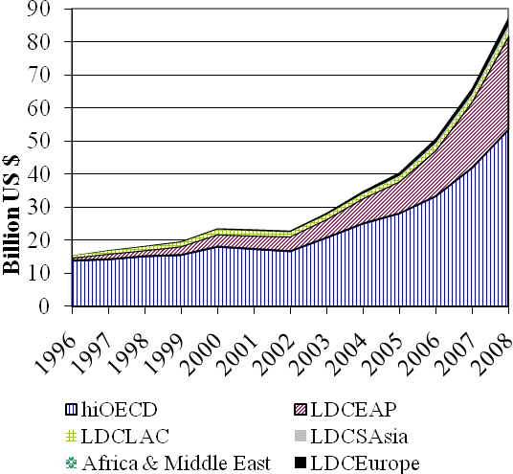
Figure 1. Development of Solar energy technology component exports by country group 1996-2008 and market structure 2008 (Source: UNCOMTRADE)
The empirical analysis strongly supports the Porter hypothesis as countries with a strong framework supporting renewable energies have gained or sustained a comparative advantage in exporting solar energy technology goods. The role of the innovation system in exporting countries remains ambiguous. On the one hand the renewable energy knowledge stock has a positive significant impact on export flows; on the other hand, public R&D spending in solar energy technology plays no significant role. Furthermore, the analysis of the importer side shows that higher tariffs significantly decrease import flows while the relationship between the institutional quality and imports is positive. Also, the impact of environmental regulation in importing countries on trade flows is weak but positive.

Conclusions
The empirical evidence shows that regulation supporting renewable energies in exporting countries has a significant positive important for the diffusion of clean energy technology via trade. Furthermore, the negative impact of trade barriers underlines the importance of liberalization efforts undertaken in the WTO framework. Promising areas for future research are the effects of increased trade with clean energy goods, such as decreasing carbon intensity, and the extent of technology transfer occurring in that framework.

References
[1] Grossman, G; Helpman E., 1991. Innovation and Growth in the Global Economy, MIT Press, Cambridge.
[2] REN 21, Renewables Global Status Report: 2009 Update, 2009, Paris.
[3] Constantini, V.; Crespi, F., 2008. Environmental regulation and the export dynamics of energy technologies, in: Ecological Economics 66(2008), pp. 447-460.
[4] Porter, M.E.; van der Linde, C., 1995. Toward a new conception of the environment competitiveness relationship. Journal of Economic Perspectives 9, 4 (1995), pp. 97–118.
[5] IEA, 2004. Renewable Energy: Market and Policy Trends in IEA Countries, Paris.
[6] Jug, J.; Mirza, D., 2005. Environmental regulations in gravity equations: evidence from Europe, World Economics 28(11), pp.1591-1615.

