ON EXERGY AND SUSTAINABLE DEVELOPMENT: SOME METHODS TO EVALUATE ENERGY AND NON-RENEWABLE RESOURCES WASTE USING SOME PLASTICS.
Carlos E. Escobar Toledo, National University of México; [(52) 5556225261]; carloset@unam.mx
Lol-chen Alegria M. National University of Mexico; [(52) 5556225261]; lolchenalegria@gmail.com
Barbara Ramirez R. National University of Mexico; [(52) 5556225261; feniciabmrr@hotmail.com

[Other Author’s Name, Affliation, Phone, email]
[Format: single space, 10 point font, Times New Roman]

Overview
This paper explores the role of energy utilization in sustainable development and the potential sources to increase energy efficiency and deals with the exergy analysis of plastic materials used for the manufacture of a lot of stuff used in our day-to-day life. This work follows the important works about the same concern by Dewulf J. (2004). Results of a lot of plastics of short life uses are presented considering the methodology proposed in this work and the utilization of Multicriteria decision making to decide among possible substitutes more exergy and energy effective as well as less non-renewable resources intensive.

Introduction
Scientific and technological development enables to provide a wide variety of goods and services, but also put at risk the quality and longer-term viability of the biosphere as a result of unwanted, ‘second order’ effects. These effects are those related to pollution, i.e. global warming, acid rain, water and soil contamination, etc.
Thus, over a period of some 15-20 years, the international community has been grappling with the task of defining the concept of ‘sustainable development’. Starting from Brundlandt report on sustainability (United Nations in 1987) that states sustainable development as: development that meets the needs of the present without compromising the ability of future generations to meet their own needs, it continues to be evident that sustainability is multidisciplinary topic including challenges for technology, based on the efficient use of energy. A lot of parameters and criteria are essential for long-term global sustainability.

This paper focuses then on two theses. The first one is that some plastic stuffs used by mankind day-to-day, are not efficient on the energy efficiency viewpoint, considering also global pollution and waste problems, within their full life cycle.
During production of those items, a waste of non renewable resources and Green House Gas (GHG) emissions are present and their lifetime use is very short, mainly at the end of their use, i.e. their final use. Then, the efficient use of energy, avoiding also energy and raw material waste are essential for long-term global sustainability.
Our second thesis concerns different materials or ways to use plastics getting longer use life cycle, saving energy and avoiding pollution; using technology-driven sustainability and economic growth, without wasting non renewable resources and energy.

General relations about energy efficiency, Exergy, and a thermodynamic parameter, such as relative irreversibility, are presented first.
Then the whole chain of production from natural gas liquids or crude oil are considered the start point of this chain until the production of plastic stuffs, are considered to perform the Exergy analysis, comparing them with other materials with a less energy and non-renewable resources consumption.
To choose which material is better and to choose the outranking substitution alternatives, Multicriteria (Vincke, Ph., 1992) (PROMETHÉE-GAIA) methods can be used, considering several criteria as: maximize Exergy efficiency, minimize non renewable resources used over their life cycle, minimize investments and operating costs both to remedy the present plastic materials and for substitution purposes, maximize a better performance in their full energy life cycle and minimize GHG emissions.

State of the Art about Exergy Analysis as a tool to measure sustainability and efficient use of energy.
In 1977, Wall outlined the basic ideas required to incorporate the concept of exergy into the accounting of natural resources. In this work the use of energy and material resources in human society were treated in terms of exergy, and exergy analysis was proposed as a method for calculating the total exergy use of a product or a service.
In 1978, Szargut suggested that ‘the index of cumulative consumption’, i.e., the loss of exergy of deposit resources, can be redefined as an index of ecological costs. Wall in 1993 proposed the use of exergy of emissions as an indicator of environmental effects and, independently of each other, Wall in 1993 and have proposed an exergy tax.
Ayres have proposed the method called Life Cycle Exergy Analysis (LCEA) that incorporates both a distinction between renewable and non-renewable resources as well as the total in and out flows of exergy during a product’s life cycle. Cornelissen has proposed a similar method called Exergetic Life Cycle Analysis (ELCA), where the exergy destruction is used as a single criterion for the depletion of natural resources.
Finnveden and Östlund [7] have successfully introduced exergies of natural resources into the methodology of environmental life cycle assessment. Jørgensen and Nielsen emphasize that exergy can be used as an ecological indicator, as it expresses energy with a built-in measure of quality.
An investigation of exergy as an ecological indicator was presented by Gong [14]. From this study, exergy will be further applied as a useful concept in the environmental field. Rosen and Dincer presented an application of exergy analysis to waste emissions. They concluded that exergy can make a substantial contribution to the evaluation of environmental problems.
As we can deduce, the concept of exergy successfully links the fields of energy, environment, and sustainable development. From these works it is obvious that exergy is gradually being adopted as a useful tool in the development and design of a sustainable society.
Therefore, sustainability is associated with ecology and energy; however, it has major implications, since it is a general concept that covers from observation of any system until implementation of tasks for the improvement in the quality of human life and the environment. The quantification of sustainability is important but also difficult because of the relations between energy, economic, ecological and social factors.

Methods
Dincer reported the linkages between energy and exergy, exergy and the environment, energy and sustainable development, and energy policy making and exergy in detail. The importance of the exergy and its essential utilization can be seen in numerous ways: (a) it is a primary tool in best addressing the impact of energy resource utilization on the environment. (b) It is an effective method using the conservation of mass and conservation of energy principles together with the second law of thermodynamics for the design and analysis of energy systems. (c) It is a suitable technique for furthering the goal of more efficient energy–resource use, for it enables the locations, types, and true magnitudes of wastes and losses to be determined. (d) It is an efficient technique revealing whether or not and by how much it is possible to design more efficient energy systems by reducing the inefficiencies in existing systems. (e) It is a key component in obtaining a sustainable development.
Sustainable development does not make the world ‘ready’ for the future generations, but
it establishes a basis on which the future world can be built. A sustainable energy system may be regarded as a cost-efficient, reliable, and environmentally friendly energy system that effectively utilizes local resources and networks. It is not ‘slow and inert’ like a conventional energy system, but it is flexible in terms of new techno-economic and political solutions. The introduction of new solutions is also actively promoted.

An exergy analysis has been widely used in the design, simulation and performance evaluation of energy systems. Exergy analysis method is employed to detect and to evaluate quantitatively the causes of the thermodynamic imperfection of the process under consideration. It can, therefore, indicate the possibilities of thermodynamic improvement of the process under consideration, but only an economic analysis can decide the expediency of a possible improvement.

Energy and Exergy modeling
To provide an efficient and effective use of fuels, it is essential to consider the quality and quantity of the energy used to achieve a given objective. In this regard, the first law of thermodynamics deals with the quantity of energy and asserts that energy cannot be created or destroyed, whereas the second law of thermodynamics deals with the quality of energy, i.e., it is concerned with the quality of energy to cause change, degradation of energy during a process, entropy generation and the lost opportunities to do work. By quality, it means the ability or work potential of a certain energy source having certain amount of energy to cause change, i.e., the amount of energy which can be extracted as useful work which is termed as exergy. First and second law efficiencies are often called energy and exergy efficiencies, respectively. It is expected that exergy efficiencies are usually lower than the energy efficiencies, because the irreversibilities of the process destroy some of the input exergy.
It should be noticed that exergy is always evaluated with respect to a reference environment. When a system is in equilibrium with the environment, the state of the system is called the dead state due to the fact that the exergy is zero. At the dead state, the conditions of mechanical, thermal, and chemical equilibrium between the system and the environment are satisfied: the pressure, temperature, and chemical potentials of the system equal those of the environment, respectively. In addition, the system has no motion or elevation relative to coordinates in the environment
At the restricted dead state, the fixed quantity of matter under consideration is imagined to be sealed in an envelope impervious to mass flow, at zero velocity and elevation relative to coordinates in the environment, and at the temperature T₀ and pressure P₀ taken often as 25 C and 1 atm.
On the other hand, Life Cycle Analysis (LCA) is a useful tool to assess the environmental impacts that produce the processes.
Using the above concepts and methods to apply to plastic materials, we present Figure 1 where can be viewed integrally. As it has been said we follows much of the work about plastics uses and exergy analysis made in the works of Dewulf et al. The differences between this works and ours are presented in Figure 2.

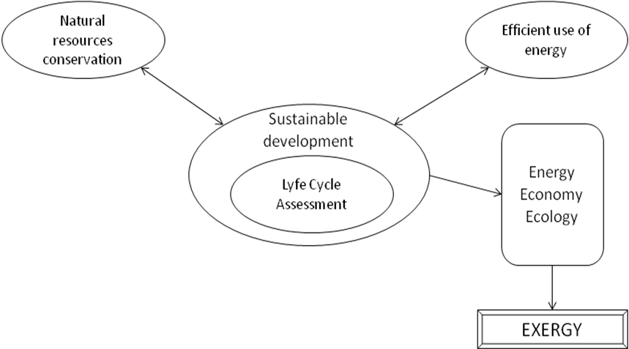

Figure 1. Methodology proposed.

A methodology has been designed in order to perform the analysis considering the different stages as it follows in Figure 2.

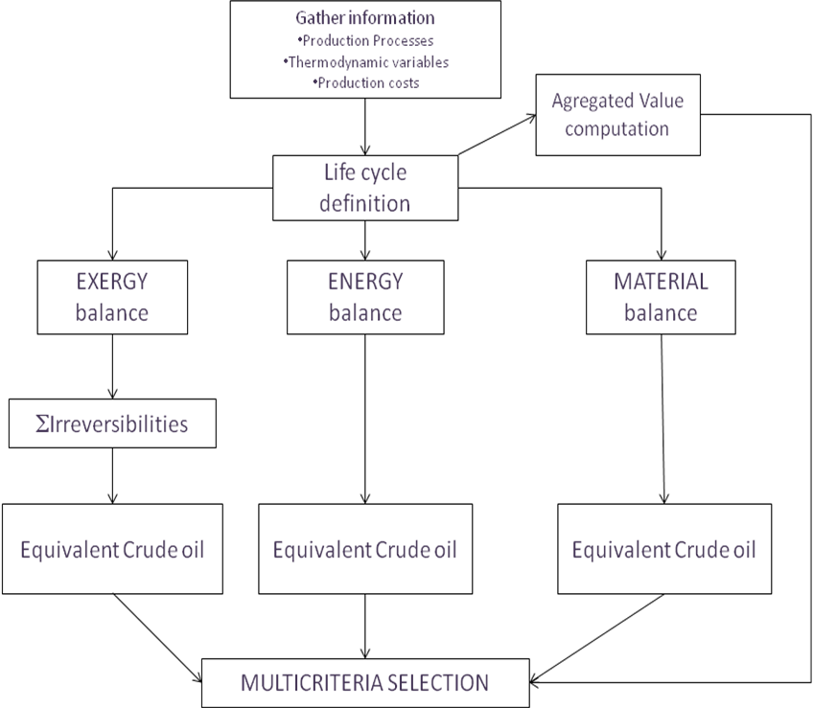

Figure 2. Methodology used in this paper.

Results
Our results for different plastics used as bags, bottles, disposable cups and other plastics will be presented in proceedings papers.

Conclusions
Exergy aspects of the substitution problem between a lot of objects used day-to-day made with plastic for other materials more exergy and energy adequate are presented in this study.
Some concluding remarks which can be extracted from this study are as follows:
(a) Exergy is a way to a sustainable development. In this regard, exergy analysis is a very useful tool, which can be successfully used in the performance evaluation of waste materials with a very short life cycle. As another conclusion, we expect that the analyses reported here will provide other researcher people with knowledge about how effective and efficient is to use its renewable resources. This very useful knowledge is also needed for identifying energy efficiency and/or energy conservation opportunities, as well as for dictating the right energy and exergy management strategies of those items to be driven results for other types of materials or services.
(b) On the other hand the use of MCDA will be of a long interest for better decision making.
(c) The MCDA will give a measure of the production and delivery of useful work to consumers. This conversion efficiency tends to increase over time, when it is also a measure of technology and important economic factors.
Calculation of the overall destroyed Exergy to obtain the selected exergy losses provides not only a measure of the energy availability or of the resource depletion but also the most suitable criterion to reduce the exergy losses and to improve the technological efficiency of the industrial production system. In this way, the exergy analysis, associated with the energy and mass balances in an industrial process, represents an important advancement in the Multicriteria analysis of products.
The analysis of different alternative material for the manufacturing of retail shopping bags for example, showed how the selected production processes accounted for exergy destruction and therefore resource depletion, and then a comparison can be made among the different alternatives within the same energy unit.
The total air emissions are considerable and they are presented in the results chapter.

References
- Ayres Robert, Turton, Castenc, Energy efficiency, sustainability and economic growth Energy 32 (2007) 634–648.
- Brans, J.P. and Mareschal, B. 1992. 'Promethee V: MCDM problems with additional segmentation constraints", INFOR, 30, n°2, pp.85-96.
- Brans, J.P. and Mareschal, B. 1994. 'Promcalc & Gaia: A new decision support system for multicriteria decision aid. Decision Support Systems, 12, pp.297-310.
- Brans, J.P., and Vincke, P. 1985. 'A preference ranking organization method: The Promethee method for MCDM', Management Science, 31, 6, pp.647-656.
- Brundtland, G.H. et al., 1987, Our common future, World Commission on Environment and Development (WCED) Cambridge Energy Research Associates. September 2001.
- Chaffee, C and Bernard R. Yaros. (Boustead Consulting & Associates Ltd) 2007. “Life Cycle Assessment for Three Types of Grocery Bags - Recyclable Plastic; Compostable, Biodegradable Plastic; and Recycled, Recyclable”. Progressive Bag Alliance Report.
- Cornelissen R. L. 1997. Thermodynamics and Sustainable Development. Ph. D. dissertation. University of Twente, Netherlands.
- Cornelissen, R.L. and G.G. Hirs. 1999. “Exergy analysis in the process Industry” in A. Bejan and E. Mamut (eds), “Thermodynamic Optimization of complex systems”; Kluwer Academic Publishers. Netherlands.195-208.
- Dewulf J, Van Langenhove H, Dirckx J. 2001. Exergy analysis in the assessment of the sustainability of waste gas treatment systems. Science of the Total Env. 273:41–52.
- Dewulf J, Van Langenhove H. 2002b. Quantitative assessment of solid waste treatment systems in the industrial Ecology Perspective by Exergy Analysis. Environmental Science and Technology 36:1130–1135.
- Dewulf J. and H. Van Langenhove. 2004. “Thermodynamic optimization of life cycle of plastics by Exergy analysis”. International Journal of Energy Research 28: 969-976.
- Dincer I. The role of exergy in energy policy making. Energy Policy 2002; 30:137–49.
- Dincer, I. and M.A.Rosen “The intimate connection between Exergy and the environment” in A. Bejan and E. Mamut (Eds), “Thermodynamic Optimization of complex systems”; Kluwer Academic Publishers. Netherlands; pages 221-230.

- Escobar Toledo, C., Garcia Aranda, C. 2002, 12th MiniEURO DSS Conference. “Integral Exergy Analysis in an Ammonia Plant Using Multiobjective Programming”. Brussels, Belgium.
- Finnveden G, Östlund P. 1997. Exergies of natural resources in life-cycle assessment and other applications. Energy 22:923-931.
- Gong M, Wall G. 2001. On Exergy and sustainable development, part 2: methods, applications and suggestions. Exergy Int Journal 1:217–233.
- Hepbasli, A. A key review on exergetic analysis and assessment of renewable energy resources for a sustainable future. Renewable and Sustainable Energy Reviews 12 (2008) 593–661.
- Kotas, T.J., 1995. The Exergy Method of Thermal Plant Analysis. Butterwood. London, 296.
- Lefebvre, L, Mason, R, Khalil, T,1998. “Management of Technology, Sustainable Development and Eco-Efficiency”, Elsevier, Netherlands. pp. 249-268.
- OLADE / CEPAL / y la Agencia de Cooperación Técnica de la República Federal de Alemania (GTZ), 2000, “Energía y Desarrollo sustentable en América Latina y el Caribe: Guía para la formulación de Políticas Energéticas”, Quito, Ecuador.
- Rosen MA, Dincer I. Exergy-cost-energy-mass analysis of thermal systems and processes. Energy Conversion Manage 2003;4(10):1633–51.
- Szargut, J, D.R. Morris and F.R. Steward. 1988. Exergy Analysis of thermal, chemical and metallurgical process. Hemisphere Pub. Corp.
- Vincke, Philippe. 1992. Multicriteria Decision-aid. John Wiley & Sons. Chichester.
- Wall G. 2009. Exergetics. Exergy, Ecology, Democracy. Bucaramanga.

