Driving factors underlying events of GDP-CO2 Emissions Decoupling in Brazil for the period 2000-2009.
Luciano Charlita de Freitas, Hiroshima University, +81-090-2867-8995, lucianofreitas@live.com
Shinji Kaneko, Hiroshima University, +81-082-424-6904, kshinji@hiroshima-u.ac.jp

Overview
Brazil experienced in the period 2000-2009 several episodes of decoupling between CO2 emissions and economic activity (Freitas and Kaneko, 2010). Events of such nature reflect improvement in emission mitigation efforts and reinforces the commitment of the country towards lower carbon economy. Following Figure 1 summarizes the trends in GDP growth and CO₂ emissions from energy consumption in Brazil over the period 2000-2009.
Figure1: CO₂ emissions from energy consumption and GDP growth in Brazil (2000–2009)
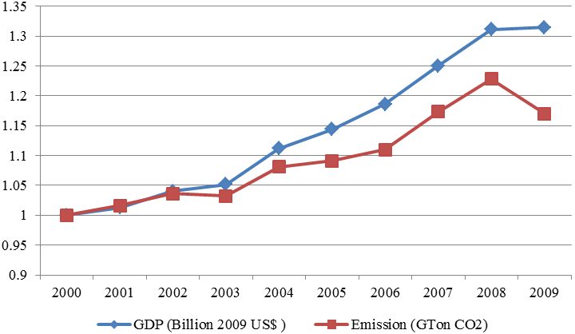
This study attempts to evaluate the determinants behind the events of decoupling in Brazil for the period 2000- 2009. Results are compared with other cases from developing and developed countries.

Methods
To identify the determinants of emissions change it was developed a decomposition model based on log-mean Divisia index (LMDI) framework. The LMDI is a preferable index decomposition method between researchers from social sciences and policy makers attempting to understand emissions change. The LMDI is proposed over robust theoretical foundations being fully documented with applications in several countries and contexts what allows comparative ground for international experiences (Ang, 2004; Ang and Liu, 2007).

To this study CO₂ emissions changes is decomposed into economy activity, structure of the economy, energy intensity, fuel mix, carbon intensity and population growth. This set of factors embodies the main factors driving emission change.

Results
Results evidence that improvements in carbon intensity and diversification of energy matrix towards lower carbon energy sources are the driving determinants of emissions mitigations in Brazil in the period 2000-2009. Energy mix diversification is the main instrument of emissions mitigation adopted in Brazil and results of this study confirms the effectivity of this strategy. Contribution of carbon intensity naturally reflects improvements in the quality of the fuels (lower carbon content) consumed in in the country evidencing that the energy mix diversification is associated to increments in the share of low carbon content sources.

Another inductor of emission reduction experienced in the period was the change in the structure of the economy. Reduction of the industry weight in the national economy, especially as consequence of world economic crises in 2008, contributed to reduce emissions from energy consumption in the country.

However, contrasting with achievemnts carried out by other countries, Brazil failed in obtaining impromvements in energy intensity factors. Energy intensity was the main driver for emission mitigation in the world (Kojima and Bacon, 2009). For example, epidodes of decoupling in China, starting in the 1990s are largely attributed to improvement in energy intensity (Wu et al., 2005; Fan et al., 2007; Zhang et al., 2009).

Rather, energy intensity figures as a primary determinant of emission increase in Brazil together with economic activity factor. Demographic pressure also played an important role in emissions change in the period 2000-2009.

Conclusions

This study complements and updates previous research activities by De Freitas and Kaneko (2011a; 2011b). In this article it is studied the changes in CO₂ emissions from energy consumption in Brazil along the period 2000-2009. The results indicate that the decoupling events in Brazil are associated to progresses in energy matrix diversification and carbon intensity improvement followed by reshaping of the economy structure.

Compared to references from the literature, it is observed that Brazil strategy to emission mitigation from energy consumption is associated to fuel diversification (rational usage of natural resources) rather than improvement in energy intensity (technological route).

References
Ang, B.W., 2004. Decomposition analysis for policymaking in energy: which is the preferred method? Energy Policy 32, 1131–1139.
Ang, B.W., Liu, N., 2007. Energy decomposition analysis: IEA model versus other methods. Viewpoint, Energy Policy 35, 1426–1432.
De Freitas, L.C., Kaneko, S., 2011a. Decomposition of CO2 emissions change from energy consumption in Brazil: challenges and policy implications. Energy Policy, doi:10.1016/j.enpol.2010.12.023.
De Freitas, L.C., Kaneko, S., 2011b. Decomposition of CO2 emissions change from energy consumption in Brazil: Challenges and policy implications. Energy Policy 39 (3), 1495-1504.
Fan, Y., Liu, L., Wu, G., Tsai, H., Wei, Y., 2007. Changes in carbon intensity in China: empirical findings from 1980–2003. Ecological Economics 62, 683–691.
Kojima, M., Bacon, R., 2009. Changes in CO2 Emissions from Energy Use: A Multi-country Decomposition Analysis. World Bank, Extractive Industries for Development Series 11. World Bank, Washington.
Wu, L., Kaneko, S., Matsuoka, S., 2005. Driving forces behind the stagnancy of China’s energy-related CO2 emissions from 1996 to 1999: the relative importance of structural change, intensity change and scale change. Energy Policy 33(3), 319–335.
Zhang, M., Mu, H., Ning, Y., Song, Y., 2009b. Decomposition of energy-related CO2 emission over 1991–2006 in China. Ecological Economics 68, 2122–2128.

