Optimal Hydrogen Supply Chains: Co-Benefits for Integrating Renewable Energy Sources
Fabian Stöckl, DIW Berlin, +49 30 89789-378, fstoeckl@diw.de
Wolf-Peter Schill, DIW Berlin, +49 30 89789-675, wschill@diw.de
Alexander Zerrahn, DIW Berlin, +49 30 89789-453, azerrahn@diw.de

Overview
The use of renewable energy sources in all end-use sectors is a main strategy to reduce greenhouse gas emissions. Beyond current electricity demand, energy demand from other sectors such as transportation may be either satisfied directly by renewable electricity, or indirectly through hydrogen or synthetic fuels. Such new demand for renewable electricity has repercussions for the power sector. Depending on its extent and temporal flexibility, it entails a different optimal portfolio of generation assets and flexibility options.
In this paper, we analyze the supply of hydrogen (H₂) for mobility. Specifically, we examine which H₂ production and distribution chains are optimal in a mid-term future German power system with increased shares of variable renewable electricity, and why. We explicitly include an electricity system perspective by co-optimizing the hydrogen supply chains with the power system. Thus, we address the trade-off between more temporally flexible and more energy efficient hydrogen options and investigate co-benefits for integrating renewable electricity, that is, making use of potential generation surpluses.

Methods
We extend the open-source power system model DIETER (Zerrahn and Schill 2017) by a detailed well-to-tank representation of the hydrogen sector. Hydrogen for mobility may be produced either with small-scale electrolyzers at filling stations or with large-scale centralized electrolyzers, using three different distributions paths and long-term storage options: via liquid (LH₂) or compressed gaseous (GH₂) hydrogen or through a liquid organic hydrogen carrier (LOHC), as shown in Figure 1. We apply the model to German 2030 scenarios and systematically vary the share of renewables in electricity generation and the demand for hydrogen at filling stations. We analyze scenarios with renewable shares of 65, 70, 75 and 80 %, as well as hydrogen demands corresponding to 5, 10, and 25 % of (passenger vehicle) road traffic.
Our modeling approach fully co-optimizes electricity generation and hydrogen provision. The objective function comprises annualized costs for investments into electricity generation and storage technologies, investments into hydrogen infrastructure, as well as their hourly use. The integrated model takes feedbacks between the power and hydrogen sectors endogenously into account, specifically at two instances: first, investment costs along the hydrogen supply chain; and second, electricity demand along the hydrogen supply chain, that is, from hydrogen production, processing, and hydrogen distribution facilities. This endogenously trades off the use of electricity for different purposes in each hour.
Figure 1: Centralized and decentralized supply chains
For transparency and reproducibility, model code and data are openly available under a permissive license.

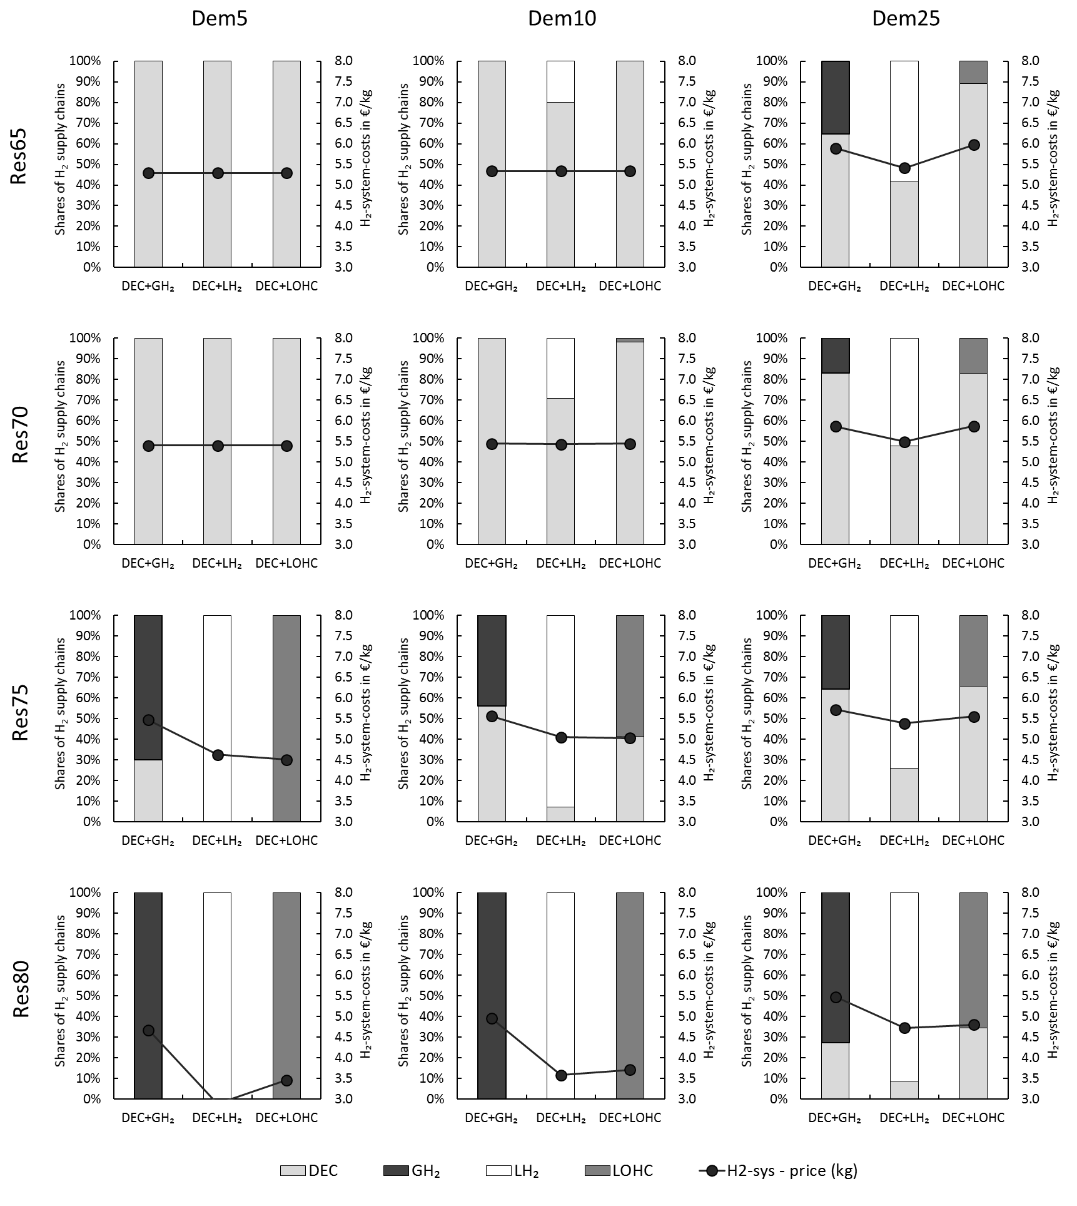
Results
Figure 2 shows cost-minimal combinations of decentralized and centralized H₂ supply chains for the different scenarios, as well as the system costs of providing hydrogen. Decentral electrolysis at the fuel station is only optimal for low shares of renewables and low H₂ demand: here, energy efficiency matters most, and temporal flexibility is of least importance. For other cases, we find that liquid hydrogen is often the cheapest option, and GH₂ is almost always the most expensive one. We accordingly find that the energy efficiency advantage of GH₂ is outweighed by a higher temporal flexibility of the LH₂ chain. In general, centralized supply chains better allow to disentangle the timing of hydrogen production from hydrogen demand. That is, on average, production is lower than demand in hours when electricity is scarce and thus expensive. Vice versa, H₂ production is above demand if electricity is abundant and therefore cheap. By contrast, the decentralized supply chain lacks a cheap storage option and, thus, needs to produce almost on demand. Accordingly, the decentralized supply plays a minor role in cases with high shares of variable renewables. We further find that the benefits of centralized supply chains depend very much on the amount of temporary renewable surplus generation. The larger the renewable surpluses, the more beneficial the flexibility offered by centralized H₂ supply chains, and the less important their energy efficiency drawbacks compared to the decentralized supply chain.
Figure 2: Optimal shares of centralized and decentralized supply chains for different scenarios
The LOHC path turns out to be optimal in only one case, but hydrogen system costs are often close to those of LH₂. In contrast to LH₂, LOHC does not incur storage losses over time. Accordingly, LOHC exhibits the strongest seasonal storage pattern and the highest storage capacity of all options considered here. Yet its high energy demand for dehydrogenation, combined with respective infrastructure costs, is a drawback.
We also carry out a range of sensitivities to explore the effects of various parameter assumptions. Amongst others, we find that GH₂ becomes the cost-minimal solution in case cheap hydrogen caverns can be developed. Another sensitivity run shows that LH₂ would be used with a much more seasonal pattern in case boil-off could be prevented. And LOHC becomes a dominant option under the assumption that existing transportation and storage infrastructure could be used, i.e., if these facilities would not incur any investment costs.

Conclusions
While the relevance of hydrogen-based electrification for decarbonisation is often highlighted in the literature, its role in the power system is generally under-researched. Our analysis contributes to filling this gap. We identify and quantify trade-offs between energy efficiency and temporal flexibility of different hydrogen supply chains. For higher renewable shares, we find that LH₂ is a least-cost option for supplying hydrogen at German fuel stations under the basic parameterization used here; yet the costs of other supply chains are very similar in many cases. Accordingly, other aspects such as operation safety, space requirements, or public acceptance may also be considered when making real-world infrastructure decisions. Based on our results, we further draw the more general conclusion that power sector interactions of hydrogen should be considered in more detail in modelling analyses which aim at identifying optimal future H₂ pathways. The same may also hold for other sector coupling strategies, including direct electrification of heating and transportation sectors. Respective analyses are a promising field for future research.

References
Zerrahn, A. and W.-P. Schill (2017): Long-run power storage requirements for high shares of renewables: review and a new model. Renewable and Sustainable Energy Reviews 79, 1518-1534. https://doi.org/10.1016/j.rser.2016.11.098

