Carbon leakages: towards tailored policies to reduce emissions embodied in the EU petrochemical sector
Michel Zimmermann, École Polytechnique Fédérale Lausanne, +41 21 69 39399, michel.zimmermann@epfl.ch
Vincent Moreau, École Polytechnique Fédérale Lausanne, +41 21 69 39398, vincent.moreau@epfl.ch

Overview
To curb carbon emissions and energy use, the European Union (EU) has introduced an average of two energy efficiency policies per year since 2000¹. These policies have been successful as evidenced by the fact that the EU exhibited relative decoupling of GDP and emissions over the last two decades. However, this conventionallyaccounts for territorial emissions only, i.e. emissions that were produced by domestic activities. Neglecting emissions that were caused by goods produced abroad. Therefore it falls short of painting an accurate picture of the impact of energy and climate policies. Consequently, there has been much research advocating for measuring consumption-based emissions, i.e. what is consumed domestically, including imports ². Unfortunately, this has not received much traction in regards to policy-making, as policies tend to have a national focus and seek to reduce territorial-based emissions only, which in turn is likely to increase domestic production costs and to induce the relocation of carbon-intensive production processes. These embodied emissions in trade (i.e. emissions from outsourced production) can be substantial in the economies of the EU and it is therefore the objective of this work to identify and quantify already outsourced emissions. Focusing on the EU petrochemical industry, we aim to support targeted policies in order to better account for emissions along the entire supply chain and the corresponding carbon responsibilities among trading Member States.

The petrochemical industry is an important sector for the EU economy and its Member States, which significantly contributes to economic growth and is responsible for a large share of EU emissions and industrial energy use. Moreover, the petrochemical industry is characterised by a very interconnected supply chain, as they both procure and sell intermediate and final goods from a wide range of industries globally. In order to assess how much embodied carbon is imported by the petrochemical industries in different EU countries, we undertake an analysis of the embodied emissions that are calculated with multi-regional environmentally-extended input-output database Eora ³ and illustrate these flows by means of a simplified network analysis. This allows us to investigate how different industries in EU Member States contribute to the petrochemical industry and its emissions in other countries and whether the measured decoupling of emissions and GDP has actually been achieved. These insights will therefore shed light on how to devise policies that account for consumption-based emissions and support the reduction of carbon leakage.

Methods

Several methods exist to estimate embodied emissions in trade, from bottom up product life cycle assessment to top down input output (IO) analysis. Multi-regional input-output databases expand the imports and exports of supply and use tables into IO tables themselves and considerably increase the level of detail on the origin and destination of embodied carbon across borders. The level of aggregation in Eora is high with 26 activities, one of which includes petrochemicals and non metallic minerals. The latest emission data is available for the year 2014 and a long time series since 1990 can make this approach dynamic. We compute the emissions embodied in trade within the EU28 Member States (+Norway and Switzerland) for all activities and aggregate trade with the rest of the world. The embodied emissions, in Gt of CO2-equivalent, are summed by activities across Member States to test the centrality of the petrochemical industry in intra EU trade. We also aggregate across activities to show which EU economies contribute to the activities of petrochemical industries in other Member States. Network analysis then points to where virtual carbon is traded the most and policies would make the greatest impact.

Results
The results show that in terms of embodied carbon in trade, within and outside of the EU, the petrochemical industry is very central along with agriculture and forestry. As shown in Figure 1, the center of the graph hosts a small set of countries and domestic petrochemical activities that rely on the largest imports of virtual carbon. In other words, these activities are more likely to outsource carbon intensive processes to European or rest of the world countries.

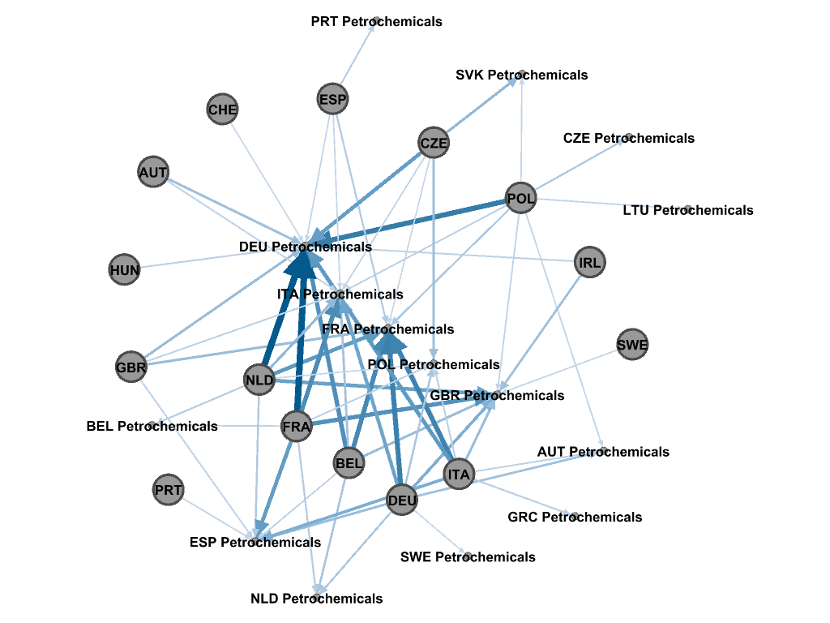
Figure 1: Virtual carbon flows (imports only) in 2014 between petrochemical sectors among EU member states (Gt of CO₂-equiv). Volume is given by the width of the network edges.

As shown above, there are substantial cross-border carbon flow dynamics in the EU petrochemical sectors with multiple carbon hotspots, such as Poland which provide carbon-intensive intermediate goods to German petrochemical production. Moreover, the German, Italian and French petrochemical industries further substantially outsource their emissions to the Netherlands, Belgium and France and by the same token have reduced their territorial emissions. The next step concerns the estimation of the actual impact that energy and climate policies over the last decades have had. By reassigning the outsourced emissions to the countries where the final goods were consumed, this will answer the question whether the relative decoupling actually occurred.

Conclusions
By illustrating the effects of cross-border embodied emissions in the EU petrochemical industry, how EU Member States contribute to this and what the actual consumption-based emissions caused by the petrochemical industry are, we highlight the priorities for policies to reduce current and future carbon leakage along supply chains. Therefore, policies, such as border carbon adjustments (i.e. carbon tarrifs), more stringency in existing emission trading systems and consumption-based taxes⁴ could be implemented beyond the national context and tailored to multiple sectors. Our findings provide important insights on cross-border carbon flows and policies that could potentially stifle increased outsourcing of production and carbon leakage in the petrochemical industry for the first time.

References
1. Moreau, V., Neves, C. A. D. O. & Vuille, F. Is decoupling a red herring? The role of structural effects and energy policies in Europe. Energy Policy 128, 243–252 (2019).
2. Davis, S. J. & Caldeira, K. Consumption-based accounting of CO2 emissions. Proc. Natl. Acad. Sci. 107, 5687–5692 (2010).
3. Lenzen, M., Moran, D., Kanemoto, K. & Geschke, A. Building Eora: A Global Multi-Region Input–Output Database at High Country and Sector Resolution. Econ. Syst. Res. 25, 20–49 (2013).
4. Böhringer, C., Rosendahl, K. & Storrøsten, H.B. Robust policies to mitigate carbon leakage Journal of Public Economics 149 35-46 (2017)

