Strategic reserve for Switzerland: Is it needed and (how) would it work?

Jonas Savelsberg, University of Basel/ University of California, Berkeley, jonas.savelsberg@unibas.ch
Moritz Schillinger, University of Basel, +41612072872, moritz.schillinger@unibas.ch
Ingmar Schlecht, University of Basel, +41612073345, ingmar.schlecht@unibas.ch
Hannes Weigt, University of Basel, +41612073259, hannes.weigt@unibas.ch

Overview

Many European countries are currently debating or starting to implement capacity mechanisms to enhance their system security in times of increasing intermittent generation. Switzerland does not have a capacity problem (22 GW supply vs. 10 GW peak demand) and therefore does not consider the introduction of conventional capacity mechanisms. However, policy makers are worried about whether the capacity is available at the time when needed. A large part of the capacity (about 10 GW) is based on storage or pumped-storage hydropower – which is only able to produce if reservoirs are filled. The Swiss Federal Office of Energy (SFOE, 2018) has proposed a storage reserve that would essentially pay hydro generators to leave a part of their stored energy unused throughout the winter, unless specifically called up in a defined contingency situation.
In this paper, we take up this approach and aim to identify for which cases a storage reserve would actually be needed and quantify the potential cost and market impact of different reserve designs. We investigate market power problems in procuring the reserve and identify whether the procured energy and capacity is actually sufficient in case of an unforeseen emergency.

Methods

The assessment is based on the Swiss electricity market model Swissmod developed at the University Basel (Schlecht & Weigt 2014). Swissmod is a DC load-flow nodal pricing electricity market model of Switzerland and its neighboring countries. The model framework has been tailored to allow for an in-depth analysis of possible future market designs in Switzerland. As a first step, a yearly nodal pricing model of the Swiss electricity market has been set up (see e.g., Leuthold et al. 2012 or Schlecht & Weigt 2014). Swissmod uses a DC load flow approach linking a detailed representation of the Swiss power system with a focus on hydropower elements on the one hand and a representation of balancing markets on the other with aggregated representations of surrounding regions. As a defining feature of Swissmod, hydropower stations are represented with a high degree of detail; hydrologic interrelations within hydropower cascades are modelled such that the outflow of an upstream power plant ends up as inflow to a downstream power plant. The model captures more than 400 hydro stations in detail, representing around 96% of Swiss hydro production.
The storage reserve is taken into account in a two stage approach. In the first stage, hydropower plants which are participating in the storage reserve have to reserve water and capacity for unforeseen emergencies. In the second stage, the system experiences an unforeseen emergency (shock) while the storage reserve is used to try to resolve the emergency. Different reserve designs and unforeseen emergencies are analyzed in this paper. At the current stage, we have a look at an unforeseen autarky situation, e.g. resulting because of political or technical reasons, the Swiss electricity system has to handle.

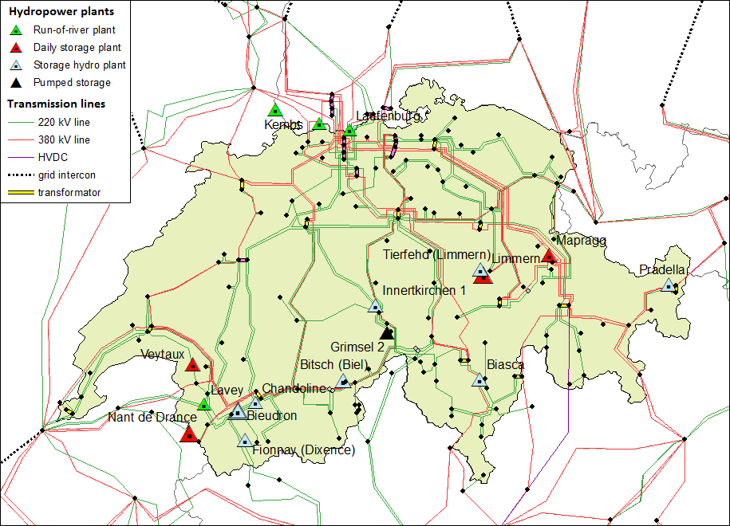
Figure 1: High voltage transmission lines and hydropower stations in the Swissmod model

Results
A critical time for an emergency in the Swiss electricity system is between March and April since the reservoir levels are low during that time. The preliminary results focus on an autarky situation during that time of the year. Our preliminary results show that for an autarky situation which lasts for less than 700 hours, no storage reserve is required to ensure that Swiss demand is satisfied by national supply. However, in an autarky situation which lasts for more than 700 hours lost load occurs. Introducing a storage reserve could help to resolve the lost load events. Therefore, at least 1000 GWh would need to be reserved in the storage reservoirs while the cost of reserving 1000 GWh are approximately 20 Mio. EUR. Table 1 summarizes the preliminary results.

Table 1. Results Summary
Storage reserve (GWh) | Autarky |  | Lost Load (GWh) | Reserve price (EUR/GWh)
Storage reserve (GWh) | from hour | to hour | Lost Load (GWh) | Reserve price (EUR/GWh)
0 | 2000 | 2700 | 319 | 0
100 | 2000 | 2700 | 316 | 3425
1000 | 2000 | 2700 | 0 | 19394

Conclusions
In our paper, we study the need and design of a storage reserve for Switzerland. While a storage reserve would not be required from a Swiss system adequacy perspective, it is claimed from several political actors in order to ensure that the hydropower capacity is available if needed for an unforeseen emergency. Our results show the potential costs of a storage reserve and the critical aspects in the reserve design. Our results contribute to the ongoing discussion on system security in Switzerland and provide policy recommendations on the need and optimal design of a storage reserve.

References
Leuthold, F. U., Weigt, H., & Von Hirschhausen, C. (2012). A large-scale spatial optimization model of the european electricity market. Networks and spatial economics, 12(1), 75-107. https://doi.org/10.1007/s11067-010-9148-1
Schlecht, I., & Weigt, H. (2014). Linking Europe-The Role of the Swiss Electricity Transmission Grid until 2050. https://doi.org/10.1007/BF03399415
SFOE Swiss Federal Office of Energy (2018), Ausgestaltung einer Speicherreserve. Version 2.0 vom 17. Oktober 2018. https://www.bfe.admin.ch/bfe/de/home/versorgung/stromversorgung/stromversorgungsgesetz-stromvg/revision-stromvg/_jcr_content/par/tabs/items/tab/tabpar/externalcontent.external.exturl.pdf/aHR0cHM6Ly9wdWJkYi5iZmUuYWRtaW4uY2gvZGUvcHVibGljYX/Rpb24vZG93bmxvYWQvOTQxNi5wZGY=.pdf

