POTENTIAL OF OFFSHORE POWER-TO-GAS TO COMPETE WITH ONSHORE BLUE HYDROGEN
Machiel Mulder, University of Groningen, +31631035729, machiel.mulder@rug.nl
Peter Perey, University of Groningen, p.l.perey@rug.nl

Overview
Hydrogen is increasingly seen as a potential energy carrier to provide high-temperature process heat, to heat buildings and produce electricity while it is also expected that it can become a major fuel in transport. In addition, hydrogen may play a role to help the electricity sector to deal with the increasing shares of renewable power by offering flexibility regarding the timing and location of production.
Hydrogen does not exist in pure form in nature and has, therefore, to be produced. Currently, the most common method to produce hydrogen is the so-called Steam Methane Reforming (SMR), a process by which hydrogen is produced from natural gas (CH₄). If the carbon emitted in the SMR process is not captured and stored, the hydrogen is called ‘grey’. Grey hydrogen has been produced for many years and is currently the only type of hydrogen being produced in large quantities. If the carbon is removed and stored, the hydrogen is called ‘blue’. This technique is increasingly considered as an option to produce hydrogen without carbon emissions.
Hydrogen can also be produced through electrolysis of water (H₂O), that’s why this is called power-to-gas. When the electricity is generated through renewable sources, like wind turbines or solar panels, the hydrogen is made in a pure renewable way and it is therefore called ‘green’. Because often users cannot distinguish electricity generated by a renewable source from electricity generated by other (non-renewable) sources as all sources are generally connected to the same grid, a system of guarantees-of-origin (or certificates) has been implemented in Europe as a tracking-and-tracing system. Users of electricity (including electrolysis plants) generally need these certificates in order to be able to prove that electricity from renewable sources is used.
A specific design of a power-to-gas facility is that the electrolysis plants operate in close connection to wind turbines. A benefit of such a design is that the electricity generated by these wind turbines need not to be transported through an electricity grid; instead, the hydrogen itself has to be transported. If the infrastructure for transporting hydrogen is already present, such as in the form of an existing natural-gas network, then there might be significant savings on network costs. A plan with these features has recently been presented by the TSOs of the Dutch high-voltage network and the Dutch high-pressure gas network. In this paper, we briefly evaluate the business case of this plan in comparison to the costs of producing blue hydrogen.

Methods
In order to assess the economic outlook for the various ways of producing hydrogen, we calculate the minimum price of hydrogen necessary for the various technologies to be profitable. This required price is the financial compensation needed to cover both fixed and variable costs over the lifetime of the hydrogen plants. The fixed costs can be related to the required hydrogen price by making assumptions on the investment costs per unit of capacity, the number of hydrogen units produced with one unit of capacity and the lifespan of a plant.
The costs of connecting offshore wind parks to the electricity grid have been estimated by several studies. Based on these studies, we assume that the network costs of connecting offshore wind parks are 20 euro/MWh. Producing hydrogen offshore spare these costs. We assume that there neither adapting the natural-gas network to the requirements of hydrogen transport nor building the offshore hydrolysis plants involves additional costs, which is of course too optimistic and results in an underestimation of the costs of this project.
Another benefit of producing the hydrogen offshore in direct connection to the electricity production by wind turbines is that there is no need to buy green certificates, as there is already full transparency on the (green) origin of the electricity.
The close connection between an electrolysis plant and a wind park also implies that the cost of using electricity is not related to the market price, but to the electricity price the investors in the wind turbines require to recoup their investments and operational costs. The price of the electricity can be estimated on the basis of the price in the recent tenders for offshore wind parks. Based on information from the recent tenders, we set this price at 45 euro/MWh.
Producing the hydrogen when the wind turbines generate electricity implies that the utilisation rate of the electrolysis plant is determined by the capacity factor of the wind turbines. We assume that the capacity factor of the offshore wind turbines is 50%. A lower utilisation of electrolysis plants implies a reduction in efficiency, while also a higher return per operating hour is required in order to recoup the investment costs.

Results
Based on the above method, we are able to calculate the required hydrogen price of an electrolysis plant which is directly connected to an offshore wind farm (see Figure 1). Because of the lower utilisation and efficiency, the total costs per unit of hydrogen are significantly higher than when the hydrogen is produced on an almost continuous basis (3.9 euro/MWh versus 2.9 euro/MWh). The savings of this project in terms of the unneeded extensions of the offshore electricity grid are estimated at 1.2 euro/kg. These benefits reduce the required hydrogen price to make this project profitable to 2.65 euro/MWh, which is below the price of a hydrogen plant which produces continuously, but also significantly above the price required by SMR-blue production. Note that the grid savings can be seen as social benefits for which the investor in the offshore electrolysis plant is remunerated in one way or the other.

Figure 1. Impact of potential grid savings on required hydrogen price of electrolysis
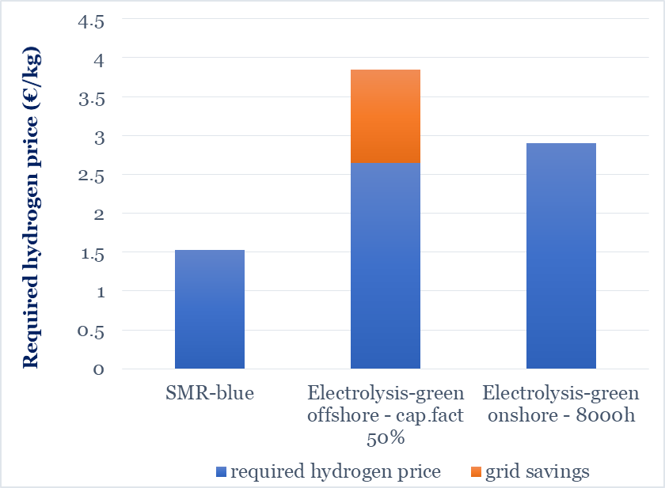

Conclusions

If an electrolysis plant is directly connected to a wind turbine or solar panel, then there is no need to buy green certificates as the origin of the electricity is clear. However, in such a setup, there is another disadvantage. When an electrolysis plant can only use electricity which is generated by a specific wind turbine, for instance, the production becomes related to weather circumstances and, hence, way more volatile. This strongly reduces the efficiency as well as the number of operating hours, which raises the required revenues per unit of hydrogen in order to be able to recoup the investments. This disadvantage of this setup exceeds the potential benefits of not having to make costs for electricity grid extensions and green certificates. Hence, we conclude that power-to-gas cannot compete with blue-hydrogen even we take into account the savings on grid extensions.

References
Mulder, M., Perey, P. L., & Moraga , J. L. (2019). Outlook for a Dutch hydrogen market: economic conditions and scenarios. (CEER Policy Papers; No. 5). Groningen: Centre for Energy Economics Research, University of Groningen, .

