US Energy-Related Greenhouse Gas Emissions in the Absence of Federal Climate Policy

Hadi Eshraghi, Department of Civil, Construction, & Environmental Engineering, North Carolina State University E-mail: heshrag@ncsu.edu

Anderson Rodrigo de Queiroz, School of Business, NC Central University, Durham, NC, E-mail: ardequei@ncsu.edu

Joseph DeCarolis¹, Department of Civil, Construction, & Environmental Engineering, North Carolina State University E-mail: jfdecaro@ncsu.edu

Overview
Given the anticipated lack of near-term federal action to address climate change, it is critical to evaluate potential baseline emissions scenarios in the absence of federal climate policy. Our analysis focuses on techno-economic uncertainty related to fuel prices and technology-specific capital costs, thus providing an indication of how changes in costs can produce different emission trajectories. In addition, careful model-based analysis of baseline scenarios can help inform discussions regarding the timing and structure of future climate and energy policy.

Methods
In this analysis, we utilize Tools for Energy Model Optimization and Analysis (Temoa)¹ an open source, publicly available energy system optimization model to examine a large set of baseline US energy futures through 2040. An input database representing the US as a single region was used in conjunction with Temoa to conduct this analysis. Our objective is to rigorously explore the future decision landscape and resultant greenhouse gas (GHG) emissions in a future where energy system changes are driven by market forces rather than top-down federal policy. We employ a sensitivity technique called the Method of Morris to rank order the input parameters that produce the largest effect on energy cost and emissions. We then incorporate the ten most sensitive parameters into a suite of Monte Carlo simulations that indicate how US energy-related GHG emissions may change under different future assumptions. The Monte Carlo simulation is repeated for three different cases (1000 runs each) that represent three different ranges of future uncertainties: Stable World, Uncertain Fuels, Uncertain World. The full set of results are used to identify plausible combinations of assumptions that can lead to either very high or low emissions.

Results
Figure 1 shows ranges of projected CO₂ emission pathways in the three modeled cases, with the baseline emissions scenario and the Obama-era Mid-Century Strategy (MCS) for Deep Decarbonization included for reference. All three cases could result in emission pathways significantly lower than the baseline.
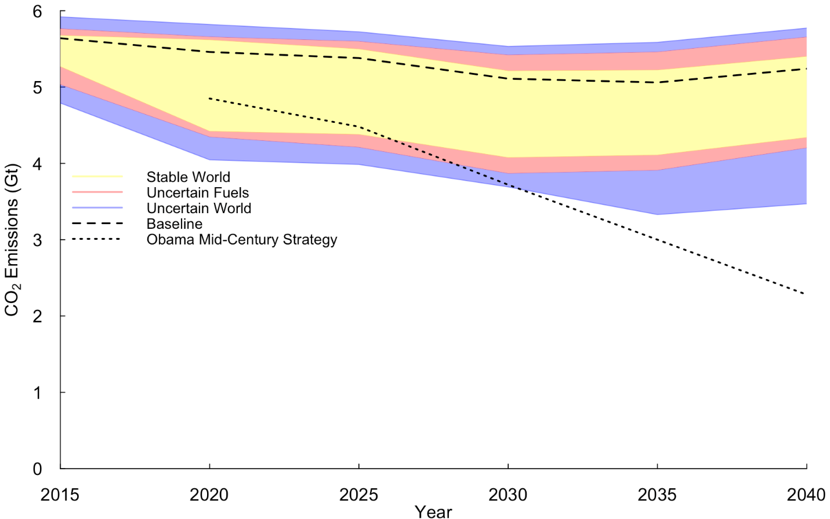
Figure 1: CO₂ emission trajectories

Conclusions
Projected variations in emissions due to market uncertainties are significant and illustrate the importance of considering techno-economic uncertainty in future no-policy scenarios. Overall, the model results indicate that market forces operating in the absence of new federal climate or energy policy will tend to produce emissions trajectories that remain relatively flat or produce modest reductions. More specifically, there are more ways to decrease emissions through the deployment of natural gas and renewables than to increase emissions through the increased deployment of coal.

References
[1] GitHub, https://github.com/TemoaProject (Accessed April 20, 2018)
[2] Morris, M.D. (1991). "Factorial Sampling Plans for Preliminary Computational Experiments", Technometrics. 33: 161–174. doi:10.2307/1269043.

