ELECTRICITY DEMAND PROJECTION FOR ELECTRIC VEHICLES (EV) IN TURKEY: BOTTOM-UP MODELLING APPROACH, AND COMPARISON WITH EU

Zafer Öztürk, Bogazici University, +90 212 359 48 72, zafer.ozturk@boun.edu.tr

Overview

Electricity is a key energy source in each country and an important condition for economic development. In this regard, it is crucial to forecast the electricity demand in order to enhance the accuracy of the assessment of development trends.

The European Union (EU ) has set ambitious targets for renewable energy and reducing carbon emissions, which would in turn require a significant transformation of the electricity system, including electrifying the transportation sector .

Conducted study is a sub-section of a broader research titled “Assessing the Possible Impacts of Electric Vehicles to Turkish Energy Scene, and Determining the Required EV Charging Infrastructure Costs” which is funded by the Scientific and Technological Research Council of Turkey (TUBITAK) under BIDEB2232 incentive programs (Project no: 114C116).

The main intention of this specific study is to develop an electricity demand projection for Electric Vehicles (EV) in Turkey for the period 2012-2035. For that purpose , electricity demand forecasting process of transport sector till end year 2035 has been carried by taking into considerations of official projections, and energy infrastructure improvement expectations as well as the sector based growth and development expectancies. A survey for end user perceptions towards electric vehicles has also been conducted.

Projection results show that electricity demand of Turkey in transport sector considerably growing. It is essential to assess the domestic demand against other countries in order to make better interpretations of the state of the electricity demand growth. As becoming a member state of the EU is among the prior development targets of Turkey, it would be deemed necessary to benchmark the electricity demand against EU member states.

The paper is structured as follows: After the introduction the second section draws a brief overview about the historical development of Turkish electricity demand. The third section addresses the development and implementation of the bottom –up modelling strategy, and depicts the forecasting results. In section four, Turkish electricity demand of transport sector (with special focus on BEV) benchmarking against EU has been carried out. In the final section the policy options for EV in electricity sector is discussed.

Methods

Survey: Comprises questionnaires with possible end users and interwievs with experts from transport industry

ii) Bottom-Up modelling: Modelling has been conducted under the LEAP (Long Range Energy Alternatives Planning System) model which follows the accounting framework approach to generate a consistent view of energy demand based on the physical description of the energy system. The power and effectiveness of the model comes from its sectorally detailed structure under an extensive and reliable database.

iii)Benchmarking: Comparison and interpretation of Turkish and EU Electric Vehicles electricity demand profiles have been carried out

Results

First, data sources, and structuring of the model has been presented.

Second, tansport sector electricity demand forecast has been obtained through the bottom-up model. The outcome the overall transport electricity consumption of Turkey rises from 0.9 TWh in 2012 (base year) to 2 TWh in 2023 (Strategic year for Turkey’s development vision), and reaches to 5 TWh in 2035 (end year) respectively (See Figure 1). The compound annual growth rate (CAGR) of transport sector electricity demand throughout the modelling period is 7.9%.

Third, it is seen that EV electricity demand rises from negligible amount in 2012 to exceeding more than the half of total electricity demand of transport sector (2.6 of 5 TWh) in 2035.

Fourth, it is found out from projection benchmarks that the growth of EV electricity demand in EU is considerably higher than the trends in Turkey. The dominant reasons for this appear to be fiscal incentives and the regulatory pressure in EU.
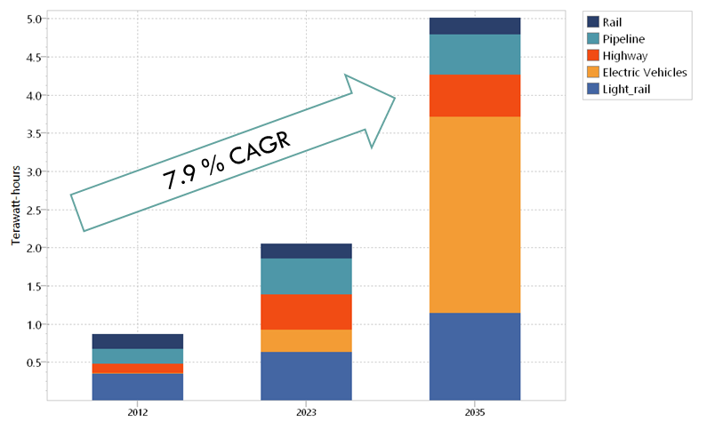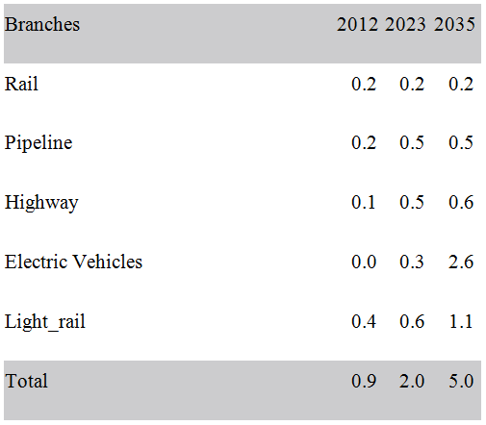
Figure 1. Electricity Demand Growth of Turkish Transportation Sector

Conclusions

It is seen that in transportation sector the demand for electricity is remarkably increasing in Turkey. Accepted opinion on energy demand is that it is an indicator of development. In that sense, it can be said that Turkey is gradually approaching to its development goals set for EU membership. On the other hand , forecasts for electricity consumption trends depict that both Turkey and EU countries have high annual growth rates in EV electricity demand. This situation can be interpreted as a high potential for cooperation in electrified transport sector.

References
European Commission,2013a.PavingtheWaytoElectrified RoadTransport,DG JRC/IET,ReportEUR25832.
European Commission,2013b.Communication—Clean PowerforTransport:A European alternative fuels strategy. COM(2013)17.
Hota, A. R., Juvvanapudi, M., & Bajpai, P. (2014). Issues and solution approaches in PHEV integration to smart grid. Renewable and Sustainable Energy Reviews, 30, 217-229.
Hjorthol, R. (2013). Attitudes, ownership and use of Electric Vehicles–a review of literature. National Academy of Sciences.
Mock, P., & Yang, Z. (2014). Driving electrification: A global comparison of fiscal incentive policy for electric vehicles. The International Council on Clean Transportation (ICCT). URL http://www. theicct. org/sites/default/files/publications/ICCT_EV-fiscal-incentives_20140506. pdf. Last accessed, 22(6), 2014.

