Reserve provision by electric vehicles: Scenarios for Germany
Acknowledgement: This paper was primarily based on research implemented within the ongoing project “ImpRES – Impact of Renewable Energy Sources in Germany”, supported by the Federal Ministry for Economic Affairs and Energy in Germany. The contents of the paper are the sole responsibility of its authors and do not necessarily reflect the views of the German Ministry.
Wolf-Peter Schill, DIW Berlin, +49 30 89789-675, wschill@diw.de
Moritz Niemeyer, (DIW Berlin at time of writing,) moritzniemeyer@gmx.de
Alexander Zerrahn, DIW Berlin, +49 30 89789-453, azerrahn@diw.de
Jochen Diekmann, DIW Berlin, +49 39 89789-693, jdiekmann@diw.de

Overview
Many countries plan to substantially increase the deployment of fluctuating renewable power sources. Germany is one of the frontrunners of this development, aiming for a share of 55 to 60% renewables in the power sector by 2035, and at least 80% by 2050 (EEG 2014). Due to limited potentials of dispatchable renewable sources, fluctuating wind and solar power will account for a major share of targets. In this context, one emerging challenge is the provision of control reserves. Reserve requirements generally increase with larger shares of fluctuating renewables (cp. Holttinen et al. 2010), while conventional means of reserve provision, i.e., thermal power plants, are declining. Another potentially major energy sector trend is the introduction of electric vehicles. Like many other industrialized countries, the German government aims to substantially increase the number of electric vehicles. In this paper, we investigate how future fleets of electric vehicles may contribute to the provision of control reserves. As a case study, we analyse different scenarios for Germany in 2035, assuming a stock of 4.4 million electric vehicles (EVs). We consider that EVs may supply their flexibility potentials both to wholesale and reserve markets. In different scenarios, we analyse the effect of varying assumption on the charging strategy, including a differentiation between Grid-to-Vehicle (G2V) and Vehicle-to-Grid (V2G) operational modes. EV reserve provision is studied in the context of other competing options both on the supply and demand side, including power storage and demand-side measures. A German version of this article will be available in the journal Zeitschrift für Energiewirtschaft (Schill et al. 2016).

Methods
We use an adjusted version of the open source dispatch and investment model DIETER, which has been extended with electric vehicles for this article. An actual version (1.1.0) is available on DIETER’s homepage www.diw.de/dieter. The model minimizes yearly power system costs with an hourly resolution, subject to numerous restrictions. Reserve provision is determined endogenously, depending on wind and solar capacities. Exogenous inputs include installed capacities, specific investments and marginal costs of various technologies as well as hourly profiles of fluctuating renewables and load. With respect to EVs, important input parameters are hourly profiles of grid availability and mobility-related power consumption of 18 different vehicles types, drawing on results of a European research project (Kasten and Hacker 2014). Endogenous outcomes include system costs, hourly dispatch of all technologies in wholesale and reserve markets and investments in new capacities. In particular, the system value of reserve provision (i.e. shadow prices of respective constraints) is endogenous and not an exogenous input parameter as in many other studies (e.g. Andersson et al. 2010, Jargstorf and Wickert 2013).
We build on the medium scenario “B” of the German Grid Development Plan, which is approved by the German regulator (Bundesnetzagentur 2014). We distinguish two main scenarios: in the “Baseline”, all capacities are fixed as exogenous parameters. In an alternative scenario “Adjusted portfolio”, the capacities of the most important flexibility options (gas-fired power plants, storage, and demand-side measures) are determined endogenously, taking into account the flexibility potentials of the EV fleet. We further distinguish different operational modes of EVs (with and without V2G, arbitrage only, reserves only, or combinations) in order to separate EV interactions on wholesale and reserve markets. We additionally carry out a sensitivity analysis with respect to V2G costs. While feeding power from EV batteries back to the grid incurs depreciation costs of €41/MWh under baseline assumptions, we abstract from such costs in the sensitivity. Outcomes are compared against a reference case in which EVs are cost-optimally charged. This reference is chosen as other studies showed that non-controlled vehicle charging would not be meaningful due to severe peak load problems (Sioshansi and Denholm, 2010, Schill and Gerbaulet 2015).

Results
We find that EVs can substantially contribute to the provision of control reserves. This is true even in case of a pure G2V operation mode (Figure 1). Under baseline assumptions, the amount of energy related to reserve activation is small compared to mobility-related electricity consumption of EVs, and wholesale arbitrage activities hardly play a role (Figure 2). Model results thus confirm earlier findings that the flexibility potentials of an EV fleet are best to be utilized in reserve markets (e.g. Andersson et al. 2010). Yet overall system cost saving (€16 mio) as well as vehicle-specific revenues of flexibility provision are rather low (Figure 3).
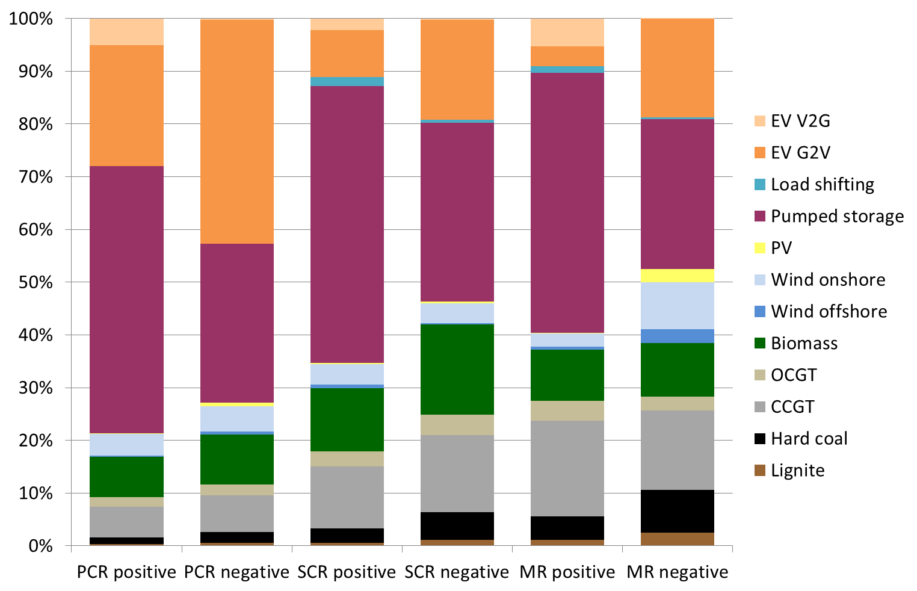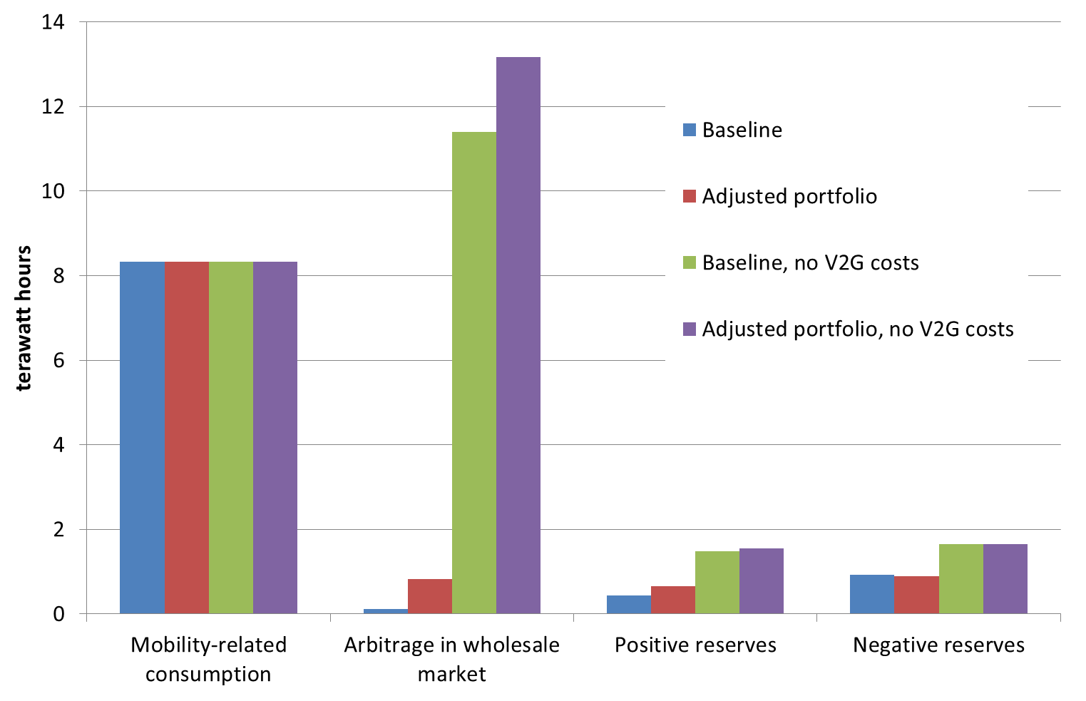
Figure 2: Yearly energy provided by EVs in different markets (Full Flexibility)
Figure 1: Reserve provision shares (Baseline, Full Flexibility)
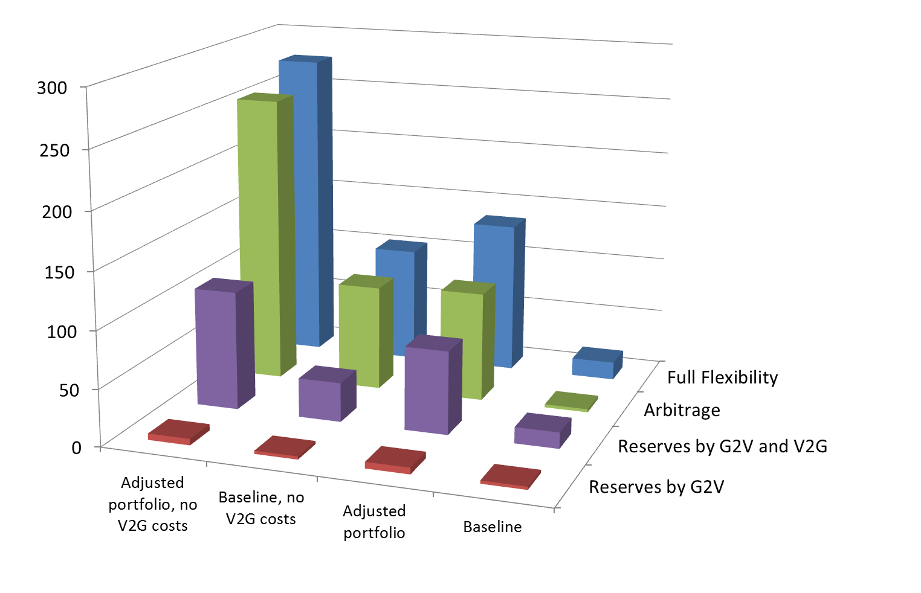
These findings change substantially under alternative assumptions. In the “Adjusted portfolio” scenario, capacities of gas-fired power plants and storage are lower. The flexibility value of electric vehicles accordingly increases, which is reflected in increased arbitrage activities, additional reserve provision, and higher system costs savings (€ 135 mio). Under the assumption that V2G does not incur additional costs, the EV fleet provides even more reserves, and is also heavily utilized for energy arbitrage in the wholesale market, while system costs decrease further (€103 mio and €276 mio for “Baseline” and “Adjusted portfolio”, respectively). Here, electric vehicles stand in direct competition to centralized pumped hydro storage facilities.

Conclusions
Figure 3: System cost differences to reference scenario
Future EV fleets could contribute substantially to a cost-optimal provision of reserves, even without making use of the Vehicle-to-Grid option. Yet the system value of such reserve provision is not very high under baseline assumptions despite increasing reserve requirements, as many other technologies, including renewables, are assumed to be able to provide reserves in the future. Accordingly, it may be challenging to find viable business cases. Then again, reserve provision should not incur much additional costs, given that EVs are charged optimally already in the reference case, i.e. an aggregator and some communication infrastructure would be in place, anyway. The value of EV-related flexibility grows further if their existence is – at least partly –considered in the power plant portfolio, and even more so if V2G would be possible without incurring additional battery depreciation costs.

References
Andersson, S.-L., Elofsson, et al. (2010): Plug-in hybrid vehicles as regulating power providers: Case studies of Sweden and Germany. Energy Policy 38, 2751-2762, http://dx.doi.org/10.1016/j.enpol.2010.01.006.
Bundesnetzagentur (2014): Szenariorahmen 2025. Genehmigung. Bonn, 19. Dezember 2014.
EEG (2014): Gesetz für den Ausbau erneuerbarer Energien (EEG 2014) [Renewable Energy Sources Act], 21.07.2014.
Holttinen, H., Meibom, P., Orths, A., Lange, B., O'Malley, M., Tande, J. O., Estanqueiro, A., Gomez, E., Söder, L., Strbac, G., Smith, J. C. and van Hulle, F. (2011): Impacts of large amounts of wind power on design and operation of power systems, results of IEA collaboration. Wind Energy 14, 179-192. http://dx.doi.org/10.1002/we.410.
Jargstorf, J., Wickert, M. (2013): Offer of secondary reserve with a pool of electric vehicles on the German market. Energy Policy 62, 2013, 185-195. http://dx.doi.org/10.1016/j.enpol.2013.06.088.
Kasten, P., Hacker, F. (2014): Two electric mobility scenarios for Germany: Market Development and their impact on CO₂ emissions of passenger cars in DEFINE. Berlin, September 2014. https://www.ihs.ac.at/projects/define/files/DEFINE-Oeko-english-version.pdf.
Schill, W.-P., Gerbaulet, C. (2015): Power System Impacts of Electric Vehicles in Germany: Charging with Coal or Renewables? Applied Energy 156, 185-196. http://dx.doi.org/10.1016/j.apenergy.2015.07.012.
Schill, W.-P., Niemeyer, M., Zerrahn, A., Diekmann, J. (2016): Bereitstellung von Regelleistung durch Elektrofahrzeuge in Deutschland: Modellrechnungen für das Jahr 2035. Zeitschrift für Energiewirtschaft, forthcoming.
Sioshansi, R., Denholm, P. (2010): The Value of Plug-In Hybrid Electric Vehicles as Grid Resources. The Energy Journal 31(1), 2010, 1-23.

