MARKET AND POLICY RISKS FOR VRE INVESTMENT AND THEIR IMPACTS ON EFFECTIVENESS AND EFFICIENCY OF RES-E POLICY TARGETS – AN AGENT-BASED MODELLING APPROACH
Matthias Reeg (PhD Candidate), German Aerospace Center, Institute of Engineering Thermodynamics,
System Analysis and Technology Assessment
Wankelstraße 5, 70563 Stuttgart
Phone: +49 (0)711 6862-282, e-mail: matthias.reeg@dlr.de

Overview
With the implementation of the Renewable Resource Act (EEG) in the year 2000 and feed-in-tariffs (FiT) as main policy instrument to support the deployment of renewable energy source for electricity (RES-E), the RES-E share in power generation has risen successfully from initially five to over 30 % in the year 2015. With the strong increase of the use of variable renewable energies (VRE) like wind and solar radiation, a better market integration of RES-E is postulated. Hence, optional direct marketing of RES-E via the variable market premium (var. MP) has been introduced in the year 2012 and in 2014 direct marketing of RES-E power generation has become mandatory for almost all new plants over 100 kW. Introducing tenders is expected to be the next big policy adaptation within the revision of the EEG in the year 2016. The intention is to expose VRE to wholesale power price signals that reflect the different value of electricity, and therefore facilitate a more demand oriented feed-in as well as the incentive to invest in more “system friendly” power plants. But VRE are capital-intensive and supply-dependent technologies and, as such, highly sensitive to investment risk, which is increased by short-term price exposure. The IEA concludes that an appropriate future policy and market design “will need to strike a delicate balance between these two objectives” (IEA 2014).
A the same time, studies on the future development of the market values of VRE expect a tremendous drop with increasing shares (Hirth 2013). This is due to the “concurrence-effect”: the simultaneous feed- in off VRE reasoned by the fact that meteorological conditions are similar in large geographical areas. Combined with more frequently market driven curtailment of VRE due to the introduced incentives of the above mentioned policy schemes, this situation leaves the investors and plant operator with high uncertainty about future revenues. In general, all of the discussed policy instruments go along with higher remuneration risks compared to FiTs; with higher risks usually resulting in risk premiums. There is evidence, that many investors of the past in Germany will not be able to diversify these new risks adequately. Therefore a sudden and radical change in policy support can lead to an abrupt ending of VRE investment activities, risking to fulfil the RES-E targets set by the German government. In order to evaluate policy instrument uncertainty from an actor’s perspective and its impact on the system development as a whole, an agent-based simulation model has been developed (Reeg et al. 2012).

Methods
Agent-based modelling (ABM) is particularly suitable for the analysis of complex systems with autonomous and heterogeneous agents acting in a changing environment (Wooldridge 2009), like liberalised markets of power systems. (Tesfatsion 2006) constitutes that “economies are complicated systems encompassing micro behaviours, interaction patterns, and global regularities. Whether partial or general in scope, studies of economic systems must consider how to handle difficult real-world aspects such as asymmetric information, imperfect competition, strategic interaction, collective learning, and the possibility of multiple equilibria”. Past experiences have shown that energy policy instruments have often either not achieved the originally intended targets or have been accompanied by unintended side-effects like windfall profits. A central reason for this is seen in the circumstance that the underlying assumptions of general or partial equilibrium models and classical economic theory do not hold in complex socio-technical systems under transition. Energy systems around the world are characterised by high uncertainty about future market and policy developments and conditions. Therefore, not only VRE market participants have to deal with high risks and imperfect knowledge as well as (political) power struggles about the “right” transition pathway (centralised vs. decentralised) (Wassermann et al. 2015). Following the approach of agent-based computational economics (ACE), the developed AMIRIS Model explicitly incorporates a multitude of uncertainty and risk aspects on the micro level of heterogeneous actors as well as on the macro level of the decision environment and system development.
In a first step, 17 semi-structured expert interviews with investors, financers, project developers and plant operators have been carried out. Under divers scenarios of future policy frameworks in Germany (variable vs. fixed market or capacity premiums (CP), administrative vs. competitive pricing) the actors perception on future VRE investment risks, changed return on equity expectations or equity-debt ratio requirements have be elaborated. In a second step, the relevant investment agents and their strategies and behaviour has been translated into a formalised modelling language (Java) and implemented into the AMIRIS model. In a third step, the results of the interview serve as input for the parameterization of the simulation model in order to dynamically calculate the effectiveness and efficiency of these policy instruments under “closer-to-real-world” conditions on an hourly resolution over a 15 year time period.

Results
As one result of the actors’ analysis, seven different investor types with different motivations, strategies, return and risk expectations have been identified (private persons, farmers, funds/insurance companies, project developers, municipal utilities, “big” utilities and commerce/industry). When seen from an actor’s perspective, first simulation results show the divers and severe impacts of different VRE support instruments, when taking uncertainty and the risk perception of the relevant actors into account (see Figure 1 for exemplary results of a project developer as investor type):
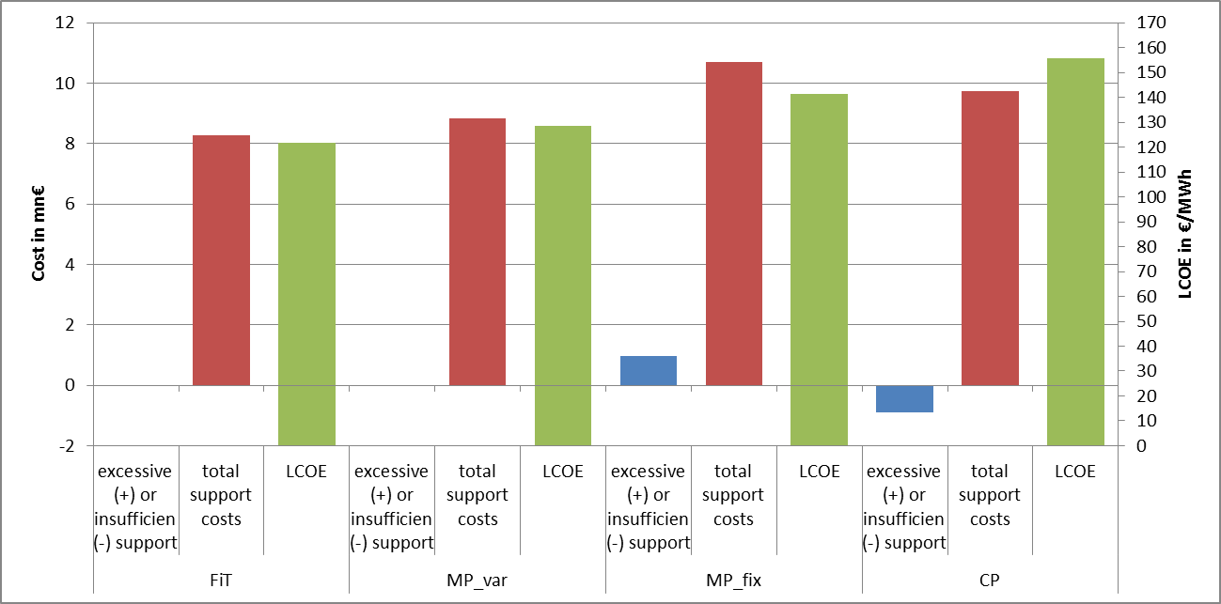
Total investment in 10 MW Onshore Wind:
- spec. investment costs: 1,090 €/kW
- var. O&M costs: 18 €/MWh
- FLH: variates from 1,089-1718 h/a
- RoE_{expected}= 5%, i_{debt} = 5%, i_{risk-free} = 1.5%
- amortization: t = 15 a
- EPEX power price = rises from 50-80 €/MWh
- VRE market value: decreases from 90-70%
Figure 1: Effects of RES-E policy and market risks on the effectiveness and efficiency of VRE investments.
A multitude of policy framework scenario simulations and analyses for different types of Wind and photovoltaic (PV) investors have been carried out: 1) to cover all variations in RES-E support schemes being currently discussed and 2) to take account of the heterogeneous actors constellation in Germany. Results reveal a contradiction in German energy policy goals. Further results of the simulation runs will be presented on the conference.

Conclusion
Within the necessary organizational transformation of the energy system and its accompanying structural and financial adjustments a huge variety of heterogeneous actors is involved. They are connected through complex interdependencies and can react very differently to changes in the policy framework. Handling of risks and uncertainty at the micro level of the actors as well as its effects on the macro level of the energy system must be taken into account when policy instruments and frameworks are being designed or changed. It can been shown that especially in the case of VRE with high fix and negligible operating costs, extensive exposure to unknown market or policy risks at an early stage of the market integration process can lead to inefficiency and ineffectiveness of policy instruments. The AMIRIS model allows for the investigation and handling of expectations and uncertainty in the short and medium terms at the firm and market levels as well as in the longer term with regard to technology and market development, policy and regulation. It therefore offers an innovative approach for the analysis and evaluation of policy instruments and financing mechanisms for the market integration of renewable energies. Finally, conclusion of the simulation results lead to specific proposals on how future RES-E support schemes should be designed, if the policy targets of the German energy transition (“Energiewende”) should be accomplished both effectively and cost efficient.

References
Hirth, L. 2013. The market value of variable renewables: The effect of solar wind power variability on their relative price. Energy Economics 38:218–236.
Reeg, M., W. Hauser, S. Wassermann, T. Kast, U. Klann, K. Nienhaus, U. Pfenning, and W. Weimer-Jehle. 2012. AMIRIS- An Agent-based Simulation Model for the Analysis of different Support Schemes and their Effects on Actors involved in the Integration of Renewable Energy into Energy Markets. Pages 339–344 in A. Hameurlain, A. M. Tjoa, and R. R. Wagner, editors. Proceedings of DEXA 2012. . Institute of Electrical and Electronics Engineers - Computer Societey.
Tesfatsion, L. 2006. Agent-based computational economics: A constructive approach to economic theory. in L. Tesfatsion and K. L. Judd, editors. Handbook of computational economics, volume 2. Elsevier North-Holland, Amsterdam.
Wassermann, S., M. Reeg, and K. Nienhaus. 2015. Current challenges of Germany’s energy transition project and competing strategies of challengers and incumbents: The case of direct marketing of electricity from renewable energy sources. Energy Policy 76:66–75.
Wooldridge, M. 2009. An Introduction to MultiAgent Systems. . Wiley.

