Overview

What is the Price of National Energy Policies?
A Scenario-based Analysis of Market Integration Impact and emission Targets on Eletricity Generation and Grid Expansion in Europe until 2035
Jens Weibezahn, Technische Universität Berlin, +49 30 314-27500, jew@wip.tu-berlin.de
Mario Kendziorski, Technische Universität Berlin, +49 157 39427319, mak@wip.tu-berlin.de
Pao-Yu Oei, Technische Universität Berlin, +49 30 314-75846, pyo@wip.tu-berlin.de
Valentin Vadim Zinnecker, Technische Universität Berlin, +49 177 3721560, vz@wip.tu-berlin.de
It is generally considered that a change in electricity generation from CO₂-intensive to CO₂-neutral technologies is necessary. Relevant global energy scenarios expect nuclear energy to play an important role in this context even though increasing investment costs, rising operation costs and open questions on dismantling and final storage make nuclear energy economically unattractive (Capros et al., 2014). Different national political frameworks like CO₂ targets or budgets to mitigate emissions, nuclear phase-outs and the level of international cooperation determine the success of reaching the climate target (Kemfert et al., 2014).
This paper investigates the impact of different determining factors on electricity generation capacities applying four scenarios. These scenarios differ in two dimensions. The first dimension describes the policy effect of decarbonization and ranges from business as usual (BAU) to a world of zero greenhouse gas emissions from the electricity sector. This leads to a high share of renewable generation (RES). The second dimension of market integration between the European states sees a national scenario with little cooperation between states (NAT) and one European scenario with high levels of cooperation (EU) (Schmid and Knopf, 2014).

Methods
For the calculation of the different scenarios the European electricity market model “dynELMOD” (Gerbaulet et al., 2014), developed at TU Berlin is used which is a dynamic investment model of the European electricity sector. Country-sharp cost-minimal generation and grid infrastructure are determined in a single optimization step while given constraints conditioned by the scenarios are taken into account. Investments are made in five-year steps from 2015 to 2050 while the generation and storage dispatch is modelled in an hourly resolution. Depending on the scenario, boundary conditions like technological availability, cost assumptions, yearly CO2 emission limits in form of a CO₂ budget and NTC are considered. Flow-based market coupling between countries is implemented.
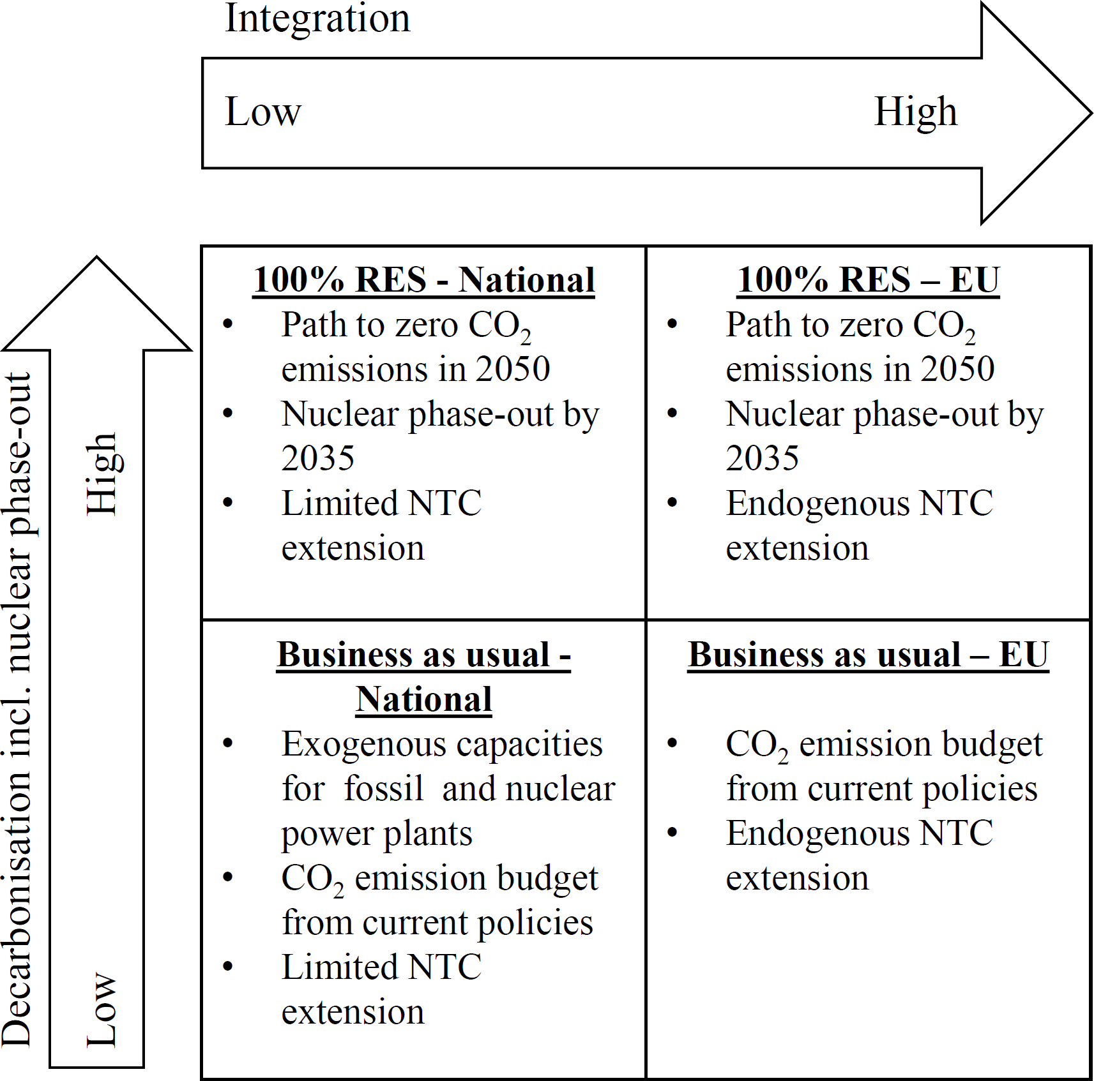
The decarbonization scenarios are represented by emission targets with corresponding emission budgets, while the market integration scenarios differ on the level of NTC (net transfer capacity) between countries. Exogenous capacities and investments are based on “EU Trends to 2050 – update 2013” and own assumptions (EC, 2013, 2011; ENTSO-E, 2014; Schröder et al., 2013).
The first scenario (BAU-NAT) depicts a setting where little international cooperation between the European countries takes place. The degree of decarbonization is low. The CO₂ emissions budget is taken from currently adopted national policies. Conventional fossil and nuclear generation capacities are set exogenously based on national scenarios. NTC extension possibilities within the model are limited as to simulate a low level of possible market integration. The second scenario (RES-NAT) on the other hand implements a viable path to zero CO₂ emissions in the year 2015 as a constraint for the power system as a whole. The expansion of nuclear power plants is considered unlikely in most countries and a complete phase-out by the year 2035 is set. The level of integration persists at a low level. The third scenario (BAU-EU) is characterized by a low CO₂-mitigation target but a high degree of market integration and allows for endogenous investment into NTC between countries compared to the first scenario in order to account for a high possible level of market integration. The fourth scenario (RES-EU) combines the zero emission path from scenario two with the high possibility of market integration into a perfect one concerning the achievement of the climate targets.
Figure 1: Scenario overview

Expected Results
The preliminary results show that, on the one hand, the implementation of strict emission targets only leads to a light increase of total costs, and on the other hand, that limited coordination between states implies a large cost increase.
The total cost of the scenarios with strict emission targets lead to slightly higher costs. The external effects of additional CO₂-emissions in the low-decarbonization scenarios are likely to outweigh the cost savings of the BAU scenarios in the long term.
The preliminary results show that depending on the scenario, the future decrease of nuclear electricity generation is mainly substituted by renewable energy, especially by solar and wind power. The installed total capacities are correspondingly higher than in fossil-dominated scenarios due to lower full load hours of renewables. Furthermore, large investments into storages occur, to compensate fluctuating generation of renewable energies. Fossil energies play a tangential role due to the CO₂ emission limitation. The yearly average discounted total cost of the modelled European electricity sector varies slightly between the scenarios.
It is expected that a renewable-only market will be slightly more expensive than in a business as usual scenario regarding investment costs. However, the interesting question is how much more costs will accrue in case of low levels of international cooperation in form of too little investments into NTC between European countries.

Conclusions
This paper provides a model-based analysis of the structure of a carbon-constrained electricity sector in Europe, at the perspective 2035. Increasingly cost-effective solar and wind power compensate the nuclear energy decrease. The total costs of the scenarios between BAU and RES are nearly equal; the question arises why not investing into a sustainable long-term solution with RES from the start. Since a shift from BAU-NAT to RES-NAT comes with only a slightly higher total cost, a 100% renewable scenario is still competitive especially when taking into account that negative external effects of CO₂ emissions are not covered by the total cost calculations. Overall, the costs can be significantly reduced if EU member states intensify their cooperation efforts in order to invest into the extension of NTC for a better market integration.

References
Capros, P., Paroussos, L., Fragkos, P., Tsani, S., Boitier, B., Wagner, F., Busch, S., Resch, G., Blesl, M., Bollen, J., 2014. Description of models and scenarios used to assess European decarbonisation pathways. Energy Strategy Reviews 2, 220–230. doi:10.1016/j.esr.2013.12.008
EC, 2013. EU Energy, Transport and GHG Emissions Trends to 2050. Reference Scenario 2013. European Commission, Brussels, Belgium.
EC, 2011. Energy Roadmap 2050 (No. COM(2011) 885 final), Communication from the Commission to the European Parliament, the Council, the European Economic and Social Committee and the Committee of the Regions. Brussels.
ENTSO-E, 2014. Scenario Outlook & Adequacy Forecast 2014-2030. European Network of Transmission System Operators for Electricity, Brussels, Belgium.
Gerbaulet, C., Kunz, F., Lorenz, C., von Hirschhausen, C., Reinhard, B., 2014. Cost-minimal investments into conventional generation capacities under a Europe-wide renewables policy. IEEE, pp. 1–7. doi:10.1109/EEM.2014.6861297
Kemfert, C., Hirschhausen, C. von, Lorenz, C., 2014. European Energy and Climate Policy Requires Ambitious Targets for 2030. DIW Economic Bulletin 4, 17–26.
Schmid, E., Knopf, B., 2014. Quantifying the Long‐Term Economic Benefits of European Electricity System Integration (FEEM Working Paper).
Schröder, A., Kunz, F., Meiß, J., Mendelevitch, R., von Hirschhausen, C., 2013. Current and Prospective Costs of Electricity Generation until 2050 (DIW Data Documentation No. 68). Berlin, Germany.

