THE EconomicS OF Natural Gas Storage in Europe

Alexandre Haikel, Uniper Global Commodities SE / E.ON, Phone +491511 0599137, E-mail: alexandre.haikel@uniper.energy
Dr. Andreas Schröder, Uniper Global Commodities SE / E.ON, Phone +49 15157004319, E-mail: andreas.schroeder@uniper.energy

Overview
This contribution deals with the economics for natural gas storage operations in the EU. We open by defining how flexibility supply & demand in natural gas markets can be determined. We then draw a picture of current oversupply in flexibility terms for the EU gas markets and correspondingly an environment of low seasonal price spreads. Departing from the current market situation, we identify fundamental drivers for the economic outlook of storage operation in the EU. Although indigenous EU production is declining (cf. Figure 1) LNG imports, storage availability and Russian pipeline imports are sufficient in covering swing requirements in the very near future. On the demand-side of flexibility, we observe an increasing seasonal swing of natural gas demand inside the EU, in large parts due to rising Gas-to-Power seasonal variability and volumes. As only few storage additions are expected for the timeframe until the mid-2020s (GSE, 2015) we expect an overall decline in the availability of flexibility in the mid-2020s. The combination of these developments may support summer-winter price spreads in the long-run and may give room for storage operators to improve their commercial position over time. Adding to our economic analysis, we take a look at the current regulatory and political developments surrounding gas storage operations. They remain a big uncertainty to the analysis. The commercial recovery could be flanked by the intentions of the European Commission on the remuneration of security of supply via LNG or storage discussed upfront to their Communication on LNG & Storage Strategy announced for early 2016, cf. Molnar et al. (2015).

Methods
The contribution opens by a qualitative definition of how flexibility supply & demand in natural gas markets can be determined (e.g. what are demand & supply components, relevant time frames and market products storage operators look at, optimization rationale of operators) and how it developed in recent history, cf. Figure 1 and Figure 2. Essentially, the quantitative work consists in establishing a supply-and-demand balance of what we previously define as flexibility indicators. When it comes to the analysis of prices, our contribution stays within the realm of linear optimization and it evolves from work done on the basis of the Wood Mackenzie Global Gas Model (Wood Mackenzie, 2015), a natural gas market equilibrium model.

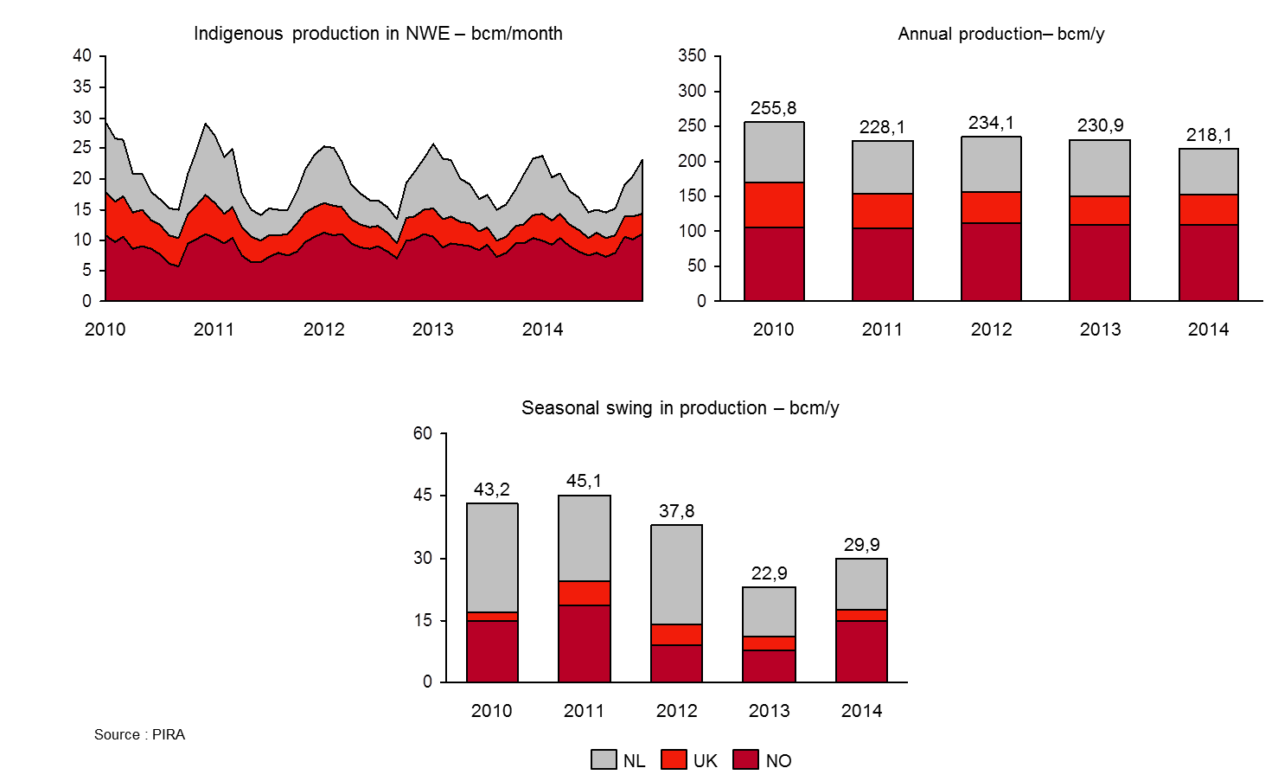
Figure 1: The historic decline of indigenous production in North West Europe does not necessarily imply a reduced seasonal swing production.
Source: PIRA 2015

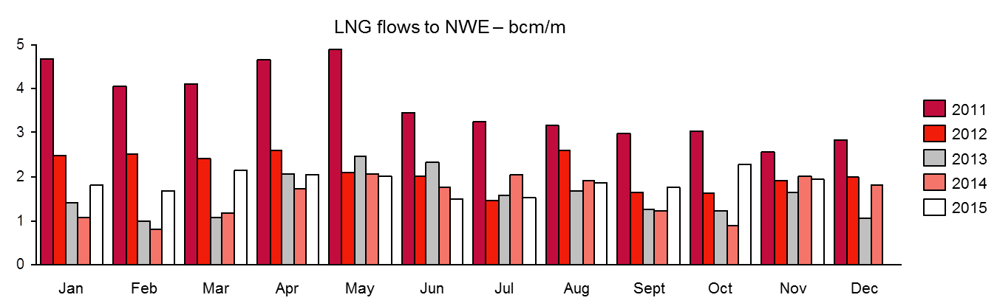
Figure 2: The historic LNG imports into North West Europe show no clear seasonal pattern.
Source: NATS 2015

Results
As a first result, we describe the situation of oversupply in flexibility terms inside the EU in the current market situation , which leads to reduced seasonal price spreads (cf. European Commission 2015, p.19). However, we expect the balance to slowly shift towards reduced system length in the future. Upside potential for summer-winter spreads consists in the rising use of gas in power plants, notably in the UK – in parts driven by a carbon price support mechanism. In Northern European countries, gas-to-power demand is particularly strong in the winter season, thus supporting winter prices. Summer gas demand is in tendency dumped further by stronger solar power production, which reduces residual demand and thus gas-to-power demand in the summer season. We expect the effect of rising gas-to-power in combination with reduced system flexibility length to lead to a recovery of the supply & demand balance for seasonal flexibility in the early 2020s. Results of our analysis inlcude a qualitative discussion on the rationale behind the supply, demand and arbitraging of LNG, which determine seasonality. The contribution closes with remarks on main factors influencing market agents’ decisions on (retrofit-) investment, commercial operation mothballing or complete closure of storage facilities. Adding to this analysis we take into account the current political and regulatory framework for storage operations.

Conclusions
The commercial outlook for natural gas storage in the EU appears challenging for the years prior to 2020 due to the fundamental situation of adequate availability of flexibility options. However, we expect demand for flexibility to increase while supply decreases slightly, leading to an improvement of the balance. On the policy-side, the signals to storage operators remain mixed: Regulatory interfearance continue to deter commercial operation in several EU countries such as Italy and France. The EU Strategy on LNG & Storage raises hopes about a framework supportive to storage operators’ commercial situation.

References

European Commission (2015): “Quarterly Report on European Gas Markets for Q1”, Vol. 8, Issue 1. Market Observatory for Energy. Available online: https://ec.europa.eu/energy/sites/ener/files/documents/quarterly_report_on_european_gas_markets_q1_2015.pdf. [Retrieved 28 Dec 2015]

GSE (2015): “Paper on the GSE Investment database 2015-2025”. Gas Storage Europe, 10 p. Available online: http://www.gie.eu/index.php/publications/gse/cat_view/4-gse-publications

Molnar, G., Behrens, A., Egenhofer, C., Genoese, F. (2015): “Submission to the European Commission: Consultation on a EU strategy for liquefied natural gas and gas Storage”, CEPS, Brussels. Available online: http://www.ceps-ech.eu/sites/default/files/CEPS%20Response%20LNG%20Strategy_formatted_v2.pdf

NATS (2015): Data Service Provider NATS. PanEurasian Enterprises Inc.. Available online: http://www.paneurasian.com/nats.html

PIRA (2015): Data Service Provider PIRA Energy Group. Available online: http://www.pira.com/

Wood Mackenzie (2015): „Global Gas Curves,“ Overview, 8 pages. Available online: http://www.carbontracker.org/wp-content/uploads/2015/07/Wood-Mackenzie-Global-Gas-Curves-Methodology-FINAL1.pdf [Retrieved 18 December 2015]

