Overview
The RES-induced Switching Effect across Fossil Fuels:
An analysis of the Italian day-ahead and balancing PRICES

Angelica Gianfreda, DEMS, University of Milano-Bicocca, angelica.gianfreda@unimib.it
Lucia Parisio, DEMS, University of Milano-Bicocca, lucia.parisio@unimib.it
Matteo Pelagatti, DEMS, University of Milano-Bicocca, matteo.pelagatti@unimib.it
Electricity generation from renewable energy resources (RES) has become increasingly significant worldwide. Several papers have emphasized that the presence of a high share of RES has affected the electricity price variability and it may modify the nexus between day-ahead electricity, gas, coal and oil prices according to the composition of the generation mix. The goal of our paper is to analyse whether the Italian policy supporting RES-E generation in the last years has affected the fuels-electricity nexus. We consider, for the first time to our knowledge, both day-ahead and balancing prices. In addition, we aim at quantifying costs for balancing needs required by the high intermittence of some renewable sources. Due to the significant growth of RES sources in most EU markets, we expect an evolution of the fuel-electricity nexus: we believe that the dynamic relationship among electricity prices and fuel prices (oil, gas and coal) might have changed. We analyse Italy as a reference case, since it is characterized by high solar penetration in connection with historically high hydro shares and absence of nuclear power. We found that the influence of RES-E on long-run relations between electricity and fossil fuels in Italy produces important effects in terms of balancing markets. We consider the time span 2006-2015 characterized by a progressive increment of RES generation from low, or even absent, to high penetration. Hence, we consider two samples for coal, natural gas, crude oil and electricity into two samples: 2006-2008 (scenario for low RES penetration) and 2012-2015 (scenario for high RES penetration). We examine the Italian market with its generation mix characterized by oil, natural gas, and mixed fuels, together with hydro, wind, photovoltaic and geothermal generation (and no nuclear power). Then, following Clò and D’Amato (2015), we investigate the substitution effect between fuels fostered by RES-E. For the two samples considered, we analyse the long-run relationship between fuel prices (crude oil, natural gas and coal), and then between fuels and electricity prices. We investigate the effect of fuel price dynamics on Italian day-ahead and also on balancing prices, given that the latter ones may be strongly affected by the increasing need of continuous balancing of demand and supply induced by new and intermittent RES-E generation. Obviously, electricity prices depend on the fuels used to generate it. However, RES may have lessened their nexus with day-ahead prices, but the same should not hold for balancing prices. Hence, on one side we expect a weakened relation between fuels prices and electricity prices (which may depend more on oil, or gas or coal according to the local generation park) and, on the other side, we expect balancing prices to be strictly and more related to gas prices. We conclude with a quantification of costs associated to balancing needs.

Methods
The time series for the wholesale electricity prices were collected directly from the Italian ISO; in addition, Crude oil Brent, coal prices and the ICE UK prices for natural gas (all converted in €/MWh) were obtained from Datastream (Reuters, 2013). Accounting for another important driver of electricity prices, the demand for electricity as measured by the system load (hence looking at different configurations of demanded quantity and supply conditions, and consequently different balancing needs), we perform our analysis only at specific hours: 3, 9, 13, 19 and 21 which clearly represent situations in which we observe, respectively, the lowest load (h3), the ramping up (h9), mid-day peak (h13), high demand but low RES levels (h19), and the ramping down (h21). We expect that the introduction of RES generation may influence the nexus between drivers and electricity prices; specifically the balancing prices mainly determined by gas-fired units. It must be emphasized that we consider hourly prices determined on day-ahead markets and on balancing markets, therefore, we can actually see the real-time relations between electricity and fuel prices induced by the required up- or down-regulation to back-up RES-E generation. In particular, we expect that RES-E reduces the production of conventional units, since renewable generation increases through years and consequently reduces the influence of price drivers on day-ahead prices, and then we expect that the reverse implication holds for balancing prices. Furthermore, the general documented reduction of electricity demand must correspond to a reduction in the electricity-fuel nexus on the day-ahead market (where we expect to observe a reduced oil/gas/coal influence on electricity prices because of the contraction of demand), whereas it should correspond to a reinforcement in the electricity-fuel nexus on the balancing market (because of the real-time balancing needs of the system, mainly granted in Italy by CCGT and hydro generation). All time series of electricity, coal and gas prices were adjusted for intra-week and yearly seasonality. Further, for each considered hour and for each subsample, we tested for the presence of cointegration among the logarithms of electricity and fuel (i.e., oil, gas, coal) prices by means of Johansen's test. In order to understand if and how the long-run relations among these prices have changed in the second subsample, we estimated a vector error correction model (VECM), coherently with the number of cointegrating relations found previously. To assess the role that oil, natural gas and coal prices play on electricity prices in the long-run, we use the forecast error variance decomposition (FEVD), which allows to determine how much of the forecast error variance of the forecasted variance of electricity prices can be explained by exogenous shocks to oil, coal and gas prices.

Results
We find that hydrocarbon price movements generally dominated day-ahead electricity prices in 2006-2008, whereas they are much less relevant in determining day-ahead electricity prices in more recent years. The fact that hydrocarbons are much less relevant in determining day-ahead electricity prices over years 2012-2015 has been explained in terms of the high RES penetration, in combination with the dynamics of demand. Similarly, we observed a reduction of average balancing prices (as reported on the Table below across two samples balanced for number of years), whereas the dynamics of balancing quantities varies across the hours: there is a decreasing trend during hours 3 and 19, opposite to a moderate increasing trend during hours 11 and 13, as shown in the Figures below.
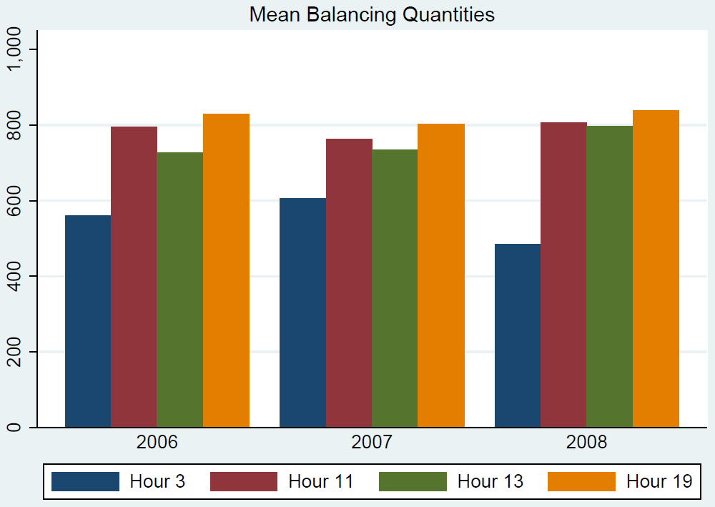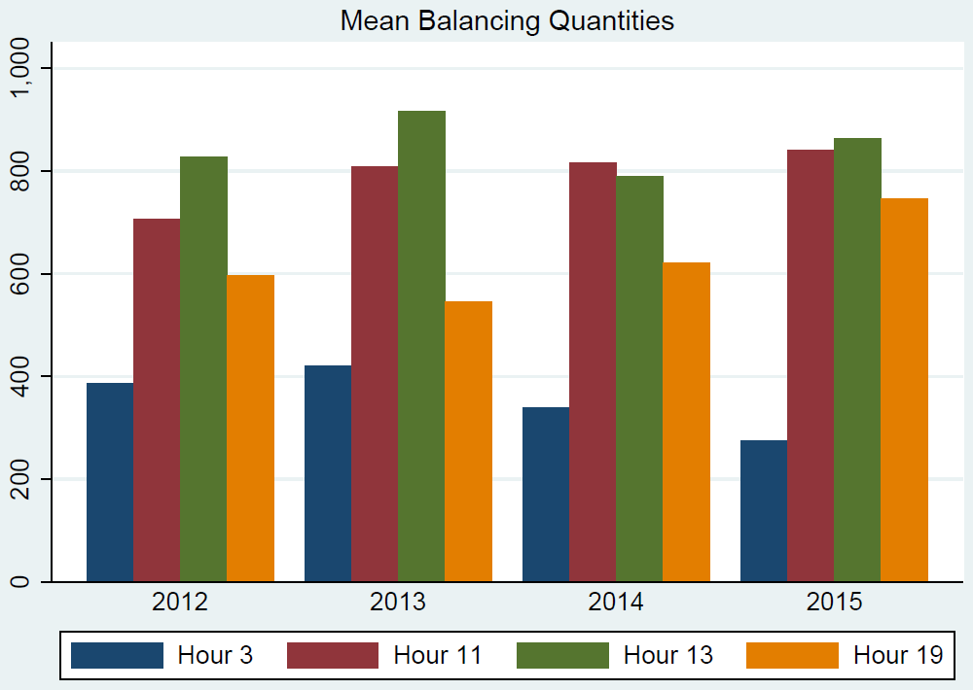
Finally, the quantification of balancing costs is reported in the Table below and obtained as all-sample mean balancing prices times all-sample mean quantities. Accounting for the fact that hydro, wind and solar PV increased in the second sample, with hydro being at highest values at hour 19 and hours 11 and 13 being strongly affected by the other two RES sources, we still confirm a reduction of balancing prices and quantities in the second sample, whereas the increasing need for regulation at hours 11 and 13 is still compensated by reduced balancing prices which consequently produced a reduction of balancing costs. Similar conclusion applies also for hour 3, where we assisted to an increase of the balancing price, compensated however by a reduced quantity. We also analyse the determinants of the spread between day-ahead and balancing prices, finding that fuels have not influence on the spread itself.
 | 2006-2008 |  |  | 2013-2015
 | price | quantity | costs | price | quantity | costs
Hour 3 | 91.37 | 551 | 50308.97 | 104.38 | 346 | 36066.55
Hour 11 | 120.74 | 788 | 95099.80 | 108.81 | 822 | 89425.08
Hour 13 | 122.23 | 754 | 92117.93 | 105.34 | 856 | 90187.42
Hour 19 | 123.95 | 824 | 102131.27 | 110.35 | 638 | 70373.62

Conclusions
For the first time we provide empirical evidence that the increasing RES penetration is lowering the traditional relationship between day-ahead electricity and fuels (oil, coal and gas) prices in Italy. In addition, our analysis provides important preliminary insights about the economic effect of RES on a reduction of balancing costs.

Clò and D’Amato, (2015), “The dark side of the sun: How solar power production affects the market value of solar and gas sources”, Energy Economics, 49, 523-530
As suggested by the preliminary inspection of the Italian intra-daily profiles of load and RES-E; for details see Gianfreda, Parisio and Pelagatti, (2016), “The impact of RES in the Italian Day-Ahead and Balancing Markets”, forthcoming on The Energy Journal. DOI: http://dx.doi.org/10.5547/01956574.37.SI2.agia

