The role of Saudi Arabia, in the oil market during the period of declining prices.

Nourah AlYousef
Associate professor of economics.
King Saud University.
nayousef@ksu.edu.sa
Key words: Oil, Saudi Arabia, low prices,
Introduction
In November 2014, the Organization of the Petroleum Exporting Countries (OPEC), led by Saudi Arabia, initiated an economic refused to cut oil production like it usually does when oil prices drop. In fact, OPEC actually increased oil production in November, which drove oil prices down to nearly $50/bbl, the price at which many shale producers can’t even break-even. Moreover, in November 2015, OPEC followed the same policy and Saudi Arabia again declined to cut oil production despite the world being oversupplied with oil, prices declined to $ 36/bbl, and expected to drop to level of $20/B or less. OPEC policy in general and Saudi Arabia in particular were explained by different reason:
- Saudi Arabia abandoned the goal of moderating the oil price to la level that does not hurt both the oil producing countries and the consuming countries and keep the level that encouraged oil investment.
- Some oil analyst explained it as an attempt to drive some U.S. shale oil producers bankrupt and stem the flow of North American shale oil onto the global market. From a production standpoint, it was considered as oil war depths conventional oil against unconventional.
- The decline has nothing to do with Saudi policy but has several factors such as the appreciation of the dollar, the increase of oil stock in consuming countries in addition to excess supply resulting from the shale oil revelation in the USA.
- The decline is a result of Share market war between OPEC and non-OPEC producer such as Russia.
- Saudi Arabia has continued to keep pumping at high levels one reason it hopes that lower oil prices will stimulate Asian demand, lead to growth in world economy, and make the world relying more in oil as vital energy source.

This study is concerned with the role of Saudi Arabia in the oil market during the period of declining of oil prices. Did Saudi Arabia continue to play a crucial role in the global oil market? Being a leading producer in Organization of Petroleum Exporting Countries (OPEC), did the Kingdom have all the means and resources to cushion any adverse impact on the declining global oil prices?.

According to Mabro(2000), Stevense(1995), AlYousef(1998) The Saudi energy policy in the past, was based on two principles: Maintaining moderate international oil prices to ensure the long-term use of crude as a major energy source and having sufficient spare capacity to stabilize oil markets in the short term. Being a long-term swing producer in the world oil market, It did not want volatility. During the period of high prices between June, 2003- Sep. 2008, Saudi Arabia raised oil production in order to moderate the prices, however, the jump in oil demand caused by the high growth of China and India economy, hardly showed any effect of Saudi policy. However, Saudi Arabia lower its production in 2009 to prevent the effect of the world financial crises from lowering the price of oil further, and the prices regain its value by 2010 to reach average of $ 79/B, also, in 2011 and with geopolitical reason the cut of Libyan crude production, offset by increase in Saudi Oil production to maintain oil prices at the level of $94/B
According to a statement of oil policy minister in Saudi Arabia: “Kingdom realizes that in the long-term, high prices and extreme volatility in the crude markets could be harmful to both consumers and producers. Low oil prices will lead to decline in investment and have a damaging effect in oil producer’s economy. Maintaining sufficient spare capacity has remained an integral part of Saudi oil policy. It has been the tool Saudi planners have used to soothe the sentiments of the markets in times of need. This spare capacity has been used many times in the past to overcome sudden supply disruptions. If Saudi Arabia did not act as it did then, oil prices could easily have hit the roof to say the least.”

The Kingdom completed a massive crude capacity expansion project in 2009 to boost output capacity to 12.5 million barrels per day (bpd). OPEC’s leading producer and exporter has around 4.5 million bpd of spare capacity, with production at around eight million bpd. That is well above the 1.5 to two million bpd the Kingdom sees as a safeguard against any surprise outage in global oil output. The Kingdom is also investing billions of dollars in refineries at home and abroad. Saudi Arabia economic plan indicate that it will continue investing in its oil sector to help stabilize crude prices at a level acceptable to both consuming and producing countries, Finance Minister of Saudi Arabia said in 2008“The Kingdom is continuing with its big efforts to achieve stability in the international oil market,”.
“This is through large investments to increase production and refining capacity to maintain balanced and acceptable prices for both producers and consumers.”
The Saudi government says prices should ensure fair returns for the producers, and be conducive to required investments in the sector. At the same time should not be high enough to lead the global economy into depression. Moderation has remained the key to Saudi oil and energy policy for many decades now.
Stabilizing role of the oil prices is a peculiar in more than one sense in a volatile crude markets. Which, are impacted by factors other than mere demand-supply fundamentals; Geopolitics, speculation, sentiments and others influence them in a big way and this makes the task of stabilizing these markets even more difficult.
Saudi Budget in 2015, with a SR326 billion deficit in nominal terms, based on revenues of SR514 billion and expenditures of SR840 billion. The deficit will continue to be financed using a combination of Saudi Arabian Monetary Agency’s (SAMA) huge stock of net foreign assets, and domestic debt, with Brent prices averaging $53.92. Saudi GDP and national budgets depend significantly on the revenues from oil exports. As a result, the revenue shortfalls incentivize the kingdom to produce as much oil as possible to mitigate the shortfall. The Saudis have increased oil production, raising up output from 9.6 million barrels per day, in the fourth quarter of 2014 to 10.5 million barrels per day in June 2015. According to Paul Stevense(2015) “Saudi Arabia likely to be adamant that it will not bear the burden alone; between 1980 and 1985-6, its production slumped from 10m b/d to below 2.5m b/d, yet prices continued to tumble. That lesson has never been forgotten.” Fattouh (2015) “co-ordinating an output cut even within OPEC is not easy: when prices are falling, the most cash-strapped countries have a big incentive to cheat, until prices become so low that the extra pain of halting production is worth the gain. Though Saudi Arabia’s public spending has tripled in the past decade, needing $100 oil to balance the budget, it has foreign assets to sell and a debt ratio of just 1.6% of GDP. That gives it the leeway to avoid making a rushed decision.” All these factors influence Saudi Arabia decision to cut oil production.

However, between November, 2014- up to January, 2016 Saudi Arabia has continued to keep producing at high levels with oil markets effected by slow economic growth and excess of supply.(U.S. Energy Information Administration).
Fig. 1 The increase of OPEC and Non-OPEC production from 2011- to Sept. 2015 MB/D

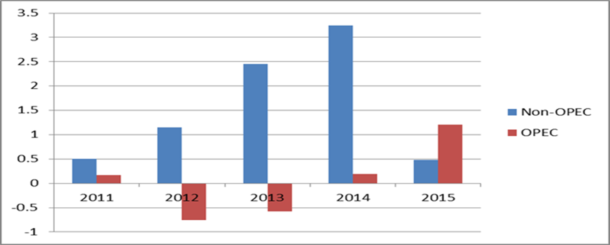

Methodology:
This paper will use monthly data from 1/2010 to 5/2016 and will expand the model to include indicators USA supply and Dollar exchange value. Saudi Arabia production Capacity utilization and OECD crude oil stocks. Most of the variables are expressed in natural logarithms in order to estimate their elasticity. So the equation will be in which Price is the real WTI (2005 US$). The variables will be expressed as follow:Days is days of forward consumption of OECD crude oil stocks, which is calculated by dividing OECD stocks of crude oil by OECD demand for crude oil. Saudi Arabia capacity utilization, which is calculated by dividing Saudi production by Saudi capacity, multiplying this quotient by Saudi’s share of global oil production, USA supply, and dollar is the trade weighted us dollar index for major currencies

4.1. ARDL bounds testing of cointegration
An autoregressive distributed lag (ARDL) approach to cointegration or an ARDL bound testing approach (referred to here as ARDL model) developed by Pesaran et al. (2001) is used to examine the effect of Days is days of forward consumption of OECD crude oil stocks. Production capacity utilization by OPEC, NOPEC is Non-OPEC supply and the world real GDP on world oil price. The main objective of this study is to analyse dynamic relationships between oil prices and its main determinants. In Eq. (2), it is important to include the short-run dynamics into our estimation procedure. This can be done by identifying Eq. (2) in an error-correction modelling format. When using quarterly data, M. Pesaran and Y. Shin recommend choosing a maximum of four lags and, proceeding with analysis, ARDL lags will be selected that minimize the SBC. Pesaran et al (2001) tabulated the critical values of the F-statistics in this. The null hypothesis of no cointegration is rejected when the computed F-statistic is higher than the UCB. The long-run relationship among variables can be estimated after the selection of the ARDL model by Schawrtz–Bayesian criteria (SBC) or Akaike's information criteria (AIC). Once a long-run relationship has been established, error correction model (ECM) can be estimated. Where the coefficient of the error correction term indicates the speed of the adjustment and shows how quickly the variables return to the long-run equilibrium and it should have a statistically significant coefficient with a negative sign. In order to check the suitability of the model some diagnostic test such as Lagrange multiplier test of residual serial correlation, Ramsey's RESET test to test the functional form, normality based on a test of skewness and kurtosis of residuals and heteroscedasticity based on the regression of squared residuals on squared fitted are employed. Furthermore, following Pesaran et al (2001) Cumulative sum (CUSUM) and cumulative sum of squares (CUSUMSQ) are conducted to test the stability of long and short-run estimates

References
Akram, Q. F. 2009. “Commodity prices, interest rates and the dollar.” Energy Economics 31: 838–851.
Al-Yousef, N.A.,(1998) "Saudi Arabia. Oil policy 1976-1996" PhD thesis .University of Surry , Guildford U.K.
Bu, H.(2014) Effect of inventory announcements on crude oil price volatility Energy Economics. Volume 46, Nov. 2014, PP 485–494
Deloitte(2015) “Considerations and Implications for the Oil and Gas Industry” http://www2.deloitte.com/content/dam/Deloitte/us/Documents/energy-resources/us-oil-prices-in-crisis-considerations-and-implications-for-the-oil-and-gas-industry-02042015.pdf
Hamilton, J. (2008) Understanding Crude Oil Prices Working Paper 14492 National Bureau of Economic Research.
http://www.idra.it/garnetpapers/C15U_Triulzi_R_L_DEcclesia_C_Bencivenga.pdf
Mabro, R. (2000) “Oil Markets and Prices” Oxford Institute for Energy Studies, Oxford University, Oxford. UK.
International Energy Agency(IEA) Paris, various reports
International Energy Agency(IEA)Paris “IEA World Energy Outlook special report on Unconventional gas “Golden Rules for a Golden Age Gas”
Kaufmann RK, Ullman B (2009) . Oil prices, speculation and fundamentals: interpreting causal relationship among spot and futures prices. Energy Economics. 31: 550-558
Kaufmann, R.K 2011 The role of market fundamentals and speculation in recent price changes for crude oil Energy Policy, 39 pp. 105–115
Stevense, P (2015)” It will take much cheaper oil for Saudi Arabia to take action”

