Overview

Technology implications for an integrated European Bioeconomy

[Schipfer F., Energy Economics Group, +43 (0) 1 58801 370363, schipfer@eeg.tuwien.ac.at]
[Kranzl L., Energy Economics Group, +43 (0) 1 58801 370351, kranzl@eeg.tuwien.ac.at]
[Haas R., Energy Economics Group, +43 (0) 1 58801 370352, haas@eeg.tuwien.ac.]

The European Union plans to shift parts of its economy towards a biobased system commonly referred to as a Bioeconomy in order to reduce carbon emissions and dependencies on fossil fuel imports. According to these plans, next to food and feed a considerable and growing amount of biomass will be dedicated for energy and material purposes. Production, consumption and supply patterns of biogenic resource are about to change driven by environmental conditions such as climate change, political and social decisions and trends but also technological development and innovation.

The purpose of this work is to discuss if and how certain conversion technologies can contribute to broaden the application of biomass substituting fossil fuels. Considered technologies include pelletisation, torrefaction, pyrolysis and gasification with a demand side focus on energy, novel biomaterials and respective trade studies.

Methods and Results
Based on forecasts of fossil based chemicals production in the EU28, substitution scenarios for biobased chemicals and respective biomass demands are generated highlighting strong growth potentials for biodegradable and durable biobased polymers, biobased bitumen for asphalt production, lubricants and solvents while biobased surfactants are expected to already dominate the market. Depending on technological learning and the commercialisation of cellulose based biorefineries demand for cellulose-, sugar-, starch- and oil feedstock for advanced biobased materials could compete against bioenergy and food purposes especially in Italy, the Netherlands, Belgium and Germany until 2050.
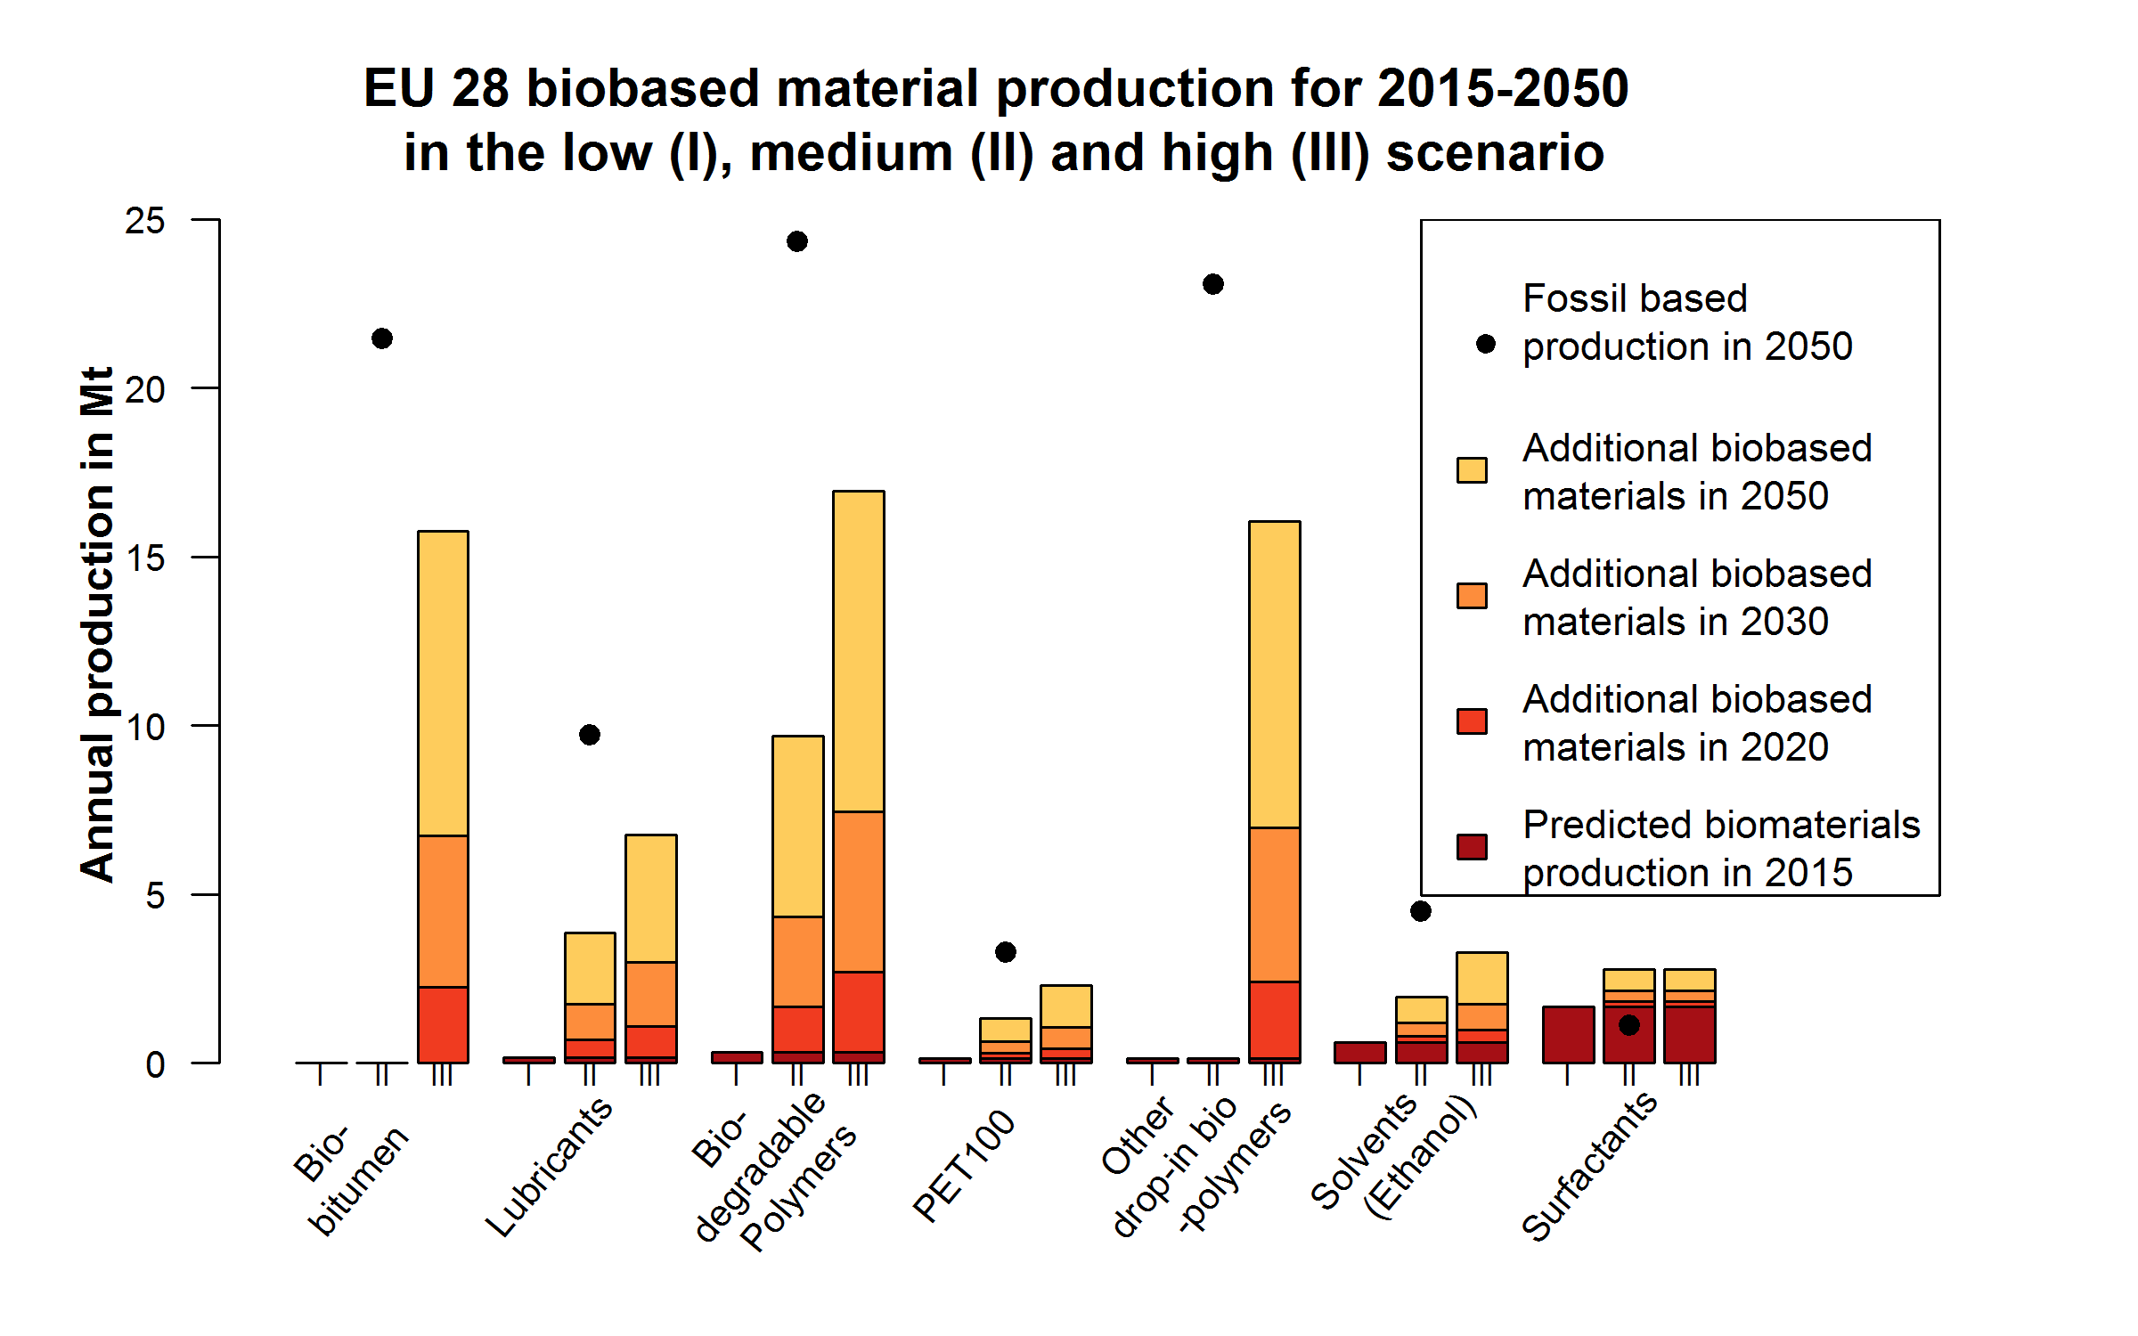
Figure 1: Projected advanced biomaterials production in 2015. For the years 2020, 2030 and 2050 the figure shows the advanced biomaterials scenarios for a stagnation, reference and full transition scenario denoted with I, II and III respectively in the x-axis. In contrast the expected fossil based material productions in 2050 are illustrated with black dots and serve as substitution bench marks for the scenarios in this work.

Therefore biomass trade is expected to increase drastically, not only to cover unmet demand but also to stabilise prices. The generic biomass-to-end-use chain assessment finds that pre-treatment technologies such as torrefaction may lead to a reduction of overall costs and emissions throughout the entire supply chain. However, this depends on some sensitive parameters: Pre-treatment factory sizes are crucial but connected to raw material supply distances which can vary due to different feedstock yield, -availability and accessibility combinations and optimised logistic networks are crucial to minimize additional costs and emissions even though energy content of the commodity is optimised thus better avoiding dead weight.
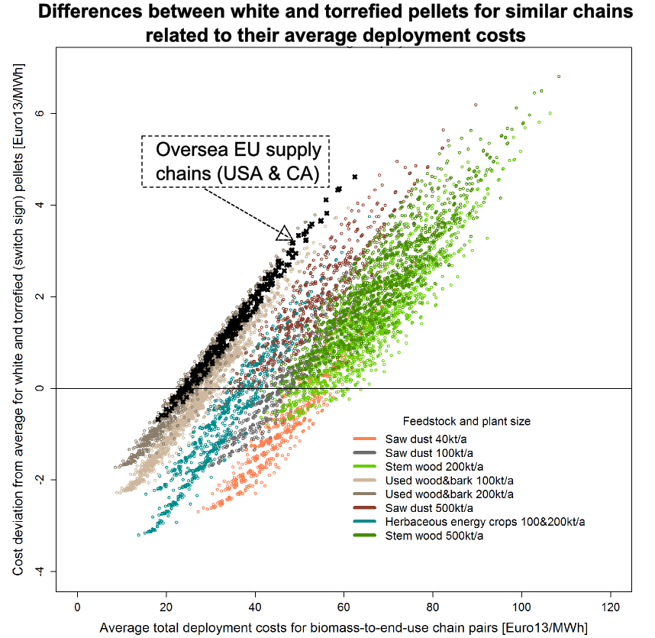
Figure 2: A set of simulated biomass-to-end-use chains. The X-axis indicates deployment costs averaged for comparable biomass-to-end-use chains, one based on torrefied and one on traditional wood pellets. The Y-axis shows the deviation from this averaged to be added to obtain the respective traditional pellet deployment costs or subtracted to obtain the respective torrefied pellet costs. Wood pellet plant sizes and feedstocks are explained in the legend.

However, the commoditisation of processed biomass optimised for trading purposes faces additional challenges as discussed by means of an econometric analysis of the emergence of a residential EU wood pellet market. While imports from third parties outside the Eurozone are dependent on favourable exchange rates intra-European trade does not instantly lead to full market integration between the MS partly due to logistical and information limitations.

Conclusions
Conclusively technological development is expected to not only help to substitute fossil based energy and materials but will also help to overcome challenges regarding the supply of biomass and the production of suitable intermediates. However emission and costs can only be saved if technology implementation is conducted using best available systems knowledge and accompanied with the development of transparent markets and products and a dynamic standardisation and material accounting process.

References
F. Schipfer,L. Kranzl,D. Leclere,S. Leduc,N. Forsell,H. Valin; Advanced biomaterials scenarios for the EU28 up to 2050 and their respective biomass demand. Submitted in Biomass and Bioenergy
F.Schipfer,K.Bienert,L.Kranzl,S.Majer,E.Nebel (2015); Deployment scenarios and socio-economic assessment of torrefied biomass chains. Part 2: Results ,Report of FP7 SECTOR-Project. https://sector-project.eu/fileadmin/downloads/deliverables/SECTOR_D9.5_final.pdf

F.Schipfer,L.Kranzl (2015); Country Report 2014 Austria; Sustainable International Bioenergy TradeIEA Bioenergy Task 40http://www.bioenergytrade.org/downloads/iea-task-40-country-report-2014-austria.pdf

