Special reference: “socio-economic impacts of RE use”
Social impacts of renewables in Germany – size, history and alleviation

Dr. Ulrike Lehr, Institute for Economic Structures Research (GWS), +49-541-40933280, lehr@gws-os.com
Barbara Breitschopf Fraunhofer ISI, Competence Center Energy Policy and Energy Markets, Fraunhofer Institute for Systems and Innovation Research ISI, Germany, 49 (0)721 6809 356
Dr. Jochen Diekmann, Deputy Head of Department. Department: Energy, Transport, Environment, German Economic Institute (DIW).

Overview
The support of renewable energy in electricity generation has been subject to much debate. Fixed and guaranteed prices have turned out as the instrument of choice in 23 EU member states and in more than 100 countries globally. The details of the burden sharing process of additional costs from feed-in tariffs differ tremendously by country.
Germany has taken early action in the support of renewables. Additional costs from guearanteed prices meanwhile amount to 18.7 billion Euro and have nearly doubled since 2010 (see below). This amount is paid by end-consumers of electricity, by means of the so-called renewable-energy-law surcharge. In 2015 this surcharge amounted to 6.170 ct/kWh and the calculated surcharge for 2016 has been projected in October 2015 to be 6.354 ct/kWh. The level of the surcharge is influenced by several factors from attainable prices on the electricity exchange to the exemption rules for certain electricity consumers. Final demand of energy intensive industry is exempt or pays a lower surcharge, not to distort international competitiveness. This mechanism, however, increases the burden on those consumers, which are not exempt. Total additional costs are also determined by the difference between the fixed tariff for renewables and the prices they can fetch on the electricity market. A typical situation is the high input of renewables and a low price at the stock market leading to a large cost difference.
Like other taxes or surcharges, the RE surcharge is regressive, too. For some household higher lectricty prices are more than a mere nuisance; they decrease household income by a significant amount. Low income households often own less efficient appliances, and have few possibilities to react to rising electricity prices.
The paper brings together several strands of results based on research implemented within the ongoing project “ImpRES – Impact of Renewable Energy Sources in Germany”, supported by the Federal Ministry for Economic Affairs and Energy in Germany. The contents of the paper are the sole responsibility of its authors and do not necessarily reflect the views of the German Ministry. The paper explains the development of additional costs in RE electricity generation as part of the annual monitoring process, it shows the distribution effects of the additional costs, with a particular focus on low income households and it reflects alternative support mechanisms and their respective distribution effects.

Methods
The paper draws from a variety of methods. The data on the development of additional costs stem from public data and own data analysis. The distribution effects are the result of model based simulation results obtained with the energy-economiy-econometric time series based model PANTA RHEI. PANTA RHEI is an extended version of macroeconometric simulation and forecasting model INFORGE, designed for analysing questions in the environmental economics field. The name, a quotation from the Greek philosopher Heraclites, means “everything flows” and sums up our approach perfectly. It models long-term structural change in economic development and in environmental-economic interdependencies. In addition to comprehensive economic modelling with our core INFORGE model, it also models energy consumption, air pollution, transport and land use and housing to a high level of detail (GWS 2015). The analysis of alternative choices to alleviate the distribution effects is based on desk research.

Results
The additional costs amounted to 18.7 billion Euro in 2014 (Figure 1, left axis). The surcharge exhibits a different growth profile compared to the increase of additional costs. This is due to several reasons. Firstly, the level of the surcharge also depends on the amount of electricity exempted from it, because this changes the denominator of the ratio from additional costs and total consumption.
Figure 1: Additional costs of electricity and RE surcharge
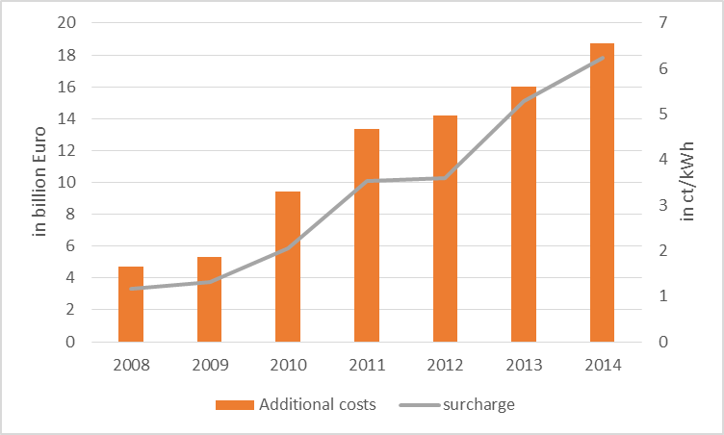
Source: Monitoring Report 2015

Secondly, the surcharge is based on an annual forecast, which projects the RE increase and the development of demand. Progbnosis errors then are compensated in the consecutive period. (Breitschopf et al. 2015)
Households bare are large share of the additional costs. On average, low income households are overproportionately affected, they spend less on all other consumption good due to their increase in electricity bills. The electricity bill takes 4.5% of all expenditures for households, where the household head is unemployed. Very large households of five people or more spend 3.2% of their total expenditure or 2.3% of their income on electricity. Compared to governmental employees, with 1.7% of their income, this is more than one third more (Lehr, Drosdowski 2015).
What can be done to alleviate these effects? The paper summarizes the findings of Diekmann, Breitschopf and Lehr (2015), who analyse alternative financing schemes for renewables as well as different burden sharing schemes. They discuss changes in finance (reduction of the electricity tax, finance additional costs from public budget); changes in the burden sharing or the choice of supported technologies towards less expensive technologies, support of low income households with transfers or provision of more efficient appliances.

Conclusions
All in all the discussion above shows no simple silver bullet for reducing distributional impacts of the EEG surcharge. It is important to note that the average burden of households is relatively low with a share of 0.6% of total consumer spending. In this respect, for households with middle incomes no significant problem of distribution occurs, despite the regressive effect. However, for vulnerable households, the increase in electricity prices, however, can lead to significant stresses, unless they are offset by the adjustment of social services.
Nevertheless, shifting the EEG costs to a general tax funding does not help. Even fund models promise no convincing solution. In addition to keeping the overall costs low, the special rules for energy-intensive companies should continue to be critically examined in order to limit the overall burden of non-privileged electricity consumers. In addition, attention should be directed specifically to the financial burden of low-income households in the discussion of distributional effects. On the part of social policy it must be ensured in particular that the benefits meet the current requirements.

References
Lehr, U. & Drosdowski, T. (2015): Soziale Verteilungswirkungen der EEG-Umlage unter Berücksichtigung von Einkommensklassen. GWS Discussion Paper 15/1, Osnabrück.
Diekmann, J., Breitschopf, B. & Lehr, U. (2015): Politische Optionen zur Verminderung von Verteilungswirkungen der EEG-Umlage. GWS Discussion Paper 15/18, Osnabrück.
Monitoring Report 2015, Breitschopf, B; Klobasa, M; Sievers, L; Steinbach, J; Sensfuß, F; Diekmann, J; Lehr, U, Horst, J. (2015): Monitoring der Kosten- und Nutzenwirkungen des Ausbaus erneuerbarer Energien im Jahr 2014

