OptimISING energy storage to balance high levels of intermittent renewable generation

Paul E. Dodds, University College London, +44 203 108 9071, p.dodds@ucl.ac.uk

Overview
A transition is underway in Europe from high-carbon baseload and flexible generation to low-carbon intermittent renewable generation. Until now, electricity generation has been varied to match constantly-evolving demands, with precursors to electricity (e.g. coal, gas) providing the energy storage required to ensure system stability. As the proportion of renewable generation increases, there will be more frequent and larger imbalances between electricity supply and demand. High renewable penetrations in Germany and Spain, and to a lesser extent Scotland, are already causing frequent system imbalances. These would be exacerbated by concomitent increases in nuclear power capacity. Numerous energy storage technologies for storing electricity are under development to address these issues.

The value of grid-scale storage to the electricity system has been assessed for some scenarios; for extreme cases, with only renewable and nuclear generation, the value is potentially substantial (Strbac et al. 2012). Yet the optimal approaches to integrating energy storage across the whole energy system are not well understood, particularly as alternative energy system scenarios in which storage options are more integrated into the energy system (e.g. producing hydrogen for transport or heat for buildings) are generally not considered in long-term analyses.

The aim of this study is to assess the values of different types of energy storage when they are integrated into the whole energy system. These values will vary according to the evolution of the energy system in different scenarios. It represents the first self-consistent, system-wide valuation of energy storage for the UK.

Methods
We use a new energy system model, UKTM, to examine the role of energy storage. UKTM is built on the TIMES framework, which is a widely-applied bottom-up, dynamic, partial equilibrium economic optimisation model (Loulou et al., 2004). UKTM portrays the entire UK energy system from imports and domestic production of fuel resources, through fuel processing and supply, explicit representation of infrastructures, conversion of fuels to secondary energy carriers (including electricity, heat and hydrogen), end-use technologies and energy service demands of the entire economy. It includes a representation of and mitigation options for all greenhouse gas emissions, both internal and external to the energy system. The model explores the potential of a wide range of energy storage technologies, working on both intraday and interseasonal timescales, including mechanical, gravitational, electrochemical, thermal and chemical technologies. As well as grid-scale storage technologies (electrochemical, CAES, etc.), other wider system technologies in the model include power-to-gas, heat storage at district and building scales, electric vehicle battery storage and hydrogen storage for transport and industrial consumption. The model is calibrated using UK energy system (DECC 2011) and emissions data (DEFRA 2012) for the year 2010.

We implement UK climate policy by applying a cumulative CO₂ emissions constraint in the period to 2050 and by assuming an 80% reduction relative to 1990 emissions is maintained afterwards. We use the TIMES elastic demand variant in this study, in which welfare (defined as the sum of producer and consumer surplus) is maximised, and hence demand and supply reach equilibrium. Behavioural change in response to increasing energy costs is simulated endogenously using reductions in the energy service demands.

Although UKTM is well placed to compare energy storage integration across the energy system, its temporal resolution is much lower than that of electricity dispatch models, means that the need for storage and the impact of renewable intermittency is likely to be underestimated. While dispatch models generally work at timescales of 30 minutes to 1 hour, UKTM has only a single representative day in each season that is split into four time periods (day; evening peak; late evening; night). We overcome this shortfall by soft-linking UKTM to a simple dispatch model that simulates electricity supply and demand matching at 1-hour periods over a representative year. Renewable generation in this model is based on a year of climate reanalysis wind speeds from around the UK, to ensure that the intermittency is captured appropriately by the data. The generation portfolio from UKTM is analysed in this dispatch model and UKTM is then modified so that excess generation is stored by energy storage technologies or lost, while the electricity system is reinforced if there are any periods of insufficient generation.

Results
The relative penetrations of energy storage in 2050 for the low-carbon scenario are shown in Figure 1. Grid-scale storage has only a minor role in system balancing, despite being the focus of most energy storage studies in the UK. Power-to-gas has a larger role, but thermal storage is the most important group of energy storage technologies, with excess electricity converted to heat and used to meet heat demands.
The impact of soft-linking the energy system and dispatch models can be seen by comparing the two graphs. The overall trends are unchanged, but grid-scale storage has a greater role when the imbalances between demand and supply are more accurately taken into account.

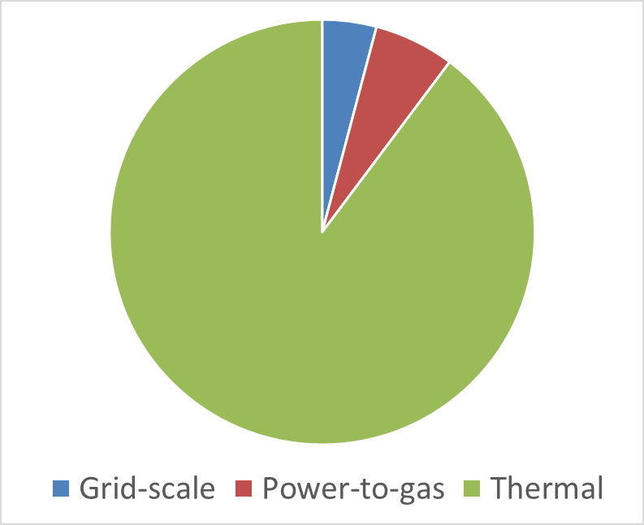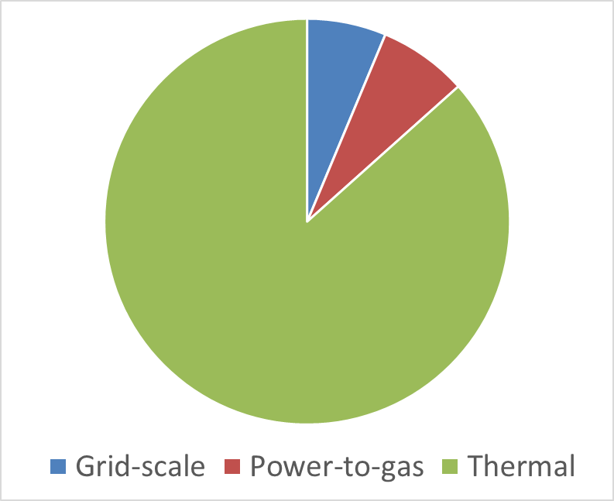
Figure 1. Energy storage in 2050 in a low-carbon UK scenario with electricity generation dominated by renewables and nuclear. The graph on the left is the initial output of UKTM. The graph on the right shows the output of UKTM when insights from the dispatch model are incorporated through soft-linking.

Conclusions
Although most energy storage system integration studies have examined only grid-scale storage, this study suggests that thermal storage and power-to-gas could have a greater role in the future. There is a need to consider and overcome the shortcomings of different types of analysis models. Using energy system models avoids a sole focus on the electricity system but at a cost of reduced temporal disaggregation. Soft-linking energy system and dispatch models enables researchers to benefit from the advantages of both model paradigms.

References
DECC. Digest of United Kingdom Energy Statistics 2011. Department of Energy and Climate Change. London, UK; 2011.
DEFRA. National Atmospheric Emissions Inventory. London, UK: Department for Environment, Food and Rural Affairs; 2012.
Strbac G, Aunedi M, Pudjianto D, Djapic P, Teng F, Sturt A, et al. Strategic Assessment of the Role and Value of Energy Storage Systems in the UK Low Carbon Energy Future London, UK: Imperial College London; 2012. Available at: http://www.carbontrust.com/media/129310/energy-storage-systems-role-value-strategic-assessment.pdf.

