Analysis of design options for the German electricity market ensuring security of supply
Dr. Dogan KELES¹, Lea RENZ, Andreas Bublitz¹, Prof. Dr. Wolf FICHTNER¹

Content
Currently there is an intensive discussion in Germany about the early implementation of a capacity mechanism (see Winkler et al., 2013). The reason for that are doubts whether the current Energy-Only-Market (EOM) can provide sufficient investment incentives to ensure a long-term supply adequacy. Due to the increasing feed-in of electricity based on volatile renewable energies, the number of operating hours of conventional power plants is decreasing and thus their revenue situation is becoming worse. However, flexible conventional back-up capacities will be still necessary, especially when peak load times meet few wind and photovoltaic power production. This raises the question whether the marginal cost based energy-only market (EOM) provides enough incentives for investments in new power plant capacity or a capacity market should be introduced as a new market segment for the product secured power.
To provide decision makers with new insights, the market design options that have been identified as relevant for Germany are implemented and analysed applying the agent-based simulation model PowerACE which simulates the German wholesale electricity market.
Methodology
This study analyzes and evaluates those design options which are currently under consideration for Germany as well as those which are already internationally implemented. The evaluation of the selected capacity mechanisms is done by using the agent-based simulation model PowerACE which consists out of the four modules: markets, electricity supply, electricity demand and regulator. The model displays all the power plants in the German electricity market. Essential input parameters are the development of electricity demand, prices of carbon dioxide and fuels, imports and exports of electricity and the expansion of renewable energies. Investments occur in the model on the basis of calculation of profitability of the simulated power plant utilization of predetermined conventional technology options. Decision basis of the investment planning agents are the hourly prices of the spot and forward market simulated in the model and any additional revenues from the capacity mechanism (see Genoese, 2010). An important model extension is the implementation of capacity mechanisms. These are analyzed under various parameter settings on the investment behavior of the agents, the development of generation capacity, electricity prices, carbon dioxide emissions and costs. Furthermore it is possible to examine whether it comes to undersupply of demand in several scenarios or under certain parameterizations.
Selected results
Simulation results for the EOM and for an energy market design with a centralized capacity market based on capacity options are briefly summarized and compared in the following. Figure 1 shows the development of installed power plant capacities in the EOM (left) and in case of an introduction of a centralized capacity market (right). The investment activity in the EOM is strongly influenced by existence of mark-up prices, which can be explained by scarcity on the market from 2023 on. The total EOM-capacity level decreases in the first years of the analysis horizon and stabilizes at about 70GW from 2023 on. This comes along with the nuclear phase out in Germany and with less demand for conventional capacity due to the strong expansion of renewables.
In the simulation with a centralized capacity market, however, the investments are carried out earlier and at a higher level. The level of security of supply is thus significantly higher in the case of a capacity market than in the EOM. Besides, about 10 GW additional natural gas capacities are built, if a capacity market is introduced. This comes along with the need of restructuring of the power sector to more flexibility due to increasing electricity generation from renewable energies.
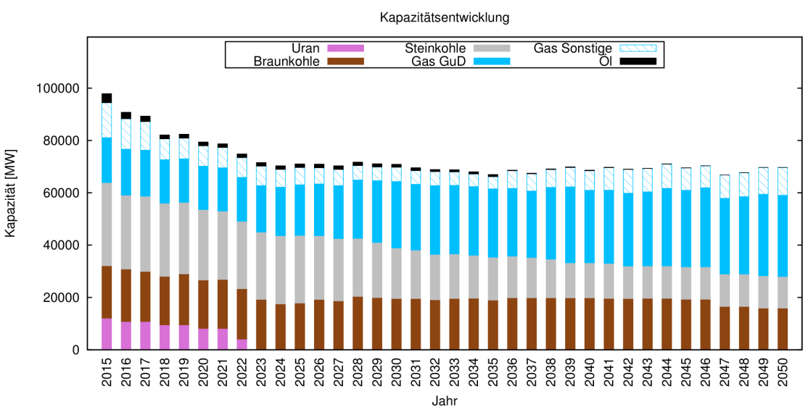
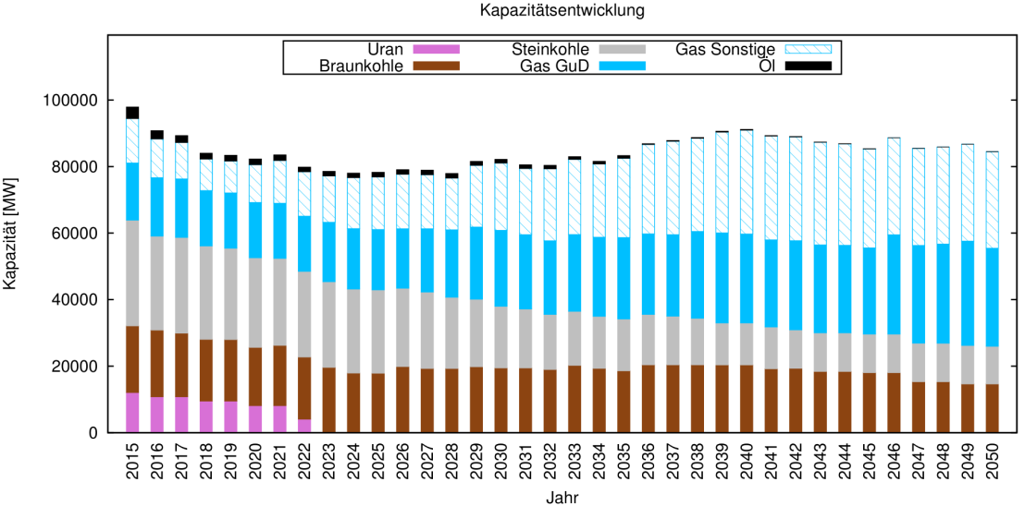
Figure 1: Development of installed conventional power plant capacity in EOM (left)
and with centralized capacity market (right)

Outlook
In this study additional capacity mechanisms, like a centralized capacity market, are implemented in PowerACE, whereby different adequate parameterizations for the mechanism are taken into account. However, other parameterizations should be analyzed in the next step to determine the most efficient mechanism and to deliver an overall contribution to the market design discussion in Germany and other European countries.

References
Genoese, M. (2010): Energiewirtschaftliche Analysen des deutschen Strommarkts mit agentenbasierter Simulation, Fakultät für Wirtschaftswissenschaften,
Karlsruher Institut für Technologie (KIT), Dissertation, Januar 2010
Winkler, J.; Keles, D.; Renz, L.; Sensfuß, F.; Fichtner, W. (2013): Kapazitätsmechansimen oder Weiterentwicklung des Energy-Only-Markts, ew - Magazin für Energiewirtschaft, Heft 10/2013
ewi. 2012. „Untersuchungen zu einem zukunftsfähigen Strommarktdesign“. http://www.ewi.uni-koeln.de/fileadmin/user_upload/Publikationen/Studien/Politik_und_Gesellschaft/2012/EWI_Studie_Strommarktdesign_Endbericht_April_2012.pdf.
VKU. 2013. „Ein zukunftsfähiges Energiemarktdesign für Deutschland“. http://www.vku.de/fileadmin/get/?24025/EMD_Gutachten__Positionspapier_-_layout_-_Internet.pdf

Institute for Industrial Production (IIP), Chair of Energy Economics, Karlsruhe Institute of Technology, Hertzstr. 16, 76187 Karlsruhe, Tel.: +49 721 608-44573, Fax: +49 721 608-44682, lea.renz@kit.edu, www.iip.kit.edu

