Overview

OLD VS NEW THINKING IN DESIGNING FUTURE ELECTRICITY MARKETS

Hans AUER, Reinhard HAAS, Georg ERDMANN
Energy Economics Group, Vienna University of Technology, E-mail: auer@eeg.tuwien.ac.at
*) Technical University fo Berlin, Institut für Energiesysteme
In recent years increasing shares of renewable electricity (RES-E) have changed the electricity markets especially in Western Europe remarkably. Conventional Power stations have difficulties to cover their costs while subsidies stimulate further investments into wind and Photovoltaics (PV). This has lead to a critical situation in which the whole electricity system is at a crucial crossing. On the one hand, the question arises how much subsidies will flow into a sustainable RES-E system. In principle the subsidies may follow the declining costs of wind and PV, but a rent seeking industry has emerged which will hardly survive without ongoing subsidies in spite of the close to cost-effectiveness. On the other hand, “old” fossil and nuclear-based generation technologies also call for state aid under the headline of capacity markets or CO₂ free electricity generation (e.g. for nuclear in England). There are also strong movements from various other stakeholders, e.g. storage operators, aggregators of demand-side measures, supporting a more competitive and more participative electricity system based on larger shares of electricity from RES.
Regarding this mismatsch of interests, the objective of this paper is to analyze and provide insights on the conditions that will bring about a sustainable electricity system with higher shares of RES without escalating political interventions. How can the original idea of competition be reestablished so that “Markets should do their work”?

Method

Our method of approach is based on the following principles:

(i) Crucial is coverage of residual load (= difference between final electricity demand and generation provided by non-flexible electricity generation from variable RES as well as coal and nuclear power plants, see Fig.1); this is modeled on an hourly base over a calendar year based on assumed RES-E generation (ii) Deduction of available conventional and backup capacities including must-run (iii) flexibility on the demand side based on consumer behavior incl. flexibility instrument such as batteries etc.(iv) Hourly electricity prices equal to short-term marginal costs and scarcity rents.

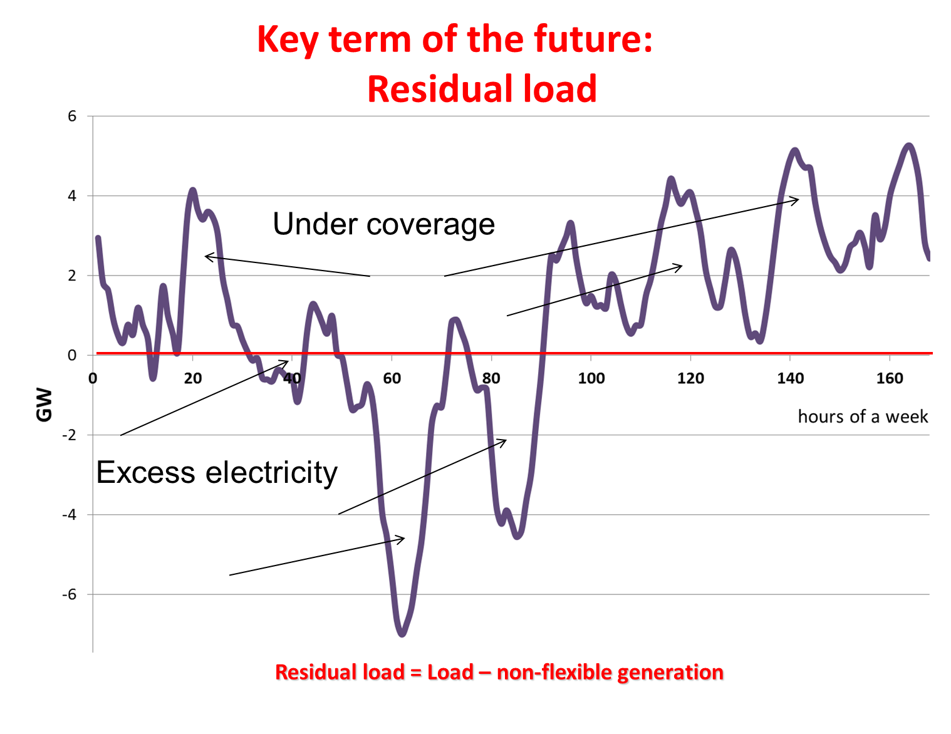 | 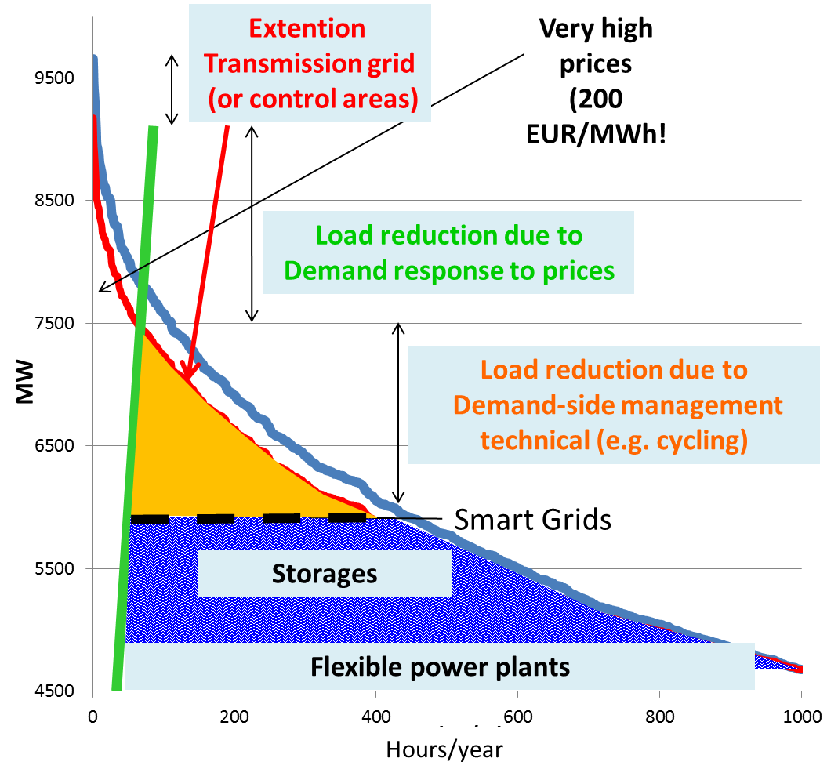
Figure 1. New thinking: The concept of residual load | Figure 2. Options for coping with peak residual load in electricity markets

Results
The major results are:
- To integrate larger shares of RES-E and to enhance competition of core relevance is a pricing system in an EOM where the prices signal scarcity or excess capacities at every point-of-time (quarters of an hour);
- More flexibility in the organization of the market is required: To better integrate RES-E in the market the time intervals in markets should be reduced (more emphasis on intraday markets, shorter trading intervals (from hours to ¼ hours); shorter ahead leading times for market clearing and forecasting of RES-E production);
- Most important to balance variations in residual load is an optimal portfolio of flexibility options which already exists today but is not fully harvested due to low economic incentives. Some of this flexibility options are, see Fig. 2:
- Short-term and long-term storages – batteries, hydro storages;
- Technical demand-side management measures conducted by utilities like cycling, load management)
- Demand response due to price signals mainly from large customers to price changes, time-of-use pricing
- Transmission grid extention leads in principle to flatter load and flatter generation profiles;
- Smart grids: They allow variations in frequency (upwards and downwards regulation) and switch of voltage levels and contribute in this context to a load balancing
- A key role in this new concept will play balancing groups. These are the entities which finally have to balance generation, flexibilities and demand options.

Conclusions
Flexibility options will only be harvested when sufficiently high price signals from the electricity markets trigger these options, when “the exploration principle in the markets work”. Yet this will only be done if the market is not distorted by centralized capacity payments. Hence, a very big danger in this context is the introduction of centralized capacity payments. In our view they would be death of competition, and head back to a strictly planned economy and freeze the old fossil/nuclear system.
The major features of old thinking are:
- Base load is important;
- Focus on centralized capacity payments (Cramton et al): this is the death of all ideas of competition and leads straightforward to a strictly planned economy. Moreover, it freeze the old fossil/nuclear system and its apologetes retain their privilegues and high salaries;
The major features of new thinking are:
- A sustainable electricity system is not a technological winner-picking issue. It is a question of integrating a broad portfolio of technologies and demand response options!
- Very important: correct price signals!!!
- The key: Flexibility! currently no economic incentives but activities started → very promising!
- most important now: exhaust the full potential of the creativity of all market participants especially of the demand-side!

References:
Koch Oliver, Electricity market design, Presentation at IAEE-conference, 18-21 July 2013 Düsseldorf.
Cramton P., Ockenfels A.: Economics and Design of Capacity markets for the power Sector, Zeitschrift für Energiewirtschaft, 36, 2/2012, 113-134.
Erdmann G., Kapazitätsmechanismus für konventionelle und intermittierende Elektrizität. In: Agora: „Brauchen wir einen Kapazitätsmarkt?“, August 2012.

