Overview

What role for renewable energy from North Africa, Western Balkans and Turkey?
Gustav Resch, Energy Economics Group, Vienna University of Technology, +43 1 58801370354, resch@eeg.tuwien.ac.at
André Ortner, Energy Economics Group, Vienna University of Technology, +43 1 58801370367, ortner@eeg.tuwien.ac.at
Gerhard Totschnig, Energy Economics Group, Vienna University of Technology, +43 1 58801370356, totschnig@eeg.tuwien.ac.at
Marijke Welisch, Energy Economics Group, Vienna University of Technology, +43 1 58801370365, welisch@eeg.tuwien.ac.at

Coordinated renewable energy support within the EU as well as with EU neighbouring countries is high on Europe’s political agenda. On January 2011, the EC called for more cooperation to meet the 2020 targets for renewable energy and the EU 2050 roadmap published in March 2011 opened up discussion on how to fully decarbonise Europe’s energy system on the long term keeping in mind that current capacity and infrastructure will be of critical importance for the long term pathways. Cooperation also has a political dimension. Against the background of the political changes in northern Africa, the European Commission has proposed to establish an “EU-South Mediterranean Energy Community”, while other European neighbour regions such as the West Balkans are coordinated within the “Energy Community” and Turkey that is in the process of integrating into the EU.

The “RES directive” 2009/28/EC entered into force in June 2009 already included four cooperation mechanisms available for EU Member States to realize part of their national renewable target abroad and therefore provides the legal basis for the implementation of such international cooperation. In the directive article 9 is dedicated to joint projects between EU member states and third countries. Against this background the key question of this action is to answer to what extend cooperation with EU neighbour countries can help Europe achieve its renewable targets in a more cost-efficient way.

Methods

In order to identify costs and benefits in the EU and in third countries related to several renewable energy deployment scenarios and cooperation cases a quantitative model-based assessment involving the energy policy assessment tool Green-X and the power system model HiREPS has been conducted. Next to the reference case of an EU RES ambition level of 27%, a medium (30%) and high (33%) ambition level – possibly relevant after 2030 – for the whole EU have been modelled. With regard to cooperation among countries the analysed cases comprise

Cooperation only within the EU,

Cooperation within EU including North Africa, Western Balkans and Turkey and

Cooperation among EU, Western Balkans and Turkey, while North Africa exports CSP via HVDC point-to-point links

Results and Conclusions
The results indicate that from an economic perspective RES cooperation between the EU and its neighbour countries is beneficial. Up to 2030 benefits occur independently of the ambition level for renewables within the EU. Figure 1 shows the absolute and relative amounts of differences in the RES export saldo compared to the reference case (no cooperation with neighbours).
The imports on part of the EU are naturally correlated with the overall ambition level and decrease in the case North Africa restrict its exports to renewable energy from CSP. The results also indicate that Turkey’s contribution not only rise with the EU ambition level, but also rise in the case North Africa only exports CSP power, thus serves as a substitute. The Western Balkans contribute in the range of 5 to 10% of the domestic demand, whereas the same characteristic can be observed as for Turkey, meaning that also the Western Balkans partially substitute the lower electricity exports from North Africa.
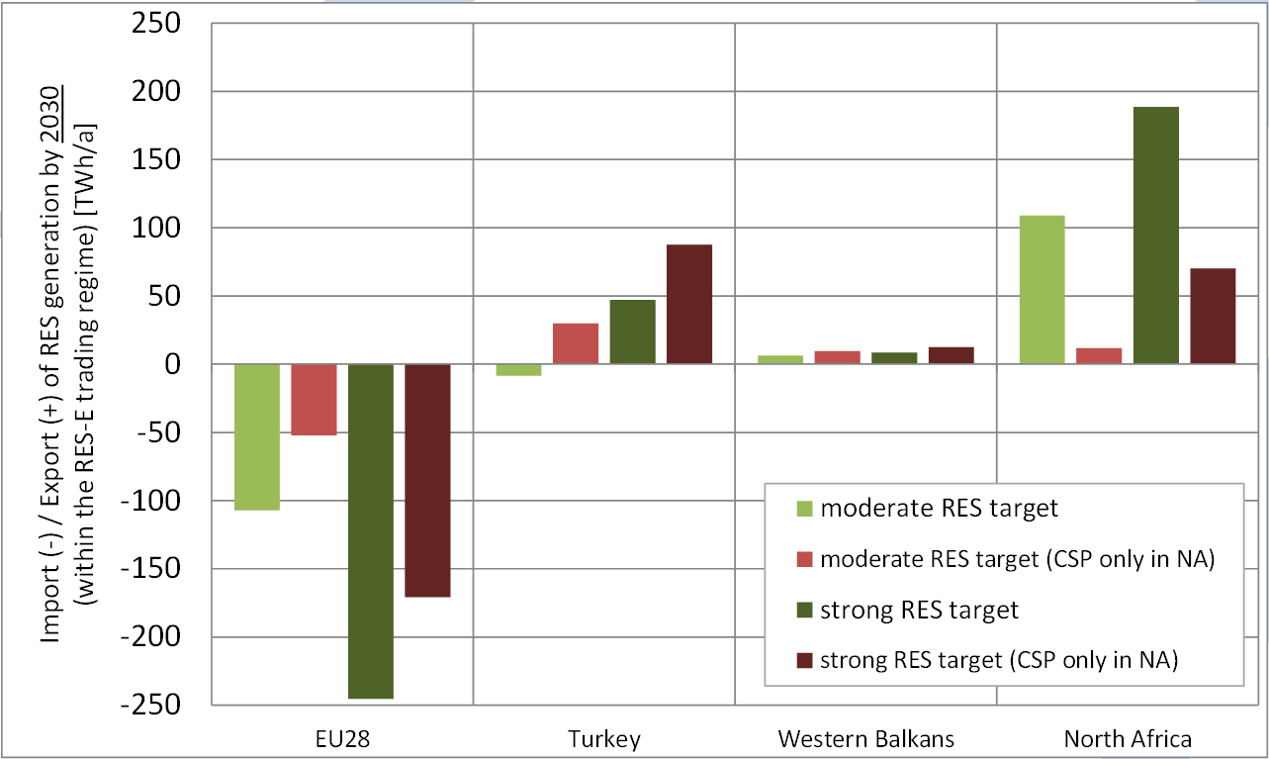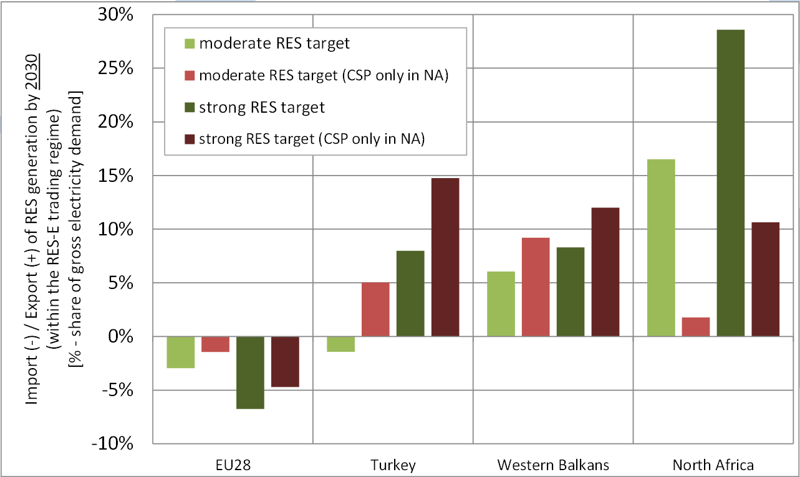
Figure 1: Export saldo of RES generation by 2030 (left: absolute amounts [TWh], right: as share of domestic demand [%])

The exports from North Africa finally show a mirror-imaged pattern to the imports of the EU with a maximum share of 28% of domestic demand in the case of a high EU ambition level.
In Figure 2 the economic benefits in terms of reduced specific costs of renewable support are depicted for the cases of moderate and strong EU renewable energy targets. Not surprisingly the benefits are greater in the case of higher demand on part of the EU and are the greatest in case the EU cooperates with all neighbours and all kinds of available RES-E technologies and range from 5 to 10 EUR/MWh in the moderate case up to 10 to 25 EUR/MWh in the strong cooperation case. Also, it is interesting to see that a strong ambition level not involving EU neighbour countries would disproportionally increase support costs within the EU, whereas a scenario with full cooperation could limit additional costs.

Figure 2: RES premiums / certificate prices for different RES ambitions levels (left: reference case 27%, right: 33%) in EUR/MWh

As article 9 of the directive 2009/28/EC requires the physical import of the amount of renewable electricity to be counted for the renewable target of the EU the analysis of transmission grids is of decisive importance, especially for the background of long lead times for the construction of new lines. Within this task a steady-state transmission grid analysis comprising infrastructure constraints and the effect of several new options for transmission grid expansion (e.g. TYNDP of ENTSO-E, additional point-to-point connections with HVDC links) has been carried out to conclude on the realizable potential contribution of all the mentioned neighbour countries.

References
[1] http://www.better-project.net

