Who takes their foot off the pedal? Heterogeneity in price and income elasticities of gasoline demand and its determinants
Aurélien Saussay, OFCE / CIRED, +33 1 44 18 54 72, aurelien.saussay@sciencespo.fr
Xavier Timbeau, OFCE, +33 1 44 18 54 57, xavier.timbeau@sciencespo.fr

Overview

Gasoline prices in the United States have been characterized by a steeply increasing trend and high volatility over the past decade, ranging from a yearly average of $1.50 a gallon in 2000 to $3.56 in 2013. Simultaneously, U.S. drivers have reduced their consumption of passenger transportation for the first time in the post-war era, from a high of 3.32 trillion passenger-miles travelled in 2007 down to 2.87 trillion in 2013. However this reduction has not been uniform across households. This period provides a new opportunity to investigate the evolution of gasoline demand with respect to price and income, notably to analyze the heterogeneity of household responses faced with increasing fuel prices. This analysis is important in determining the distributional effects of proposed taxation on fossil fuels, notably carbon taxation.

Price and income elasticity of gasoline demand are usually estimated at the aggregate country level. This masks the heterogeneity of elasticities across income levels, and prevents any further analysis of the determinants of this variability. In this paper, we present a model linking the price and income elasticities of gasoline demand with income level, controlling for household demographic characteristics and its choice of vehicle fleet.

The paper is structured as follows: after an introduction, we present a model of household gasoline demand integrating the dynamic relationship between household income, gasoline price, household vehicle choice and household characteristics. We then discuss our use of data from the Panel Study of Income Dynamics (PSID), supplemented with regional and state-level gasoline prices from the U.S. Energy Information Agency. We finally present and discuss our estimated price and income elasticities for gasoline demand, and conclude.

Methods

We specify gasoline demand (in volume) as a log-linear function of gasoline price, income and household characteristics. We then estimate this model in a fixed-effects panel regression, to obtain both aggregate and by-decile long term gasoline price elasticities:

The model is estimated using data from the Panel Study of Income Dynamics (PSID), a longitudinal survey of 5,000 U.S. households tracking socioeconomic characteristics, consumption expenditures and durables ownership, from 1999 to 2009. This data is supplemented with regional and state-level annual gasoline prices from the U.S. EIA.

Results

We find an overall aggregate long term gasoline price elasticity of -0.13 and an aggregate long term income elasticity of 0.12.

Furhter, we find that gasoline demand from poorer households, while still relatively inelastic, is more elastic than for their richer counterparts.
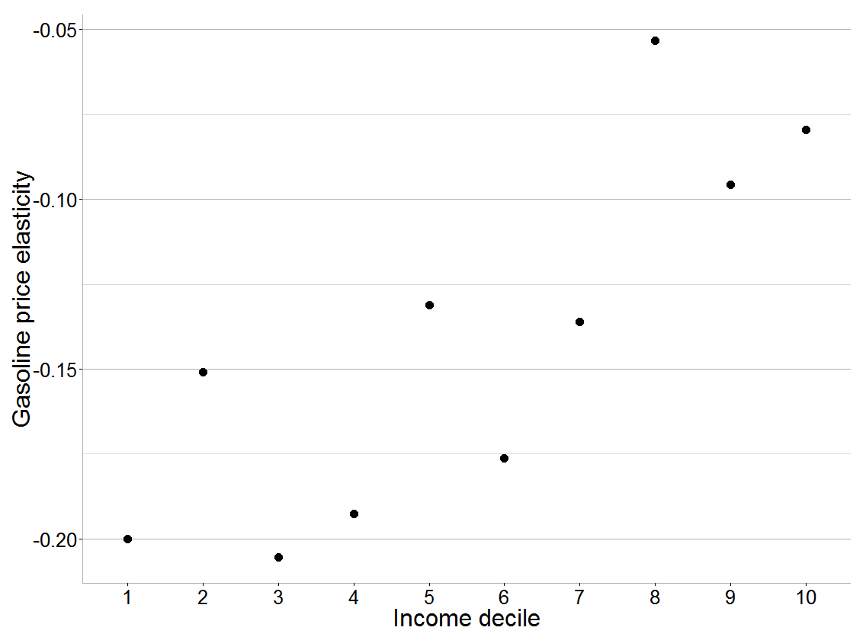

Conclusions

While gasoline demand is relatively inelastic in the long term, the elasticity of gasoline demand to price and income varies with income level. Gasoline demand from poorer households is more elastic – they answer to an increased price signal with a forced reduction in their consumption, while richer household are less price sensitive. This result needs to be considered in the design of compensation schemes for future carbon price proposals.

References
Brons, M., Nijkamp, P., Pels, E., & Rietveld, P. (2008). A meta-analysis of the price elasticity of gasoline demand. A SUR approach. Energy Economics, 30(5), 2105–2122.
Cozad, M., & LaRiviere, J. (2013). Fuel price increases and the timing of changes in household driving decisions. Journal of Environmental Economics and Management, 65(2), 194–207.
Havranek, T., & Kokes, O. (2015). Income elasticity of gasoline demand: A meta-analysis. Energy Economics, 47, 77–86.
Hughes, J. E., Knittel, C. R., & Sperling, D. (2006). Evidence of a Shift in the Short-Run Price Elasticity of Gasoline Demand. SSRN Electronic Journal.
Kayser, H. a. (2000). Gasoline demand and car choice: estimating gasoline demand using household information. Energy Economics, 22(3), 331–348.
Kyriazidou, E., & Kyriazidou, E. (1997). Estimation of a Panel Data Sample Selection Model. Econometrica, 65(6), 1335–1364.
Wadud, Z., Graham, D. J., & Noland, R. B. (2010). Gasoline Demand with Heterogeneity in Household Responses. The Energy Journal, 31(1), 47–74.
West, S. (2004). Distributional effects of alternative vehicle pollution control policies. Journal of Public Economics, (651).
West, S. E., & Williams, R. C. (2004). Estimates from a consumer demand system: Implications for the incidence of environmental taxes. Journal of Environmental Economics and Management, 47, 535–558.

