forecasting and event MAtching of Natural gas price using wavelet decomposition

Junghwan Jin, Hanyang University, Phone +82 2 2220 4469, E-mail: jhjin@hanyang.ac.kr
Jinsoo Kim, Hanyang University, Phone +82 2 2220 2241, E-mail: jinsookim@hanyang.ac.kr

Overview
The Development of unconventional gas, the accident of Fukushima nuclear plant, and so forth made the importance of natural gas has been increased. Additionally, spots and short term trades of natural gas have been increasing(Hartley, 2013) and recently, decoupling of oil and gas price also have been studied. Based on this body of literature, we thought there are needs for analysis of natural gas spot price. In addition, since 2000s, wavelet decomposion is used for preprocessing process in various studies. Wavelet decomposition makes the data separate into approximation and details which is suitable for analyzing main behaviour and volatility of data respectively. Liu et al.(2013) used wavelet decomposition in their study to forecast their data, and they showed better result than not using wavelet decompotion case. We showed the same result in henry hub monthly spot price from 1997 to 2014 october by using ARIMA(Auto-regressive Integrated Moving Average) and ANN(Artificial Neural Network) models which are combined with wavelet decomposition. However, there are few studies used detail components to explain volatility of data. We showed detail components matched well to events influencing price change. This result showed that we could rapidly figure out the time and events which influenced volatility of the data. From these results, we figure out that wavelet decomposition is useful to anlyze time series.

Methods
We used wavelet decomposition, ARIMA, ANN, as mentioned above. Wavelet decomposition is a preprocessing process which decomposes signal into approximation and details of components. Approximation represents main behavior of original signal. And details represent variation of original signal. Therefore, wavelet decomposition is useful to analyze the main movement and volatility at once. According to the Reboredo and Rivera-Castro(2013) the equation of wavelet decomposition is as follows.
 | $$φ_{\text{j,k}}(x)=2^{\text{-j/2}}φ(2^{j}t−k)$$ | (1)
 | $$ψ_{\text{j,k}}(x)=2^{\text{-j/2}}ψ(2^{j}t−k)$$ | (2)
$φ$is called father wavelet, $ψ$is mother wavelet, j is scaling factor and k is translation factor. Using these two wavelets, we can get the approximation and details.
 | $$A_{j,k}(x)=\int{φ_{j,k}y(x)}\text{dx}$$ | (3)
 | $$D_{j,k}(x)=\int{ψ_{j,k}y(x)}\text{dx}$$ | (4)
A of equation 3 is the approximation component, D of equation 4 is detail component. We used a trous wavelet decomposition to handle the boundary problem and applied ARIMA and ANN to these decomposed signals to forecast 3 point(1 quarter) ahead prices. Detail components also used to match events which influenced price change.

Results
First, we applied ARIMA, ANN to decomposed data and original data to compare the forecasting performance. Late 200 months of forecasting results are used to compare the performance of forecasting. From the table 1 showing the forecasting results, we could find that wavelet decomposition made the forecasting performance increased.

Table 1. RMSE of 3 step(1quarter) ahead forecasting results
ARIMA only | ANN only | Wavelet-ARIMA | Wavelet-ANN
1.1292 | 1.7095 | 0.7311 | 0.8846

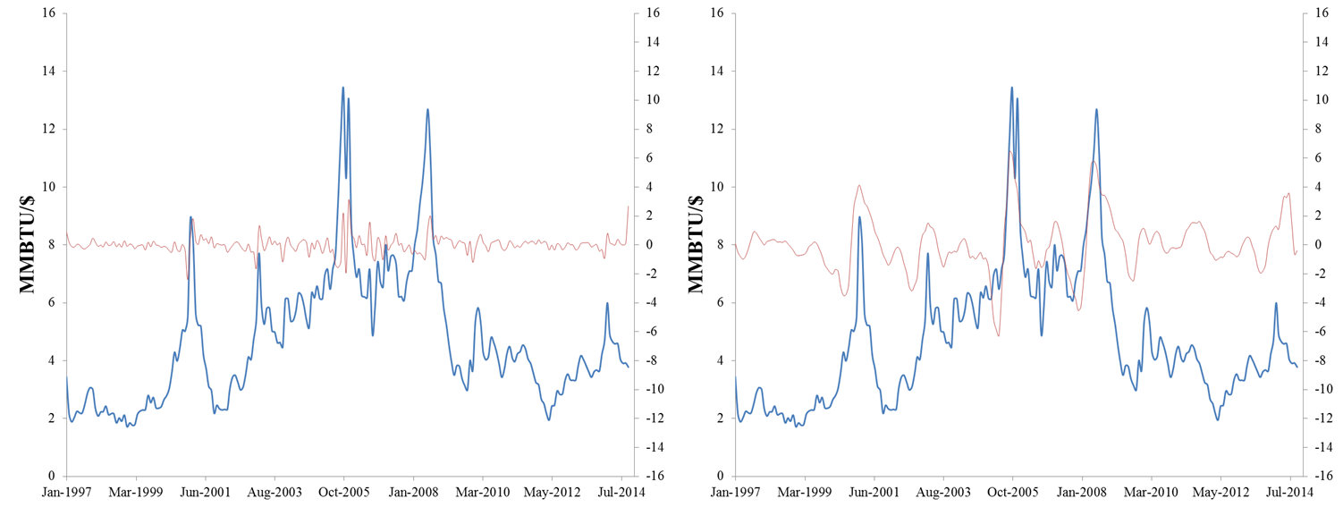
Fig. 1 Detail components matched to original gas price changes

The figure 1 shows original signal matched with detail component once decomposed, three times decomposed. Detail component more decomposed means the longer volatility of the original signal. In other words, detail component once decomposed shows shorter frequent volatility, three times decomposed detail component shows longer volatility. From the magnitude of each detail component shown in the figure 1, we can figure out that the longer volatility the bigger magnitude. This means that impact of shorter volatility is smaller than impact of longer volatility in henry hub spot price. We matched events related with natural gas to these detail components. Each detail component could show different events or same event both. This is because short-term events would be included in long-term events. In this paper, we matched events to three times decomposed component. There are 3 points showing the big volatility; June 2000, May 2005, December 2007. According to IECA(Industrial Energy Consumers of America), natural gas crisis started in June, 2000 and there is increased demand of the natural gas supply in May, 2005. In December, 2007 the demand of natural gas was increased but there was no increasing in the supply. These events explain the reason why the gas price was increased well. Therefore, we could figure out that the detail component which was decomposed thrice is suitable to identify the events to change the gas price.

Conclusions
We showed that wavlet decomposition could make the performance of the forecasting increased. We also showed that detail components of the wavelet decomposition are suitable to identify the events which make the henry hub gas spot price change. According to these two results, we could conclude that wavelet decomposition is useful to analyze the natural gas price.

References
Hartley P, 2013, “The future of long-term LNG contracts”, James A. Baker III Institute for Public Policy of Rice University.
Liu, H., Tian, H.-q., Pan, D.-f.,Li, Y.-f, 2013, "Forecasting models for wind speed using wavelet, wavelet packet, time series and Artificial Neural Networks", Applied Energy, Vol.107, No.0, pp. 191-208.
Reboredo JC, Rivera-Castro MA, 2013, “A wavelet decomposition approach to crude oil price and exchange rate dependence”, Economic Modelling, Vol. 32, No.0, pp. 42-57.

Acknowledgement
This work was supported by the Energy Efficiency & Resources program (No. 2012T100201535) of the Korea Institute of Energy Technology Evaluation and Planning (KETEP) grant funded by the Korea government Ministry of Trade, Industry and Energy.

