Energy efficiency and the “triple 20” european policy: lessons drawn from the French casE
Nadia Maïzi, Centre for Applied Mathematics, Mines Paris/ParisTech, France, nadia.maizi@ensmp.fr
Edi Assoumou, Centre for Applied Mathematics, Mines Paris/ParisTech, France, edi.assoumou@ensmp.fr
Vincent Mazauric, Schneider Electric and Centre for Applied Mathematics, Mines Paris/ParisTech, France, vincent.mazauric@schneider-electric.com

Overview
The European Union’s main goal for climate protection has been stated recently as a firm independent commitment to achieve at least a 20% reduction of GHG emissions by 2020 compared to 1990's level. In order to meet the 2020 objective, the European Council (8/9 March 2007) has also stated its confidence “that a substantive development of energy efficiency and renewable energies will reduce GHG emissions.” More precisely, specific additional recommendations were addressed as follows:
- “stress the need to increase energy efficiency in the EU so as to achieve the objective of saving 20% of the EU's energy consumption compared to projections for 2020”
- “put a binding target of a 20% share of renewable energies in overall EU energy consumption by 2020”

This paper questions the relevance of the announced energy efficiency target (i.e. translated as energy consumption savings) as leverage for the GHG mitigation in the French case. We explore the impact of both primary and final energy consumption savings, when combined with a 20% reduction of CO₂ emissions by 2020. This is done through long-term planning exercises using Markal/Times modeling tool for France. The results show the impact of energy consumption savings on the future energy mix. This is discussed through the “French model” framework, where a unique energy policy has lead the country to rely on the highest nuclear power share worldwide.

Methods
In order to tackle the central topic of this paper, we use a bottom-up French model based on the Markal/Times approach [1], [2].
Various exercices based on a “reference” low carbon society scenario (including assumptions on demand side management [6]) have been assessed over a 50 years period (2000-2050). The energy system has to meet a required demand over the horizon and has to satisfy a constraint on CO₂ emission levels i.e. a reduction by 20% of the emissions by 2020 compared to their 1990 level. The alternative scenarios depict two different situations:
- an energy efficiency improvement defined as a primary consumption reduction : 20% by 2020
- an energy efficiency improvement defined as a final consumption reduction : 20% by 2020
The results give the impact of energy saving over the 2000-2050 period in terms of evolution of CO₂ emissions for France, level of renewable energy, primary and final energy consumption by technology and by sector.

Results
Given a reference low carbon scenario with a CO₂ target of a 20% reduction by 2020, we assess the two previous alternative scenarios of energy consumption savings.
We observe that the constraint on primary consumption induces a shift from nuclear energy to gas and biomass. This is illustrated in figure 1, where results on primary consumption by sector are given for both reference and saving of primary energy consumption scenarios. Thus, the constraint on primary consumption penalizes zero-CO₂ emission (mainly nuclear electricity) technologies. In the two barcharts the sectors are listed with their order and color of appearance as follows:
agriculture, commercial/residential, industry, transportation, generation, heat and power, energy, non energy
In figure 1, the scenario with a constraint on final energy consumption penalizes renewable energies. Indeed, when focusing for instance on useful heat energy by technology in the residential sector, a 20% reduction of final energy consumption implies a shift from biomass to gas. More generally, the results confirm the exit of the less efficient renewable sources from the mix.

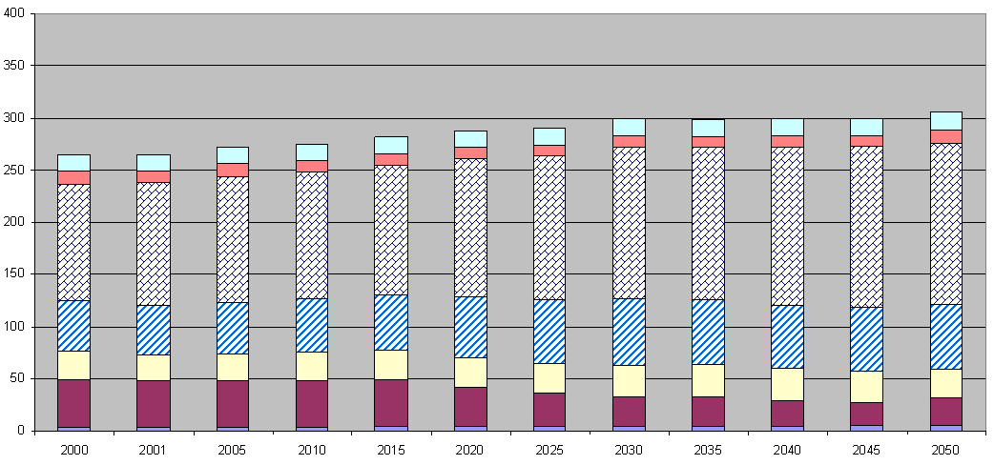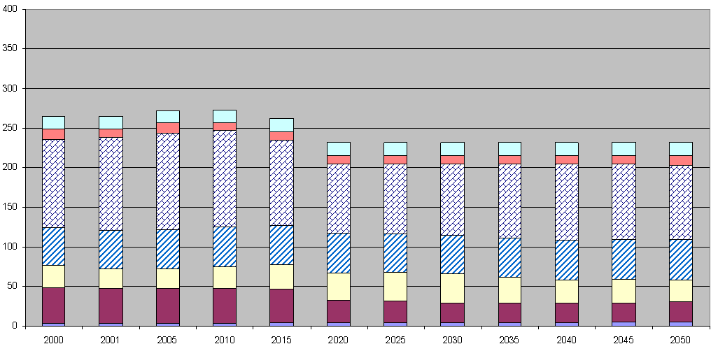
Figure 1: right : Primary energy by sector (in Mtoe): low carbon reference scenario
left : Primary energy by sector (in Mtoe) : saving of primary energy consumption scenario

Because of a unique energy policy dominated by nuclear power, these results enhance the lack of consistency, for France, of the three concurrent criteria :
mitigation of GHG emission , improvement of energy efficiency, targets on renewable energies,
in order to respond to climate change.

Conclusions
The assessment of alternative scenarios of energy consumption savings for France have raised the question of the relevance the european commission recommandation statement on energy efficiency in order to mitigate french CO₂ emissions and to promote renewable energy.
These long term planning exercises have stressed the importance of the “good use” of targets when dealing with climate change. It suggests that if international commitments rely on non clear criteria or definitions, some countries will be penalized. Moreover, if the edicted targets were unefficient to achieve GHG mitigation targets, free riding might occur. This is why an endorsement of mitigation target independent of national circumstances requires a more precise definition of criteria.
Back to energy efficiency, its potential may be properly quantified through the localisation of the losses in the energy chain [3]. Furthermore, there is a link between the producer and the consumer through the transformation stages of primary energy : to final energy and then to useful energy. Focusing on year 2002, the estimated losses were:
- global primary energy consumption of 10.4 Gtep [4] for useful energy of 3,857 Mtep, equal to a global energy chain yield of 37%;
- electricity's share in the global assessment therefore accounts for 3,300 Mtep in terms of primary electricity and for 900 Mtep of useful electricity, equal to an electric yield of only 27%, making it inferior to the yield of the global chain.
The importance of losses, apparent all along the energy chain, can thus be seen to predict energy efficiency. In particular, in France in the year 2000, the transformation yield from final energy to useful energy indicated that more than 45% of final energy could have been economised [5]. The principal reserves concern transports, followed by habitat (both residential and tertiary).
The previous elements emphasize the idea that a simple translation of energy efficiency improvement as saving in primary or final energy consumption is a shortcut that cannot be satisfactory. In summary, in order to efficiently “think globally, act locally”, well-defined and transparent criteria and targets should be cautiously chosen.

References
[1] Fishbone L.G, Abilock H. “MARKAL, a linear programming model for energy systems analysis: technical description of the BNL version”. International journal of Energy research 1981;vol. 5, 353-375.
[2] Maïzi N., Assoumou E. “Modélisation prospective et spécificités de la politique énergétique française”, J3eA 6, (2007).
[3] Mazauric V., Maïzi N. and Wendling P., “A Global Approach of Electromagnetism Dedicated to Energy Efficiency”, International Power Engineering Conference - IPEC2007, 3 - 6 Dec 2007, Singapore.
[4] Key world energy statistics. International Energy Agency 2004.
[5] Radanne P. “La division par 4 des émissions de dioxyde de carbone en France d'ici 2050 - Introduction au débat”. Rapport de mission pour la Mission Interministérielle de l'Effet de Serre du Ministère de l'Ecologie et du Développement Durable 2004.
[6] Centre d’Analyse Stratégique, “Les perspectives énergétiques de la France à l’horizon 2020-2050”, Commission Energie, Rapport Syrota, 2007.

It should be stipulated that primary energy is defined as extracted, final energy as produced in a form fit for commerce, and useful energy is that which is truly necessary when taking into account the best available technology.

